

October 7, 2019

To: Prospective Bidder

Subject: Request for Proposal

Grand Valley State University is accepting proposals for five (5) Ford Transit Connect Vehicles for our Facilities Services Department. Reference attached instructions and specifications.

If you wish to bid on these vehicles, please submit your proposals for bid #220-22 no later than 10:00 A.M. Wednesday, October 16, 2019. E-mail your proposal to: RFP-Received@gvsu.edu

Your proposal must be received electronically by the bid opening date and time. Grand Valley State University is not responsible for e-mail bids affected by spam or not received by the bid opening date & time. No fax, verbal, or telephone proposals will be accepted.

Before submitting proposal, check to be sure that:

- The Proposal/Certification/Contract form is signed and witnessed. *
- All addenda received are acknowledged

*Note: Electronic submission becomes your authorized signature

Thank you for your participation,

Valerie Rhodes-Sorrelle, C.P.M.
Vendor Relations Manager

Procurement Services - 2033 Zumberge Hall - Allendale, MI 49401
Phone - 616/331-2283 - Fax 616/331-3287
Grand Valley State University
Information & Instructions

Ford Transit Connect Vehicles
Bid #220-22

- Grand Valley State University’s sales tax-exempt no. 381684280

- GVSU qualifies as eligible for the vehicle fleet and/or government incentive programs.

- Provide vehicle availability

- Bid proposal must include dealer “best offer” per attached specifications

- DO NOT BID OTHER MODELS. No bids for alternates will be considered at this time. All vehicles must be E85 compatible.

- Vehicle shall be new and shall be of highest quality, free from defects and in conformance with the contract documents.

- Vehicle must be free from all dealer advertising/promotional decals.

- GVSU will provide license plate. Dealer-provided license plate is not required.

- Successful bidder will be responsible for order verification and specifications accuracy.

- Successful bidder will be responsible for providing all operation manuals, any necessary operation instructions and delivery to site.

- Specify vehicle warranties, other guarantees and/or services as appropriate.

- Quote pricing delivered to GVSU Allendale Campus. All title, manufacturing and dealer prep charges and delivery to be included in price of vehicle. GVSU is not responsible for any cost not included in price proposal.

- GVSU reserves the right to inspect, test drive and general approval of vehicle prior to acceptance.

- At Grand Valley State University, socially responsible procurement -- which is defined as supporting diversity, socially responsible procurement, and sustainability -- is highly valued. These ideals are fundamental to our academic, research, and athletic excellence. GVSU promotes supplier participation that is reflective of the diverse business community and of the University's desire to procure environmentally friendly products, while remaining focused on socially responsible procurement methodologies.

- Grand Valley State University endeavors to buy products made in the United States of America whenever an American-made* product is available that meets or exceeds the specifications requested and the price is equal to or lower than a foreign-made product. Vendors are requested to bid American made products and or services whenever available. Vendors may bid foreign-made products or services when:

- They are specified
- They are identified as an alternate by the vendor as long as they are technically acceptable.

*More than 50% of the manufactured or assembled in the United States.

- Contract to purchase vehicle will not be considered complete until a purchase order has been issued and the vehicle has been delivered, inspected, accepted by authorized University personnel.

- GVSU reserves the right to accept or reject any or all Proposals not withdrawn before the opening date and to waive any irregularity or informality in the Proposal process. The University reserves the right to conduct discussions, request additional information and accept revisions of Proposals from any or all bidders. The University reserves the right to negotiate with the bidder whose proposal is deemed most favorable.

- Any decision made by the University shall be final.

- Any questions regarding this request for proposal should be directed to Valerie Rhodes-Sorrelle at 616/331-2283

Grand Valley State University

Specifications
Ford Transit Connect Vehicles
Bid #220-22

Five (5) - 2019 Transit Connect XL to be equipped as follows:

(Specs per State contract, standard factory equipped items, specified additional options and special additional equipment)

Please note: All vehicles must be E85 compatible.
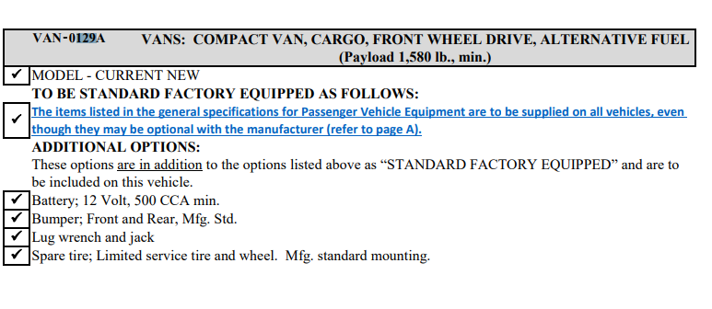
- Requires back window
- Power windows
- Power lock
- 4 sets of keys
- White in color

Used Adrian Steel Catalog (can swap with similar products)

Van Spec 1 – Painters Van Upfit (KP)
- Full wire mesh partition P2TCFW14
- 2 Bar Aluminum Utility Rack 2BTCS19
- 2 - Adjustable 3-Shelf Unit, Gray 32 x 12 x 44 – AD1232TC14 (right & left side of van)
- Vehicle must be E85 compatible

Van Spec 2 – General Maintenance (MC)
- No additional shelving units or partition
- Vehicle must be E85 compatible

Van Spec 3 – General Maintenance (EL/DW)
- Full wire mesh partition P2TCFW14
- 4-Hook Bar Gray – TA1 (installed drivers’ side)
- 1 – 3 shelf unit, Gray AD1426TC14 (installed passenger side)
- Vehicle must be E85 compatible

Van Spec 4 – HVAC (MR)
- HVAC Starter Package #5217
- Adjustable 3 shelf unit AD1226TC14
- Vehicle must be E85 compatible

Van Spec 25 – General Maintenance (MG) (set up same as picture below)
- Full wire mesh partition P2TCFW14
- 1 – 3 Shelf adjustable unit AD1432TC14
- 1 – 3-drawer unit w/lock, gray - #919
- 1 – 3 drawer unit 12” gray – DC12
- Vehicle must be E85 compatible

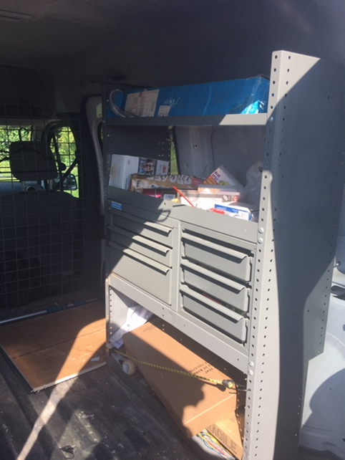

Record pricing information on page six of this document.

Grand Valley State University
Proposal & Contract

Bid #220-22

Contractor: ________________________________________________________________________________

Date: _________________________________________ Bid No.: __________220-22____________________

Project: Ford Transit Connect Vehicles __ _________________________ ________________________

Bid opening date and time: ___Wednesday, October 16, 2019 - _10:00 AM ____________________________

Location: _ __________ Zumberge Hall ____________________________ ________________________

______________________ Allendale, MI, 49401_________________________________________________

Attached or included are the following proposed Contract Documents:

- Introduction

- Instructions to Bidders

- Specifications

4. Proposal & Contract

Bidder acknowledges receipt of the following addenda:

Addendum No. ____________ Dated ________________

Addendum No. ____________ Dated ________________

If awarded this contract, upon receipt of contract sign by Grand Valley State University, the undersigned agrees to begin and complete all work and or provide product(s) in accordance to the schedule coordinated with the Facilities Services Department.

The undersigned proposes to furnish all labor, materials / product, equipment, tools and services required, unless otherwise noted, to complete the work and or provide product(s) in accordance with the proposed contract.

Documents listed herein, including all addenda issues pertaining to same, for the same, for the sum or sums stated below, and agrees that these documents will constitute the contract if accepted by Grand Valley State University.

The undersigned declares the following legal status in submitting this quotation:

[ ] A corporation organized and existing under the laws of the State of ________________

[ ] A partnership

[ ] An individual doing business as (DBA) _______________________________________

The undersigned certifies that company is at least 51% owned, controlled and actively managed by:

African American Asian American Hispanic American
Native American Woman/Women Disabled Person(s)
Veteran

The undersigned certifies that their company ____ IS or ____IS NOT currently debarred, suspended or proposed for debarment by any federal entity. The undersigned agrees to notify the University of any change in this status, should one occur, until such time as an award has been made under this procurement action.

Bid Proposal Sum 2019 Ford Transit Connect Vehicle Spec #1: _____________________________dollars

($__________________________________)

Vehicle Availability: ________________________________

Bid Proposal Sum 2019 Ford Transit Connect Vehicle Spec #2: _____________________________dollars

($__________________________________)

Vehicle Availability: ________________________________

Bid Proposal Sum 2019 Ford Transit Connect Vehicle Spec #3: _____________________________dollars

($__________________________________)

Vehicle Availability: _________________________________

Bid Proposal Sum 2019 Ford Transit Connect Vehicle Spec #4: _____________________________dollars

($__________________________________)

Vehicle Availability: _________________________________

Bid Proposal Sum 2019 Ford Transit Connect Vehicle Spec #5: _____________________________dollars

($__________________________________)

Vehicle Availability: _________________________________

Grand Total for the above 2019 E85 compatible Vehicle(s): _______________________________dollars

($__________________________________)

____________________________________________________________________________________

Company Name

____________________________________________________________________________________
Address City/State/Zip Code

_________________________ _________________________ ______________________________
Telephone No. Fax No. E-Mail Address

___________________________________________ _______________________________________
Contractor's Signature Name & Title

___________________________________________ _______________________________________
Witness' Signature Name

_____________________________ _____________ _______________________________________
Tax Identification No. Date

ACCEPTANCE: This proposal is accepted by Grand Valley State University

__________________________________________ ________________________________________
Signature of Authorized Agent Name & Title

_________________________ _________________________ ______________________________
Telephone No. Fax No. E-Mail Address

__________________________________________ ________________________________________
Witness' Signature Name

__________ 38 1684280______________________ ________________________________________
GVSU Tax Identification No. Date

