How to Reserve Travel in the Lightning Online Booking Tool 12-10-25
Click this link to get the latest version of this user guide

How to Access Lightning and Your Lightning Profile p. 2

Complete Your Profile p. 2-5
Add your name to the Arranger/Assistant Field p. 3
Add a person as your Travel Arranger/Assistant p. 3
Add a credit card to reserve hotels & car rental p. 3-5
Add traveler preferences, loyalty & passport info p. 5
Profiles for Temporary Employees p. 2

Start a Reservation p. 5
Traveling together with other employees p. 5
Guests & Students reservations p. 6
Employee ID when reserving for Guests p. 6, 10
To View or Change Existing Reservations p. 11, 12, 15

Flight Reservations p. 7-10
Airfare Allowed by GVSU Policy p. 7
Multi-City Reservations p. 7
Filtering & Sorting Search Results p. 8
GVSU Travel Policy Compliance p. 9
Payment p. 10
Important Note about Unticketed Flights p. 11
Change or Cancel a Flight Reservation p. 11-12
Unused Tickets / Flight Credits p. 9, 12, 20

Hotel Reservations p. 12-14
Card Payment & Declining Balance Cards p. 12-14
Member Rate Listings p. 13
For a Student or University Guest p. 13
Change or Cancel a Hotel Reservation p. 14
Car Rental Reservations p. 14-16
Card Payment & Declining Balance Cards p. 14
Sales Tax Exemption p. 14
Change or Cancel a Car Rental Reservation p. 15

Train Reservations p. 23
To View or Change Existing Reservations p. 11, 12, 15

Collegiate Travel Planners (CTP) Travel Agent p. 16

Lightning Fees & CTP Travel Agent Assisted Fees p. 17-18
Fees for Reservations p. 17
Minimizing Fees p. 18
Receipts for Your Expense Report p. 18

How to Access Lightning and Your Lightning Profile
Go to the Okta Dashboard login page
Login with your GVSU network User ID and Password.
Click the app square that says CTM Travel. You will be taken to the CTM Portal webpage.
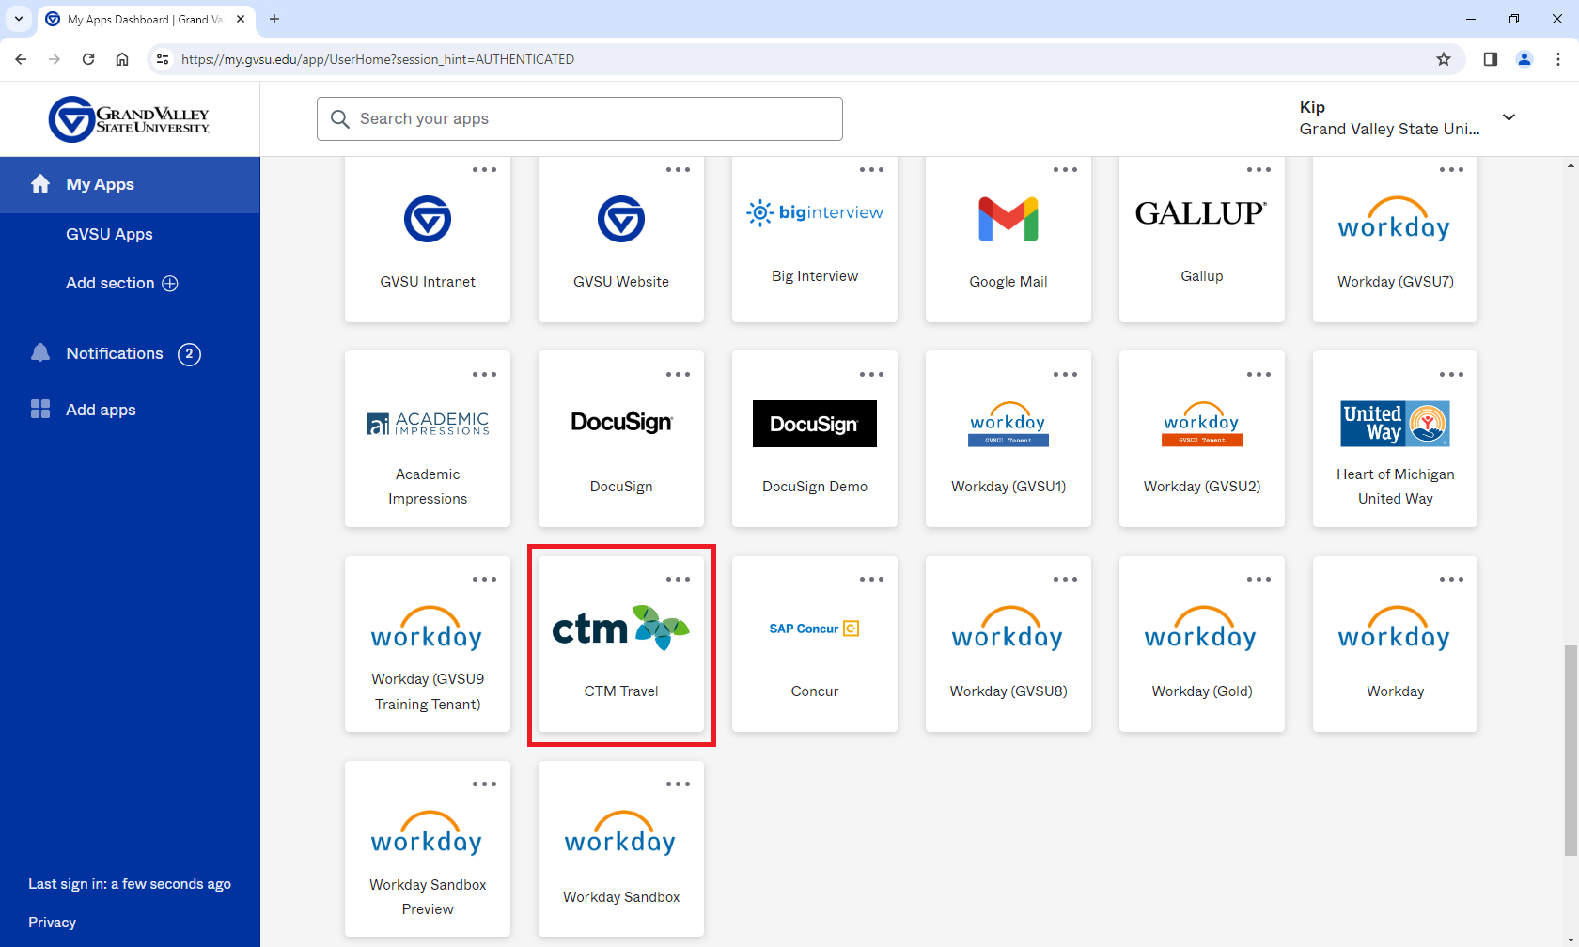

In the CTM Portal, click either Lightning to make reservations or Profile to view your profile.
To use Lightning, employees must first complete their traveler profile and add their birthdate and GVSU expense card and/or declining balance card information.
Note: If you are a former GVSU employee returning to GVSU in a temporary position,
contact Kip Smalligan 616/331-3211 to have your profile added.
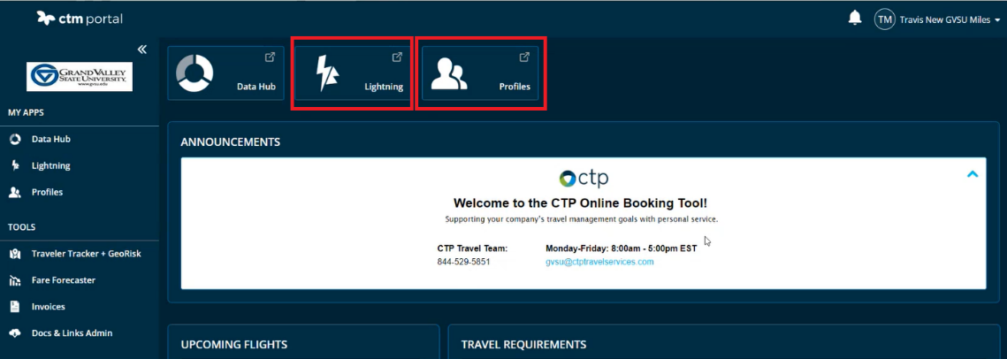

Complete Your Lightning Profile
In your Lightning profile, go to the Administration section. If the Arranger / Assistant field does not already have your name in it, add your name (must be your legal first and last name).
Click the blue Save button in the left column – you might have to scroll down a little to see it.
Note: It can take a minute or two for changes made to your profile to take effect in Lightning.
Try refreshing your Lightning screen or closing and re-opening Lightning.
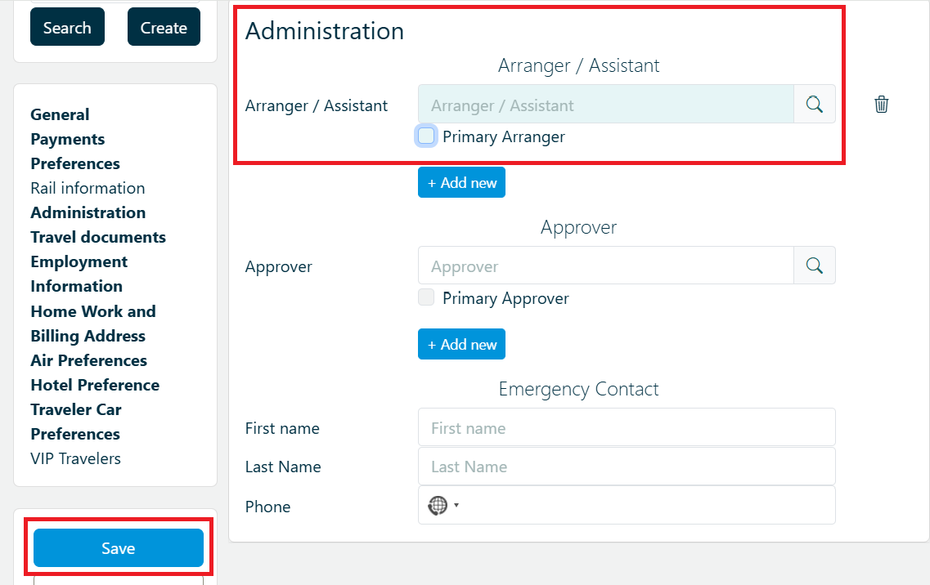
You can allow other employees to reserve travel for you by clicking the Add New button to make them a travel arranger. Travel arrangers can view and edit your profile, can make reservations for you, and can view and change your reservations.
You can ignore the Approver field as GVSU does not require travel approval through Lightning.

Verify that all the other information in your profile is correct.
In the General section, add your Date of Birth if not already entered. This is required to book flights.

You will need to enter a credit card in the Payments section in order to reserve lodging,
car rental, and trains. You also need to select your card in the Hotel, Rental Car, and Guarantee dropdown fields.

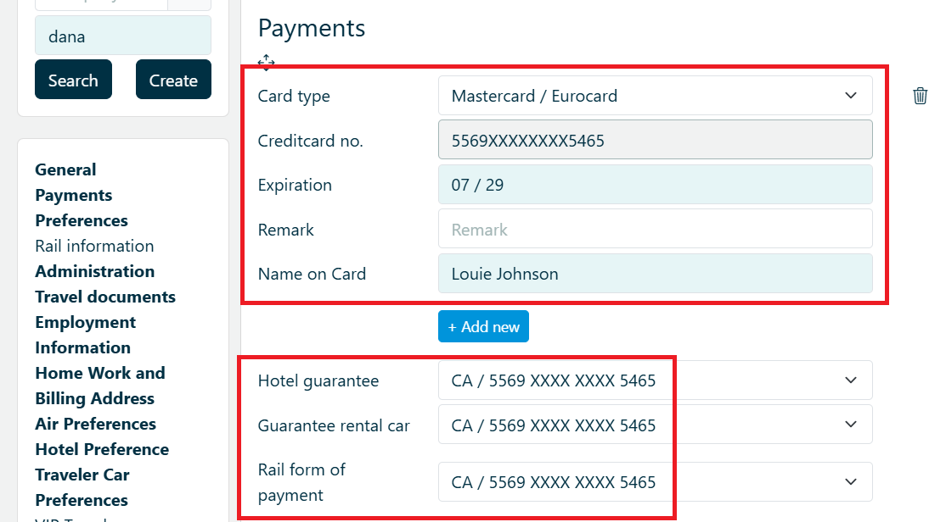
You can apply for a GVSU expense card (formerly called purchasing card). Airfare is paid with a separate GVSU credit card that is on file in Lightning (card number ends in 5807).
You can add your preferences for airline, hotel, car rental, and train providers and your loyalty numbers in the Preferences section. You can add more preferences in the Air Preferences,
Hotel Preference, and Travel Car Preferences sections.
You can add passport, visa, and known traveler numbers in the Traveler Documents section.
If you have any questions, contact Kip Smalligan in Procurement Services at 616/331-3211.

Start a Reservation

To start a reservation, open Lightning and select the New Booking tab at the top.
Check the circle buttons to select all the applicable travel services from Flight, Hotel, Car, Rail
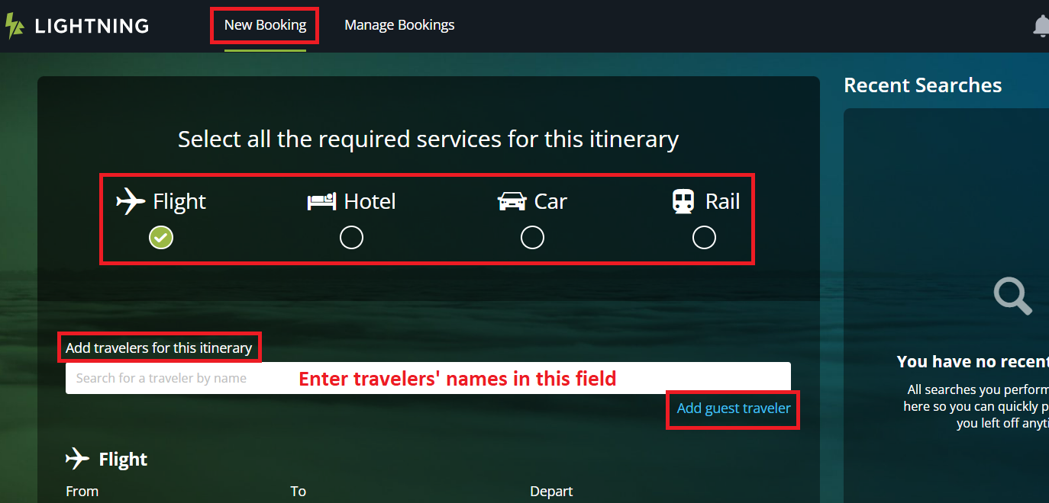
Type in the your legal first and last name in the Add travelers for this itinerary field. Your name will pop-up; select the name to populate the field.
Tip: If your name is not popping up try entering only the last name. Or check that your name has been added in the Arranger/Assistant field in your Profile (see page 3).
Note: If you are traveling together with another employee(s) and you also want to reserve for them, the other employee(s) must first complete their Lightning profile and make you a travel arranger on their behalf in their Lightning profile. Or contact Kip Smalligan at 616/331-3211 for assistance.
If you want to add other employees to the reservation, type in the name of the next employee and select from the pop-up. You may choose up to 9 travelers who are traveling together on the same itinerary. If you have more than a few travelers, it might worth it to have GVSU’s travel agent do the reservations to ensure prices don’t change and travelers are seated together. There will be an agent fee per ticket.
Collegiate Travel Planners 844-529-5851 or gvsu@ctptravelservices.com

Add a university guest traveler or a student as a traveler
Click the Add guest traveler link. Then complete the required guest traveler detail fields (see illustration on the next page). You should not use the Add Guest Traveler function for employees. You can reserve travel for other employees as a Travel Arranger /Assistant

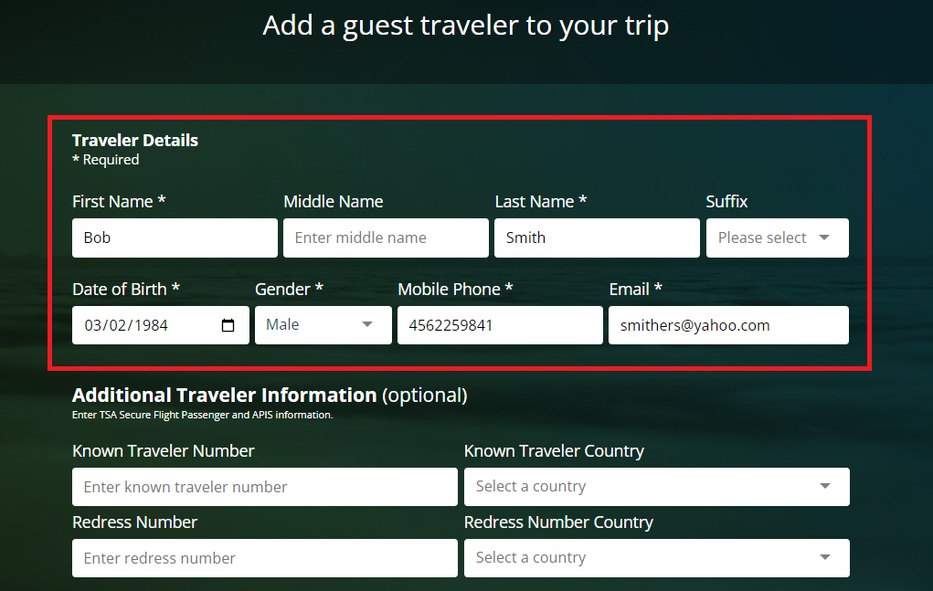
Click Save Guest Details. Your guest’s name will now appear in the Add Travelers for this itinerary field.
Note: If you are reserving for a guest and it asks you in the Company Reference section for an Employee ID and a Department, enter your GVSU G-number and your department name.
The guest’s charge will be routed to your Workday account to be added to one of your expense reports.

If you are reserving for a guest through our travel agent, Collegiate Travel Planners, they will ask you for an Employee ID. Give them your G number.

FLIGHTS
Airfare Allowed by GVSU Policy (click link)
Note: If your travel is federally funded, you may be required to use a US airline per the
Fly America Act.

Enter the flight departure and destination locations by city name or airport code and select in the pop-up. Enter the date and times. You can do domestic multi-city itineraries* (more than a one destination itinerary, e.g., Grand Rapids to Miami to Boston to Grand Rapids) by clicking the Add Flight link to add another flight segment. You may add up to 5 flight segments. Click Search to display results.
*International multi-city itineraries (that is, more than a one city destination trip,
e.g., Chicago to London to Zurich to Chicago) cannot be reserved through Lightning, They must be reserved through the GVSU’s travel agent, Collegiate Travel Planners (CTP) 844-529-5851, gvsu@ctptravelservices.com).
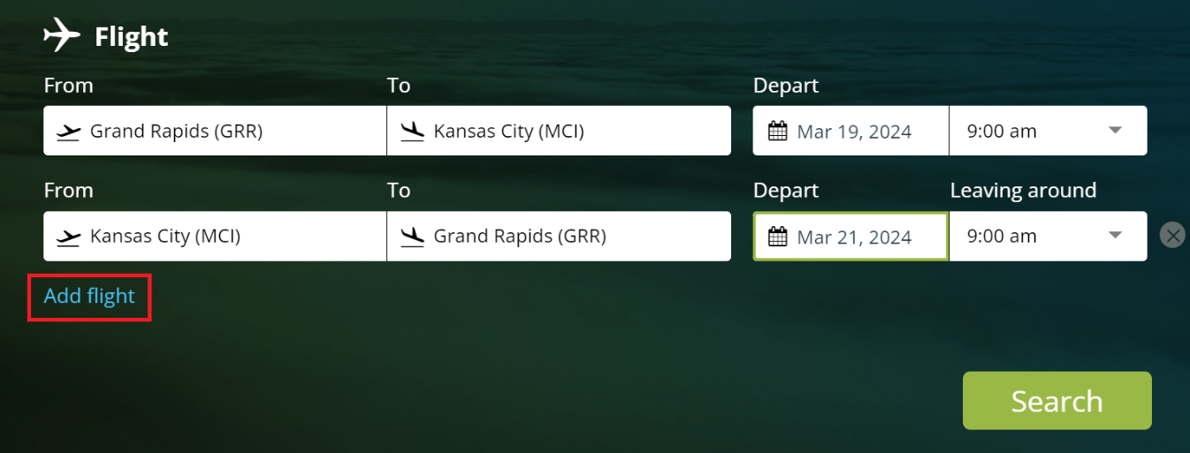

After your search results display, you can toggle between your outbound and return flights using the tabs at the top of the page.

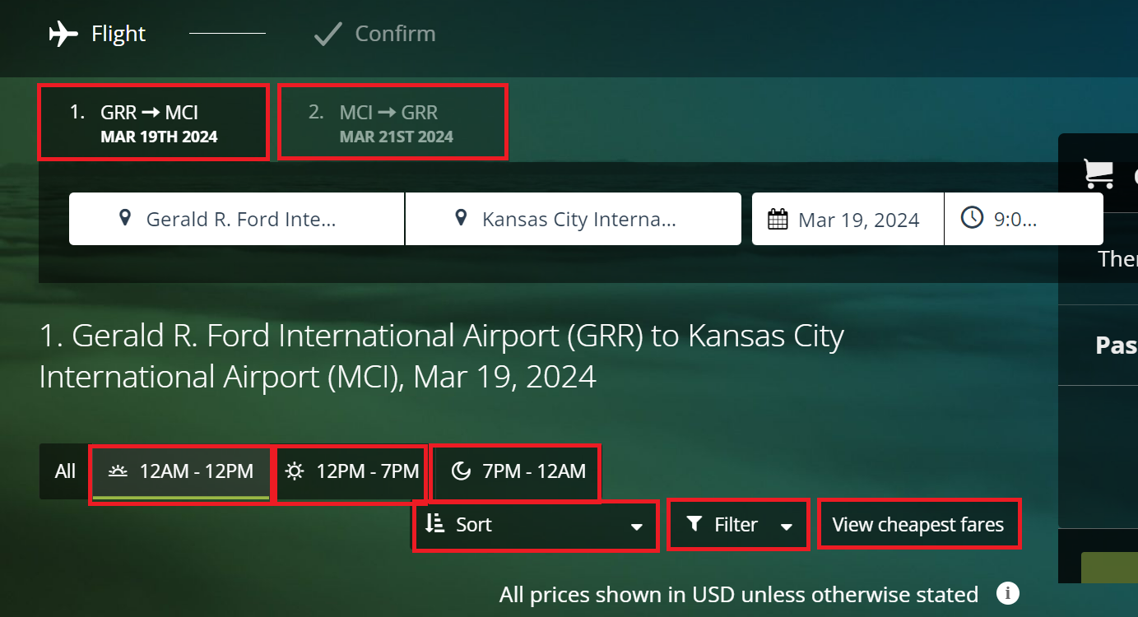

You can quickly modify the search results to view different departure times by clicking one of the three pre-set buttons for time ranges:
12:00 am (midnight) to 12:00 pm
12:00 pm to 7:00 pm
7:00 pm to 12:00 am (midnight)

You can filter the search results for:
Price
Departure
Arrival
Carbon Footprint
Airlines
Number of Stops

You can sort search results for:
Most Direct
Cheapest
Shortest
Earliest Departure
Earliest Arrival
Carbon Footprint

GVSU Travel Policy
See Airfare Allowed by GVSU Policy. Lightning prioritizes search results that are within GVSU’s travel policy and cost variances. If your travel selection is not within these, you will see a  symbol. Click the symbol for more information. You might have to provide a reason for that selection before proceeding with the booking.

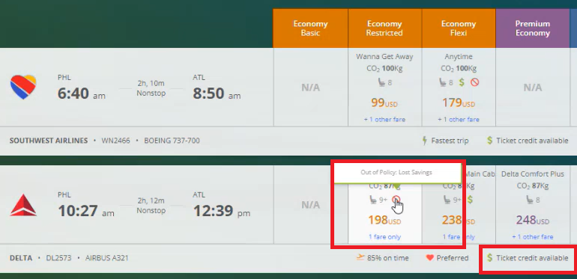

If the traveler has an unused ticket credit available to be used for a flight, it will be noted in the fare options with $ Ticket Credit Available.
You will be prompted to apply the credit at checkout. See page 20 on how to use flight credits.

Note the rules for Basic Economy fares are restrictive. Rules vary by airline.

▪ They might not allow flight changes or cancellations
▪ If you cancel your flight, credit will range from no credit to partial credit, and usually there is a fee to cancel.
▪ Includes a carry-on or it is allowed for a fee
▪ There is a fee for checked bags
▪ Seat selection is not included; usually allowed for a fee
▪ Passengers traveling together usually will not be seated together

GVSU policy does not require Basic Economy fares – standard Economy and standard Main Cabin fare are also within policy.

Click the desired outbound and return trip fares to select.
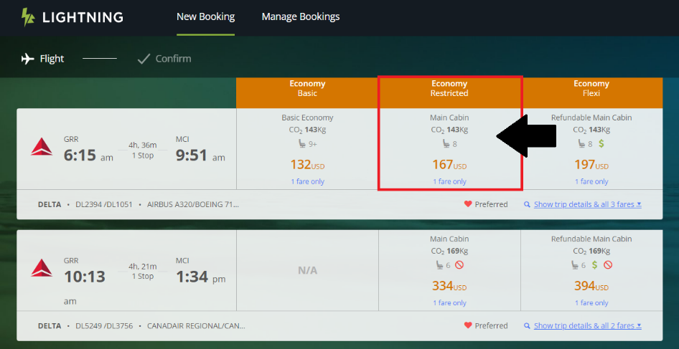

If advance seat selection is included in your fare, you may be prompted to select your seat in Lighting. If not, that can also be done via the airline’s website.
If you are booking for a guest and it asks you in the Company Reference section for an Employee ID and a Department, enter your GVSU G-number and enter your department name.

Confirm Your Booking page: You can review your itinerary and view Payment Method.
All employee and guest flights will be paid with a GVSU credit card on file with our travel agency (card ends in 5807). Your flight expense will get routed to your Workday expenses for reconciling on an expense report.
If you later decide you want to add hotel or car rental you can do so by clicking the desired service here
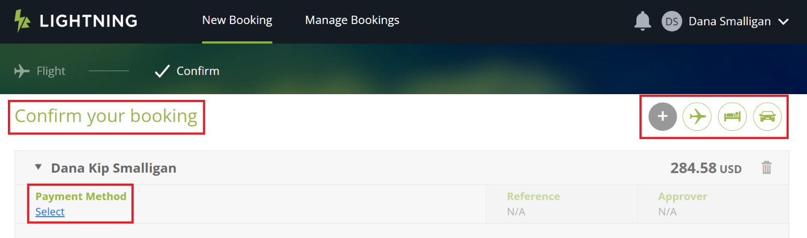

Click the View Terms and Conditions link to review the airline rules for your flight.
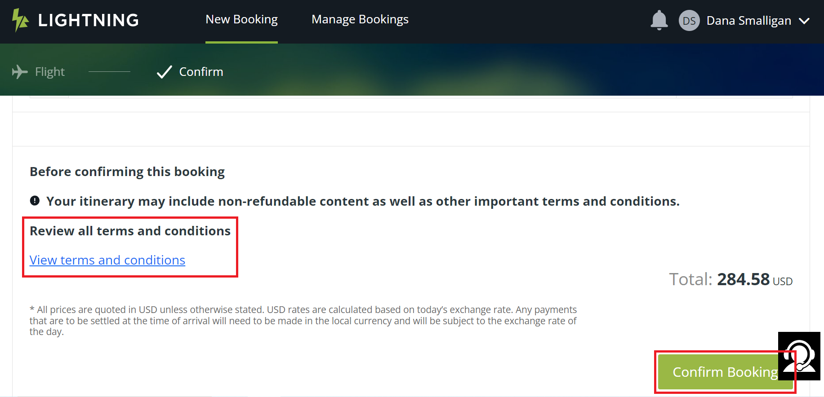
To complete the booking, click the Confirm Booking button. You will receive an email confirmation from ctptravelservices.com. The email might not arrive immediately as there can be a delay. You can also view your reservations by clicking the Manage Bookings button on the Lighting home page (see below section, To View Existing Reservations).

*** IMPORTANT ***
Email or Voice Message Regarding Unticketed Flight from our Travel Agency
If you receive an email or voicemail from our travel agency, Collegiate Travel Planners (CTP), stating that your flight was not ticketed it means that you do NOT have a reservation even if you have a confirmation number. This is caused by a decline of our credit card on file with the travel agency or other technical issue with ticketing. Call our travel agency right away to get corrected: Collegiate Travel Planners (CTP) at 844-529-5851

To View Existing Reservations
You can view your existing reservations by going to the Lighting home page and click
Manage Bookings at the very top. Enter the traveler’s last name or agency record locator number (6 characters, all letters) in the PNR/Name field; and the booking or travel date range. Click Search then look in the Booking Status section in the lower left. Click the desired reservation in the search result.

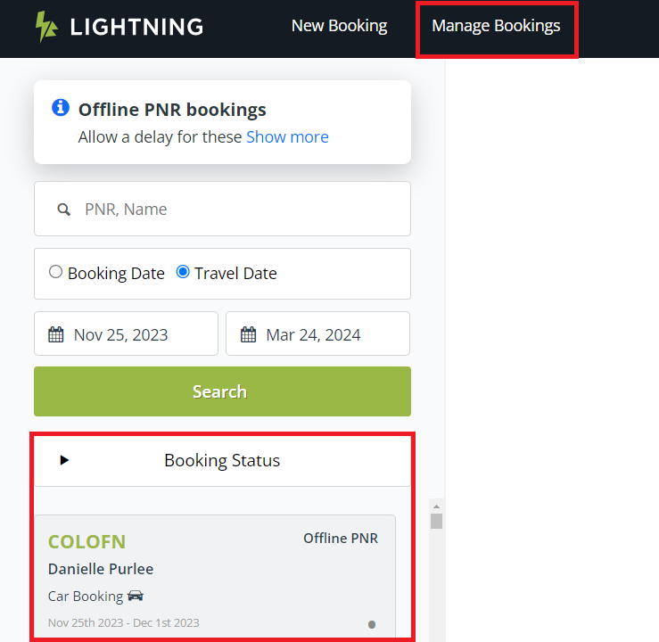

To Cancel or Change An Existing Flight Reservation
Pull up your flight in Lightning - See page 9 “To View Existing Reservations”
To cancel, it is recommended to call GVSU’s travel agent, Collegiate Travel Planners
(844-529-5851) and have them cancel the flight especially if the cancellation is time sensitive. Online cancellation in Lightning is not real time and does not immediately cancel with the airline; the travel agent still has to do the cancellation. There is no agent fee for cancelling through the travel agent. To cancel online, click the Cancel button at the top of the screen.
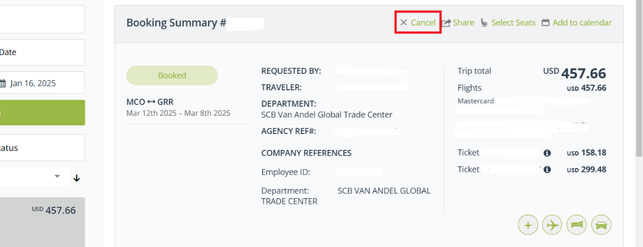

To change a flight reservation, click the Change button in the displayed itinerary (see below next page) for the flight you want to change. Depending on the original fare type, there may be an airline change fee and you’ll have to pay the difference if the new flight is a higher price than the original flight. An agent fee will also apply.
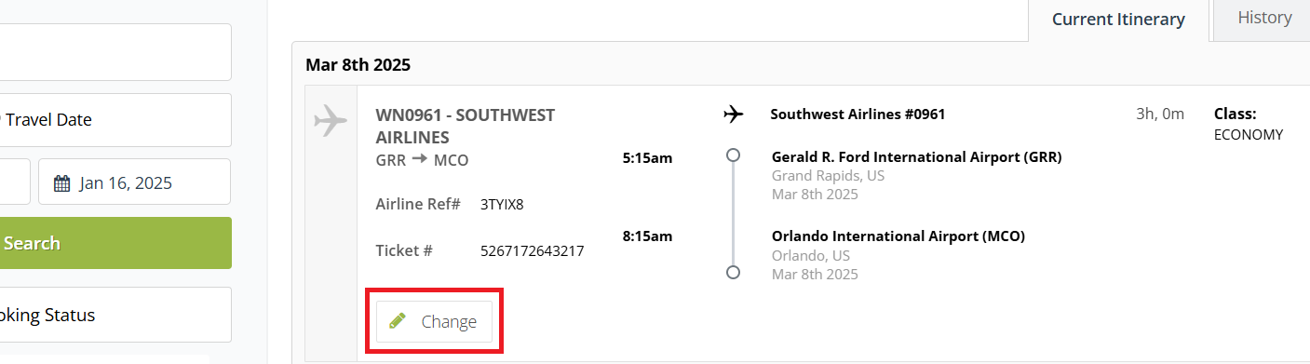

Unused Tickets / Flight Credits
If you must cancel your flight, your fare might provide a flight credit that can be used on a future flight with the same airline. Lightning prompts you to use credits when applicable.
Most airlines give you up to a year to use the credit. Some discount airlines may be less.
To use a flight credit, see page 20.

For Delta and United, if you cannot use the credit before it expires, GVSU can request a name change through our travel agent, Collegiate Travel Planners (CTP) to allow any other GVSU employee, university guest, or student to use the credit. There is $100 fee. Requesting a name change is not guaranteed as the airlines decide whether to grant it. Contact Kip Smalligan 616-331-3211 for more info.

HOTEL

Credit Card Required in Your Lightning Profile
To reserve hotels in Lightning, you need a GVSU credit card number added in your Lightning profile in the Payments section to hold the reservation; if you haven’t added one to your profile, do that first. Then select the credit card in the Hotel Guarantee drop down menu. You will still need to present your physical credit card at check-in to charge your room. If you have a GVSU declining balance card, check in advance if the hotel accepts declining balance cards.
If you have any personal incidental expenses, provide a personal credit card to charge those separate from the room.
Member Rate Listings
You may see some hotel listings that state “Member Rate”. Those rates are only available if you are a member of the applicable hotel loyalty group or association. Member identification or proof will be required either in Lightning or at hotel check-in.
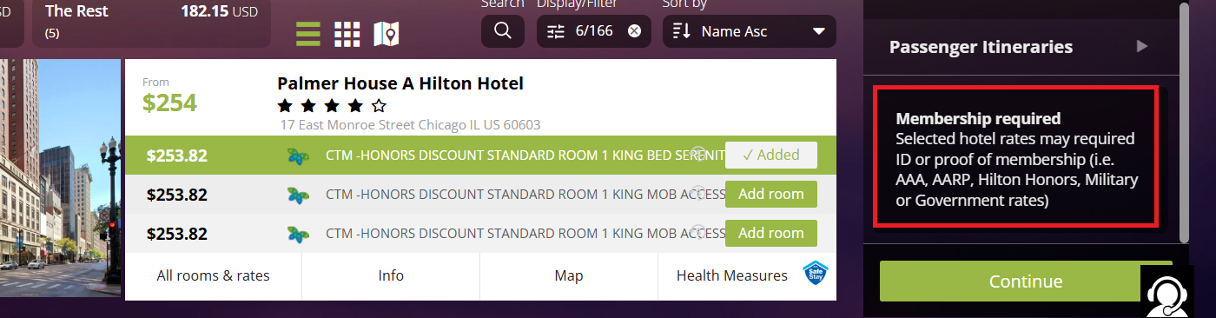
Cancellation and Check-In/Out Policies
You may view the cancellation and check-in/out policies by clicking those links in the Additional Information section
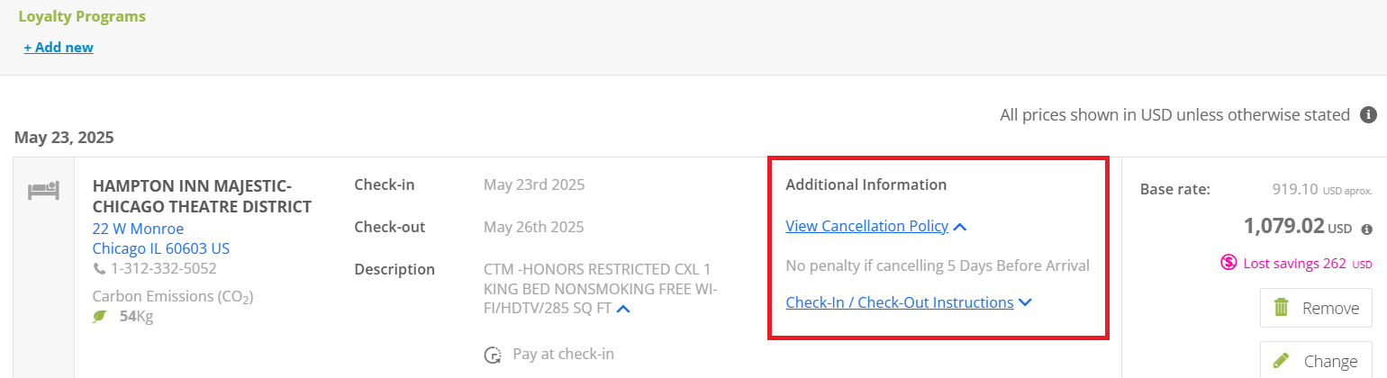

Lodging for a University Guest or Student
If you are booking a hotel for a guest or student, and GVSU is paying for only the room and tax, and you will not be present with the guest at check-in to provide your physical credit card, you will need to contact the local hotel directly and request to put a GVSU credit card on file. The hotel will provide you with a credit card authorization form. On the form, authorize the card for room and tax. The room and tax will be charged to that credit card upon check-out.
The guest will still need to present a personal credit card at check-in to pay for any incidental expenses (movies, etc.).

If you are booking a hotel for a guest or student and GVSU is paying for the room, and you do not want the guest to have to present a personal credit card at check-in or check-out (e.g. VIPs), you will need to contact the hotel directly and request to put a credit card on file. The hotel will provide you with a credit card authorization form. On the form, you must authorize for all charges.
If you are reserving a hotel for a guest or student, you will be asked in the Company Reference section for your Employee ID and Department name: Enter your G number and your department. The charge will go to your Workday account to add to an expense report.

To Change or Cancel An Existing Hotel Reservation
Pull up your reservation in Lightning using the Manage Bookings button (see page 9 “To View Existing Reservations”)
To cancel, click the Cancel button at the top of the screen. If the cancellation is time sensitive call the travel agent, Collegiate Travel Planners (844-529-5851), to cancel it. Cancelling online in Lighting is NOT a direct, real time cancellation with your car rental company. The CTP agent must still do the cancellation which is not guaranteed to be immediate or the same day. There is no fee for CTP to cancel a reservation.

CAR RENTAL
Note: See the GVSU Vehicle Rental Procedures and GVSU Driving Vehicles websites for important and helpful information regarding vehicle rental.
Enterprise and National are GVSU’s preferred rental companies as we have a contract with them. Travelers should use Enterprise or National unless they cannot meet your needs.
Search results for Enterprise and National include GVSU’s contract rates.
If GVSU is sales tax exempt in the state where the rental originated, have the rental company remove the sales tax when you return the vehicle.
Credit Card Required in Your Lightning Profile
In order to reserve car rental in Lightning, you need a GVSU expense credit card number stored in your Lightning profile to hold the reservation. If you haven’t added one to your profile, do that first. You will still need to present a credit card at check-in to charge your rental. Declining balance cards are not accepted at most or all car rental companies as they are considered a pre-paid card. Some may let you use it for final payment but not to reserve.
The car rental company might check your card at check-in to see if there is adequate balance available or place a hold against your card for several hundred dollars which will be released when you return the vehicle.
You may be asked to show your GVSU employee ID at check-in at Enterprise or National.

Renting a Vehicle to be Delivered to Allendale Campus
If you are renting a vehicle that you want dropped off to Allendale campus, contact
Kip Smalligan in Procurement Services at 616/331-3211

Non-GVSU Employees Needing Rental Vehicles
For liability and insurance reasons, non-GVSU employees needing car rental that GVSU has agreed to fund, should reserve their own reservation using their rental company of choice, pay out of pocket, and submit for reimbursement or invoice GVSU if they are an independent contractor. Non-GVSU employees are not allowed to use GVSU’s contract with Enterprise and National.

To Change or Cancel An Existing Car Rental Reservation
Pull up your reservation in Lightning using the Manage Bookings button
See page 9 “To View Existing Reservations”
To cancel, click the Cancel button at the top of the screen (see illustration on page 14).
If the cancellation is time sensitive call the travel agent, Collegiate Travel Planners (844-529-5851), to cancel it. Cancelling online in Lighting is NOT a direct, real time cancellation with your car rental company. The CTP agent must still do the cancellation which is not guaranteed to be immediate or the same day. There is no fee for CTP to cancel a reservation.
To change, click the Change button and follow the instructions.
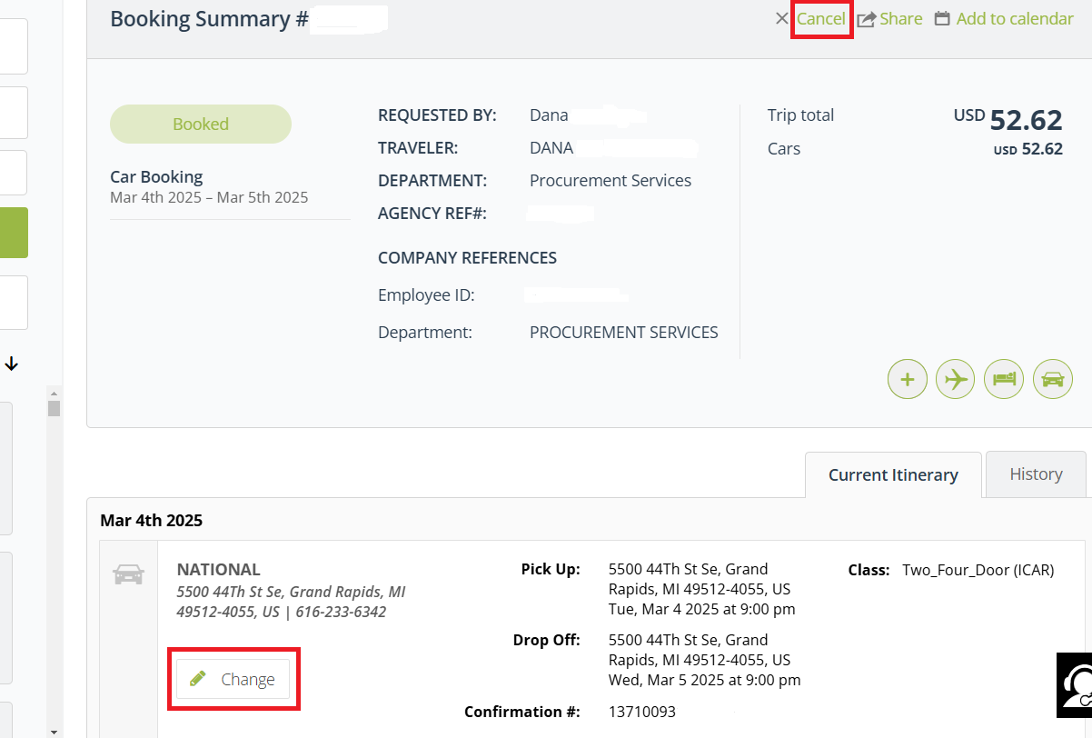

GVSU’s Travel Agent is Collegiate Travel Planners (CTP)
You may see CTP referred to as CTM (Corporate Travel Management) which is CTP’s parent company.
Collegiate Travel Planners supports the reservations made through Lighting.
Faculty and staff may also make reservations directly with Collegiate Travel Planners (CTP). Their contact information is below. The agent fee for reserving through CTP is higher than reserving through Lightning ($28 to $30 versus $4 to $5). See fee schedule on page 15.
If you are making a reservation and the agent asks you for an Employee ID or
Organization ID, give them your employee G-number. This usually happens when you are making a reservation for another person.
Contact Collegiate Travel Planners (CTP)
Individual Travel and Small Group Travel (2 to 9 persons)
gvsu@ctptravelservices.com 844/529-5851

Large Group Travel (10 or more persons)
Shelly Parks, Large Groups GVSU designated agent
shelly.parks@ctptravelservices.com Direct: 781-496-3798
Business Hours: Mon - Fri 9:00 am – 6:00 pm ET (8:00am-5:00pm CT)
After Hours Assistance: 833-997-1935 / 720-836-1874

Alternate Large Group Travel Contact:
groups@ctptravelservices.com 800/810-2695 or 210/530-0857

After Hours Assistance: 833-997-1935 / 720-836-1874

Lightning Online Booking Technical Support:
Questions on error messages in Lightning or other issues with the booking tool
na_online@travelctm.com 877-208-1396 M-F: 8:30 am - 8:30 pm ET

Lightning Reservation Fees & Collegiate Travel Planners Travel Agent Assisted Fees

Lightning Online Booking for Individual Travel Domestic International
Air reservation only*** $4 / person $5 / person
*** Air reservations with multiple airlines will be charged a fee for each airline.
Air reservation with hotel and/or car rental $4 / person $5 / person
Airline Ticket Exchange (changing flights) $4 / person $5 / person
Direct Connect air reservation $8 / person $8 / person
Direct Connect air reservation with hotel $8 / person $8 / person
and/or car rental
Car Rental only $4 / person $5 / person
Car Rental with Hotel $4 / person $5 / person
Hotel only $4 / person $5 / person
Rail reservation $4 / person $5 / person
Air, Car Rental, Hotel void or cancellation No Charge No Charge

Travel Agent Assisted Booking for Individual Travel
Domestic International
Air reservation only $28 / person $30 / person
Air reservation with hotel and/or car rental $28 / person $30 / person
Airline Ticket Exchange (changing flights) $28 / person $30 / person
Air, Car Rental, Hotel void or cancellation No Charge No Charge
Car Rental only $10 / vehicle $10 / vehicle
Hotel only $10 / room $10 / room
Car Rental with Hotel $10 / person $10 / person
Rail reservation $28 / person $30 / person

Travel Agent Assisted Booking for Small Group (2-9 persons) & Large Group (10 or more persons)
Domestic International
Group Airlines (2 – 9 passengers) $23 / person $25 / person
Group Airlines (10+ passengers) $20 / person $22 / person
Group Airline Ticket Exchange $20 / person $20 / person
Group Airline Name Change $20 / person $20 / person
Group Car and/or Hotel $5 / vehicle / room $5 / vehicle / room
Group Airline void or cancellation No Charge No Charge
Group Ground Transportation and/or Hotel 10% of net or No Fee if CTM receives a commission from provider
After Hours, Full Service Travel Agent Assistance
(7:00 PM to 7:00 AM Mon-Fri; weekends & holidays) Cost per Transaction
Call without airline, car and/or hotel reservation ticketing $16
Call with airline, car and/or hotel reservation ticketing $27
Call with airline ticket exchange $40
Call with airline, car and/or hotel reservation void or cancellation $26
VIP Full Service Travel Agent Assistance
(7:00 AM to 7:00 PM Mon-Fri excluding holidays) Cost per Transaction
Airline reservation with or without car and/or hotel reservation $35
Airline exchange (changing flights) $35
Airline, car and/or hotel reservation void or cancellation No Charge
Rail reservation only $10
Car and/or hotel reservation only $10
VIP After Hours, Full Service Travel Agent Assistance
(7:00 PM to 7:00 AM M-F, weekends & holidays) Cost per Transaction
Referral Fee $ 3
Call without airline, car and/or hotel reservation ticketing $26
Call with airline, car and/or hotel reservation ticketing $37
Call with airline ticket exchange $50
Call with airline, car and/or hotel reservation void or cancellation $36

You can minimize reservation fees:

▪ See the Lightning reservation fees and CTP travel agent assisted fees on page 16

▪ For individual travel, use the Lighting online booking tool instead of having an agent book for you
▪ For individual travel in the Lightning booking tool, reserving airfare, hotels, car rental, etc. together at the same time in one session. You will be charged just one $4 booking fee when booked in the same session. A Lightning booking tool session ends if you log out, time out, or close your web browser.

▪ Contact travel agent during business hours (7:00 am – 7:00 pm Mon-Fri) to avoid the “after hours” fees.

Receipts for Reservations and Booking/Agent Fees
You need to have receipts for your reservations and for your booking fees (online or agent) to add to your expense reports. You should receive email confirmation of your reservations that includes your online and/or agent fee charges.

If you are missing receipts, you can download them from the CTM portal (the first screen that appears after you open CTM Travel app (in a separate browser tab from Lighting).

Click on Reprint My Invoices, then …

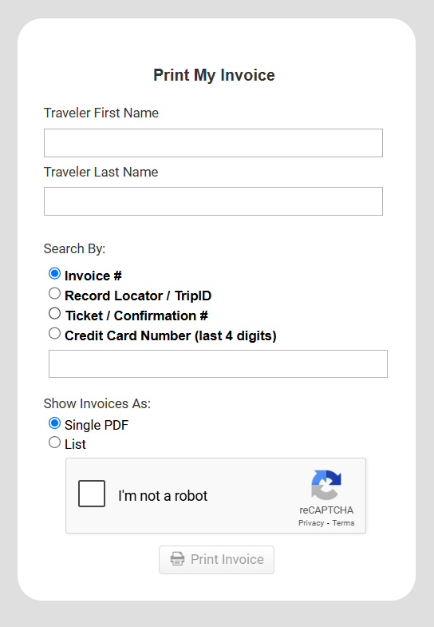

Enter your name and
Record locator or Agency Reference Number -- six character alpha or
Airline ticket number or airline confirmation number or
Credit Card Number last 4 digits (5807 for flights reserved through Lighting)

When you do your expense report, you can change your fees Expense Type to “Agent Fee” and it will not require you to add a receipt. Or just upload the same receipt you used for your flight, hotel, car rental, or train for your agent fee receipt.

Frequently Asked Questions
How do I use an airline flight credit toward a new flight?
Because the airlines may have rules regarding use of unused tickets, it is recommended to contact Collegiate Travel Planners (CTP) 844-529-5851 gvsu@ctptravelservices.com to reserve the new flight and apply the credit.
TIP: Airlines usually require your new ticket to be the same fare type as the unused ticket.
If the entire flight credit amount is not used, the airline’s rules determine if the leftover balance can be used for a future flight.

My Lightning reservation is not appearing in Lightning “Manage Reservations”
Make sure your date ranges are correct
If your reservation was made using the CTP travel agent (offline reservations), it may take a minute more to appear.

Primary travel arrangers do not have access to their traveler’s reservations that were made by a previous travel arranger.

Can I make train reservations in Canada?
Amtrak reservations can be reserved at Canadian train stations that are served by Amtrak.

How to Reserve Travel in the Lightning Online Booking Tool 12-10-25
Click this link to get the latest version of this user guide

How to Access Lightning and Your Lightning Profile p. 2

Complete Your Profile p. 2-5
Add your name to the Arranger/Assistant Field p. 3
Add a person as your Travel Arranger/Assistant p. 3
Add a credit card to reserve hotels & car rental p. 3-5
Add traveler preferences, loyalty & passport info p. 5
Profiles for Temporary Employees p. 2

Start a Reservation p. 5
Traveling together with other employees p. 5
Guests & Students reservations p. 6
Employee ID when reserving for Guests p. 6, 10
To View or Change Existing Reservations p. 11, 12, 15

Flight Reservations p. 7-10
Airfare Allowed by GVSU Policy p. 7
Multi-City Reservations p. 7
Filtering & Sorting Search Results p. 8
GVSU Travel Policy Compliance p. 9
Payment p. 10
Important Note about Unticketed Flights p. 11
Change or Cancel a Flight Reservation p. 11-12
Unused Tickets / Flight Credits p. 9, 12, 20

Hotel Reservations p. 12-14
Card Payment & Declining Balance Cards p. 12-14
Member Rate Listings p. 13
For a Student or University Guest p. 13
Change or Cancel a Hotel Reservation p. 14
Car Rental Reservations p. 14-16
Card Payment & Declining Balance Cards p. 14
Sales Tax Exemption p. 14
Change or Cancel a Car Rental Reservation p. 15

Train Reservations p. 23
To View or Change Existing Reservations p. 11, 12, 15

Collegiate Travel Planners (CTP) Travel Agent p. 16

Lightning Fees & CTP Travel Agent Assisted Fees p. 17-18
Fees for Reservations p. 17
Minimizing Fees p. 18
Receipts for Your Expense Report p. 18

