MOV SCOOP
GVSU, DEPARTMENT OF MOVEMENT SCIENCE

Students creating new exercise device.
Students in Dr. Glass’s research lab are currently designing an exercise device using 3D printing technology. Previous studies in the lab have demonstrated that a water-filled training tube can be used to force the muscles of posture to quickly adapts and contract during a movement due to water turbulence creating random forces. Unfortunately, the research device is large and difficult to manage for all but fit subjects. So now students are 3D printing a special valve and attachments such that different sized water tubes can be used for various movements and client fitness levels. If successful, the key parts will be scalable for different sized training tubes and serve as a prototype for a commercial training system.
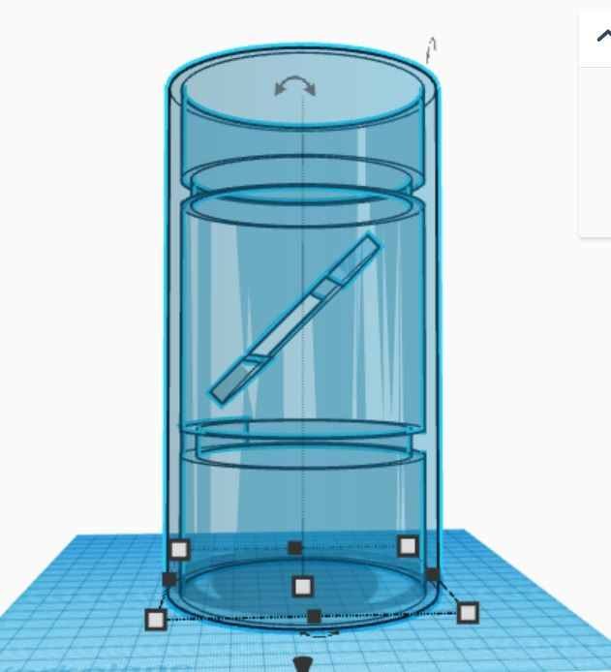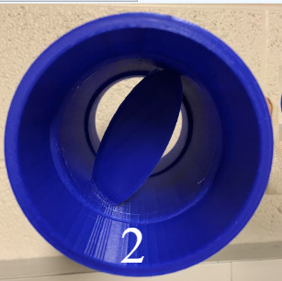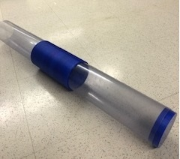

Dr. Glass gives Keynote Address at MIACSM
In March, Dr. Steve Glass (Exercise Science) gave the keynote address at the Michigan-American College of Sports Medicine meeting, in Gaylord, MI. Hi talk was title “Upgrade your learning!” Research experience to build your skillset in critical thought and problem solving. The conference brings together undergraduate and graduate students from Michigan universities from across the state.

Dr. Glass co-presents at World Voice Day
In April, Dr. Steve Glass (exercise science) co-presented along with Dr. Sri Nandamundi (Speech Language Pathology) at the 4th Virtual World Voice Day, sponsored by GVSU. The talk was titled “Building Muscle Strength and Endurance: Applications for Voice Intervention”. The talk was for SLP students and covered topics central to exercise physiology around strength, endurance, fatigue, and specificity of training. Then voice specific examples were given to link the basic science to the practitioner.

Undergraduate Research team complete 2 research studies.
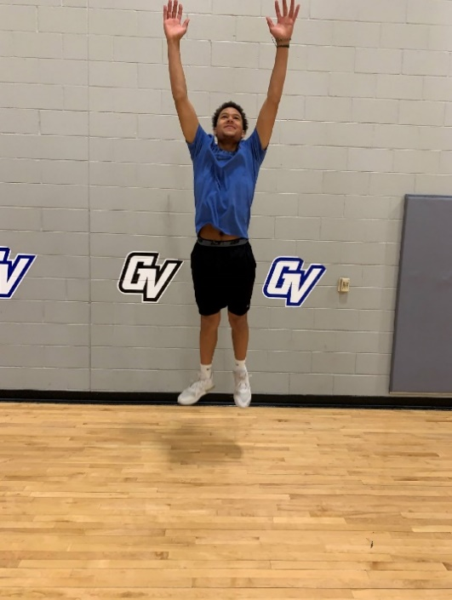
The undergraduate research team of 15 students within Dr. Glass’s lab completed 2 research studies, one of which was a student-initiated project. That study, initiated pre-COVID by Steven Zanders (class of 2020) was titles “Effects of pre-exercise warmup on muscle activation and jump power.” We specifically were studying the impact of a vibrating foam roller (a new device) compared to a standard foam roller as well as stretching. The study took 3 years to be completed due to COVID shutdowns, but data are now collected, and the students are in the process of computation of all data. The second study was a 2-week training study, examining the effects of instability training on improvements in muscle activation stability during a challenge. Subjects trained for 2 weeks with a “slosh tube”, a water-filled training device, while control subjects trained with just a tube (no water). Results showed significant improvements in stability after just 6 sessions of training. Students designed all of the treatment protocols and a method of accurately measuring jump height using high speed cameras. Future studies will use training devices currently in design in the lab for weaker and more clinical populations.
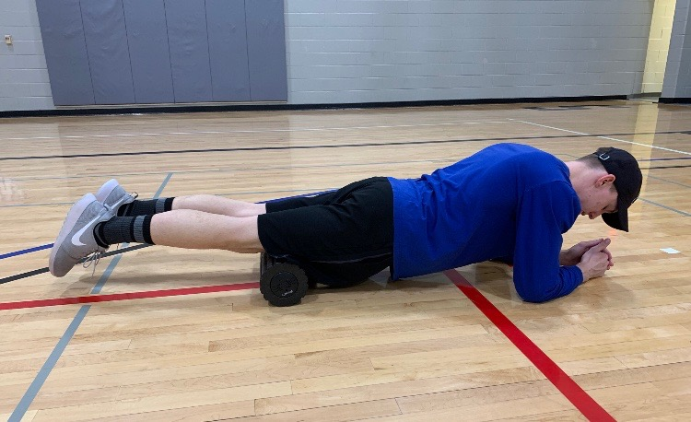

Faculty Attends SHAPE Conference
As she has been doing for the past several years, Dr. Beaudoin attended the Society of Health and Physical Educators (SHAPE) America conference in Seattle, WA as a presenter and chairperson for the College/University Instructional Physical Activity Programs (C/U IPAP) session and Coffee Talk held on March 31. The session had 4 presenters representing instructional physical activity and wellness programs from across the country who shared information related to innovative teaching strategies, effective administration, research, and advocacy related to IPAPs. Additionally, Dr Beaudoin and Co-authors Dr. Lewis and Karol Tiemersma had a presentation titled “Instructional Physical Activity Courses and Student Success: Impact of COVID”. This presentation shared preliminary descriptive data and suggestions for gathering markers of student success (e.g., retention, graduation rates, and academic performance) and the potential impact of instructional physical activity programs in supporting student wellbeing. Attending SHAPE allows Dr. Beaudoin to connect with faculty and administrators of instructional physical activity programs on college and university campuses. Learning more from a network of colleagues that share best practices for IPAPs allows us to enhance our FIT course offerings at GVSU. It is essential for student health and wellbeing that we continue to offer these instructional PA courses. Each year we continue to expand our FIT course offerings, refine course objectives and assessments, critically examine best practices relative to enhancing instructor effectiveness, and overall student and instructor experiences within the FIT program.
Unified Sports Given a Shot at Broomball
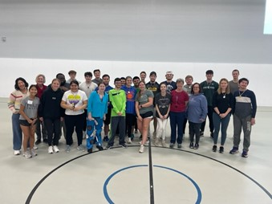
This winter semester in FIT 139: Team Sports, Unified Sports had a two-week spotlight as the class played Broomball with students from the Grandville Region 3 Transition Program. Unified Sports is played with athletes who have intellectual or developmental disabilities and athletes who do not. Students were placed in teams and competed in a round robin tournament and ultimately played for a tournament championship. Students from both Grand Valley and Grandville developed relationships through playing sports together and had the benefit of physical activity. One student from FIT 139 wrote, “When people participate in a sport, they are working towards a common objective, which can help build bonds and foster teamwork. Not only that but also sports can provide a platform for people of all abilities to showcase their skills and abilities. This can help to break down stereotypes and misconceptions about people with disabilities and promote a greater understanding and appreciation of diversity.” Look for Unified Sports as a FIT 180 class in the Fall of 2023.
Breaking Boards in Taekwondo
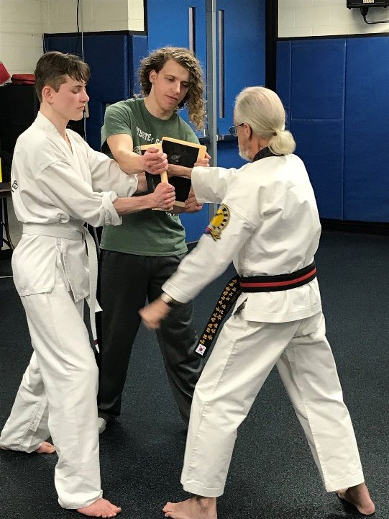
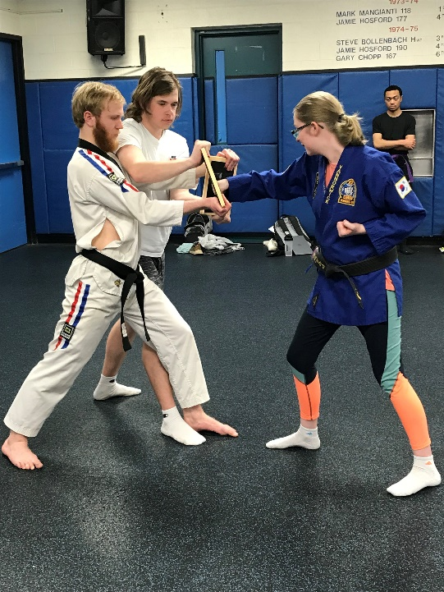
At the end of each semester FIT 103 under the instruction of Mr. Allen, an eighth degree black belt, takes turns breaking boards with strikes learned and practiced in class. It is a demonstration of skill and technique from the semester. As each person approaches the board, it is quiet and after striking the board, the class applauds each successful break.

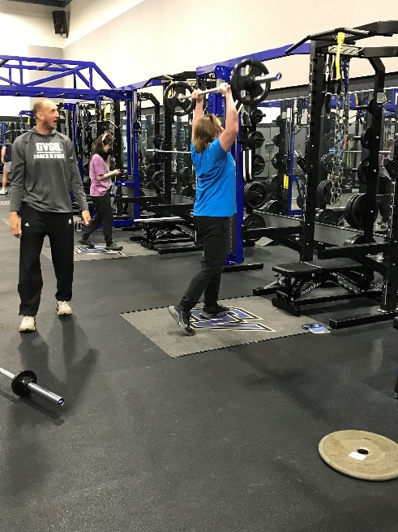
Coach Jones Is in the FIT Spotlight
The 2022-23 academic year marked the fifteenth year for Steve Jones teaching the one credit weightlifting classes for the Movement Science Department. Jones is also the jumps coach as a member of the national championship track and field coaching staff for GVSU. When he started teaching, Coach Jones taught every section of weightlifting of the then PED classes. He currently teaches FIT 125 Performance Weight Training and FIT 147 Olympic Weightlifting. When he is not teaching FIT classes or coaching jumps, Coach Jones can be seen managing behind the scenes for the GVSU track and field meets and other events in Laker athletics.

Teaching Innovation Grant Received
Dr. Steve Glass (Exercise Science) working in collaboration with Dr. Katelyn Lowman from the Cardiovascular Sonography Program received a teaching innovation grant of $ 4,916 from the Faculty Teaching and Learning Center to purchase a portable, mini echocardiogram for a joint learning project between our programs. The mini echocardiogram is linked with a tablet PC and offers visualization of the beating heart.
In the clinical field, exercise scientists work in close contact with cardiologists, nurses, ultrasound technologists and others to both test the function of the heart while under stress, and also to rehabilitate patients suffering from heart attack, heart surgery or another heart/lung related ailment. One of the most common tests to examine the heart is called the "Stress Echo". This is a combination diagnostic exercise test and echocardiography. The diagnostic stress test is currently taught in our EXS 465 Cardiopulmonary Rehabilitation class. This involves increasing levels of work on a treadmill, while measuring the electrical actions of the heart and measuring blood pressure. Currently our lab teaches skills related to this and the lecture portion covers a range of tests, including the addition of echocardiographic imaging to the test.
The specific objectives of the grant include: 1. Provide EXS 465 students real time contact with ECHO imaging and how the ECHO procedure blends in with the diagnostic stress testing they currently learn.
2. Provide opportunity for senior students in the GVSU Cardiovascular Sonography to demonstrate skills they are learning (students teaching students). This tool will provide a learning opportunity not usually available to either sets of students, or will help better prepare them for the work setting.

Professor Shonk Earns Master Instructor in Tai Chi
Senior Adjunct Professor Ray Shonk recently earned the title Master Instructor in Tai Chi. Since 2017 Shonk has taught Tai Chi as FIT 107 for GVSU along with a variety of group fitness classes including the new FIT 113 Body Weight Workout. In his “other job” Professor Shonk owns and operates Quest Fitness in Kentwood, MI.
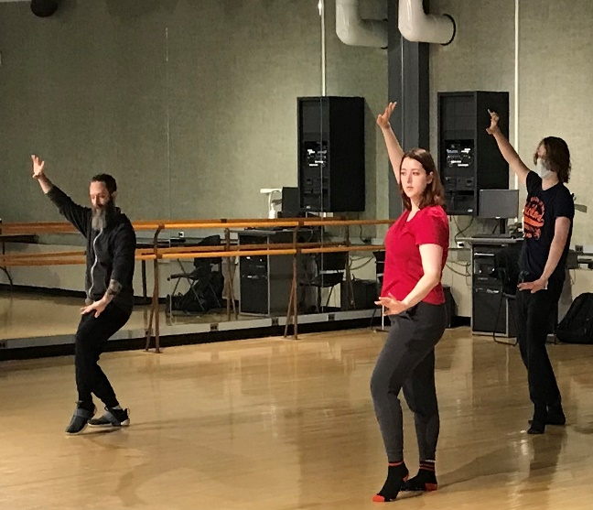

Human Trafficking Education in HPE 267
Guest speakers Teresa Fetterley, Jamie Presler, and Kevin Akin were invited by Professor Rachel Fetterley to lead her HPE 267 (Health and Movement Education for Elementary Teachers) in a presentation on human trafficking (HT). This took place in Professor Fetterley’s class during both Fall and Winter semesters. Teresa Fetterley and Jamie Presler are certified A21 Human Trafficking Trainers and Kevin Akin is the principal of Grant High School, where Teresa is a counselor and Jamie is an interventionist and academic coach. Teresa and Jamie are a part of the Michigan Think Tank Team, contributing to the development of A21's Human Trafficking Prevention K-12 Curriculum. The three guest speakers recently presented this curriculum to the MDE and to the Governor's Office.
The presentation was aligned with the safety and social and emotional health content that is part of HPE 267, and students were able to learn first-hand from professionals at the forefront of the creation of a HT curriculum. The K-12 Human Trafficking Education Curriculum is:
- standards-based (aligned to MI Health, SS, & ELA)
- developmentally and age-appropriate
- evidence-informed & evidence-based
Many students were unfamiliar with what HT was and they voiced after the class how much they benefited from learning about the dangers of this crime. The speakers were able to engage them in discussion about the statistics, risk factors, and warning signs to look for in their future classrooms. Students also took part in a 5th grade lesson that was part of the proposed curriculum.
The feedback post- presentation was very positive. Here are some quotes from Professor Fetterley’s students:
“I think it was useful because it is important to know as a future teacher the warning signs to look for with your students to see if they are being human trafficked.”
“I think this training was very useful. I didn't know how prevalent of an issue child trafficking was in the state of Michigan. I also think that the prevention factors were very helpful. I think we forget how great of an impact we can have as educators.”
“Yes, it was useful, because we got to learn more of what educators can do to help prevent human trafficking (and all the aspects that go along with it). It also helped bring more awareness to the topic and the risk factors to be aware of.”
Students were highly engaged and curious, albeit shocked and saddened by some of the statistics. Many voiced how they were extremely appreciative of the opportunity to learn about HT both from the perspective of a college student and a future teacher.

This Newsletter was Brought to you in Part by:
Publication:
William Clark

Editing:
Melanie Siebert
Kat Ponton

Story Contributions:
Christina Beaudoin
Stephen Glass
Karol Tiemersma
Rachel Fetterley

