 | 
Your subscriber number:
398GDA962014T
DOWNLOAD THE ASSISTANCE APP

The International SOS Assistance App is an essential tool for preparing, informing, and keeping you safe. No matter where you are on assignment or travelling to, you will be able to access the latest health and security advice. And if you should need medical or security assistance the worldwide team of International SOS experts, are just one tap away!
The Assistance App allows you to:

- View proactive Medical and Security Alerts wherever you work or travel to
- 24/7 health and security assistance when you need it most, from the global International SOS Assistance centre network
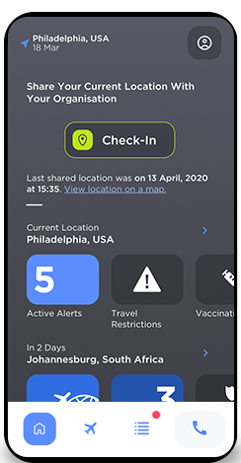
- See the latest COVID-19 Vaccine & Visa Information
Click and watch the videos in how to use the International SOS Assistance App





Having issues downloading or logging into the app? Visit International SOS Client Support.
Kind regards,
[Signature]

LOG ON TO ACCESS  subscriber portal  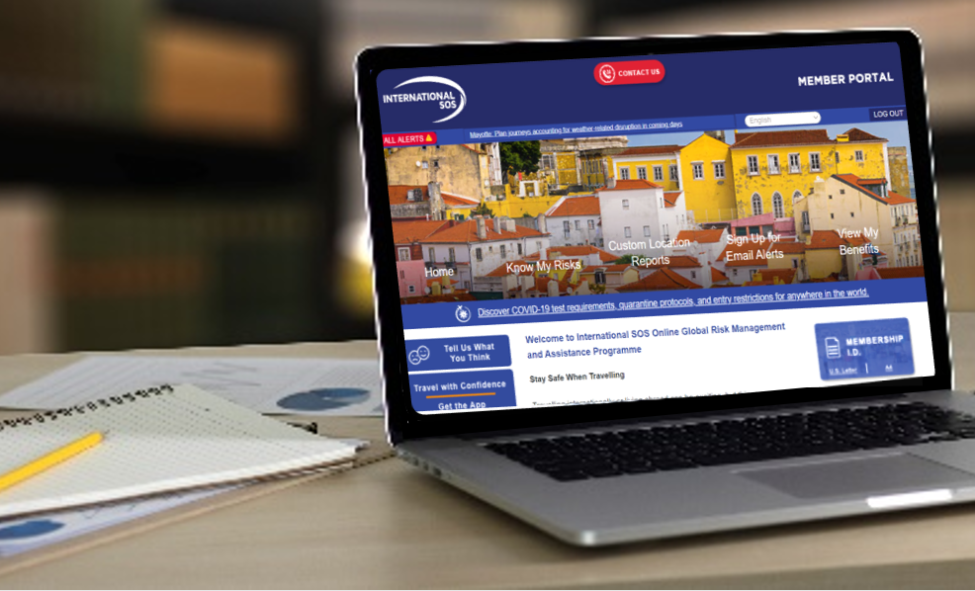 | HOW INTERNATIONAL SOS CAN SUPPORT YOU   | DOWNLOAD THE ASSISTANCE APP  