Faculty Accommodation Memo Acknowledgment
This process outlines how faculty members can view and acknowledge a student's accommodation memo.
Receiving the Memo
- Once an accommodation memo is generated for any of your students registered with Student Accessibility Resources, you will be notified via email to sign or acknowledge receipt of the memo.
- The exact memo sent is subject to change and might differ from the sample provided.
- From the email, click on the login to accommodate URL to view and acknowledge receipt of the memo.

Below is a sample of the email sent to Faculty once an accommodation memo is created for a student
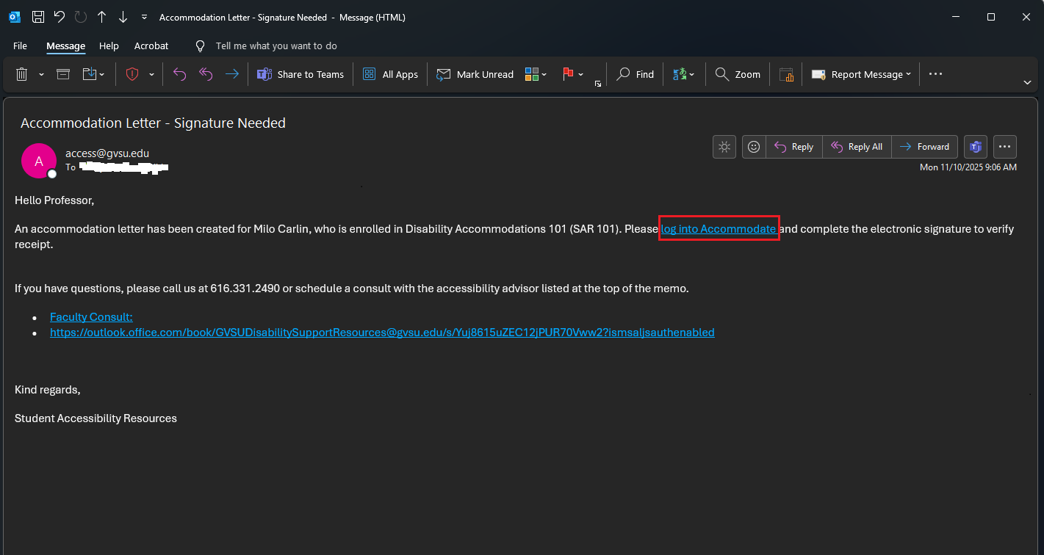

Steps to Acknowledge the Memo
- Log in: On the Accommodate login page, select Faculty and log in with your GVSU credentials.
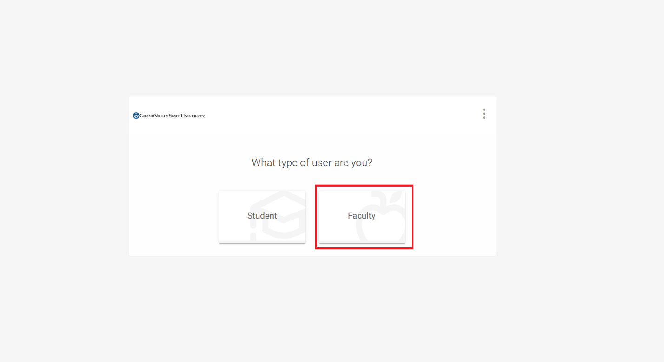
- View Letters: On the home page, the accommodation letters generated for your students will be displayed and grouped by your courses.
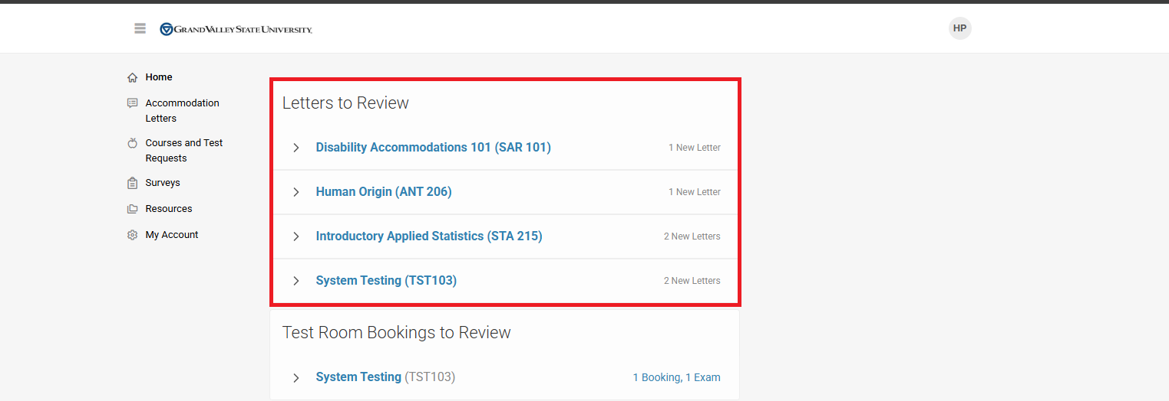
- Review Letters: Expand your courses one after the other to review the letters generated for your students. For example, you can expand the SAR 101 course and click Review to see a student's accommodation letter.
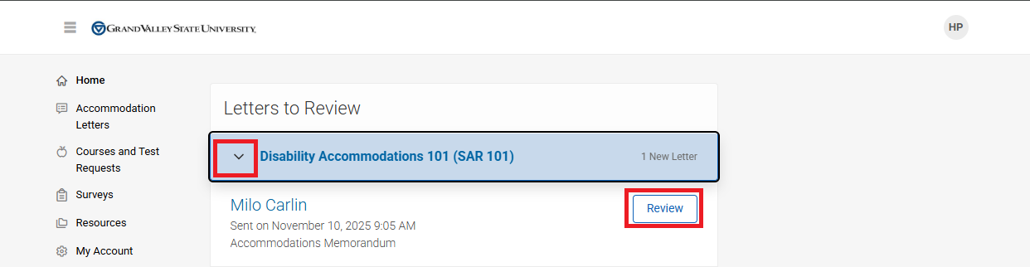
- Read the Memo: The review page details the accommodation approved by SAR for the student in your course. Carefully read through the entire letter.
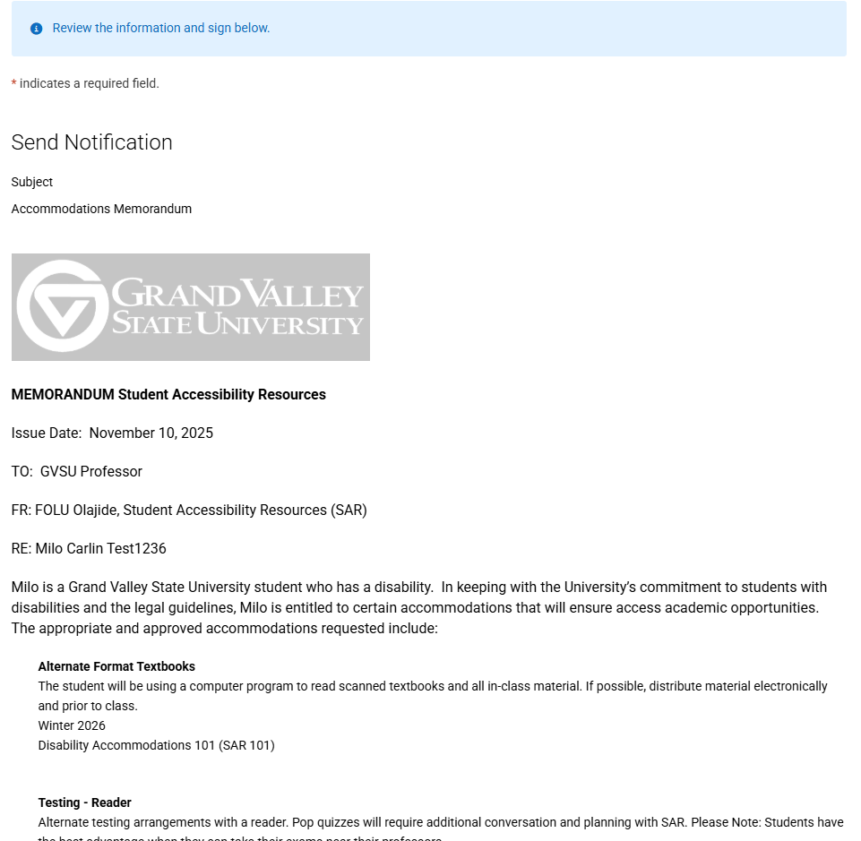
- Sign and Acknowledge: Once you have reviewed the letter, scroll down and sign the letter in the box provided. You can either type your full name or your initials and click Sign.
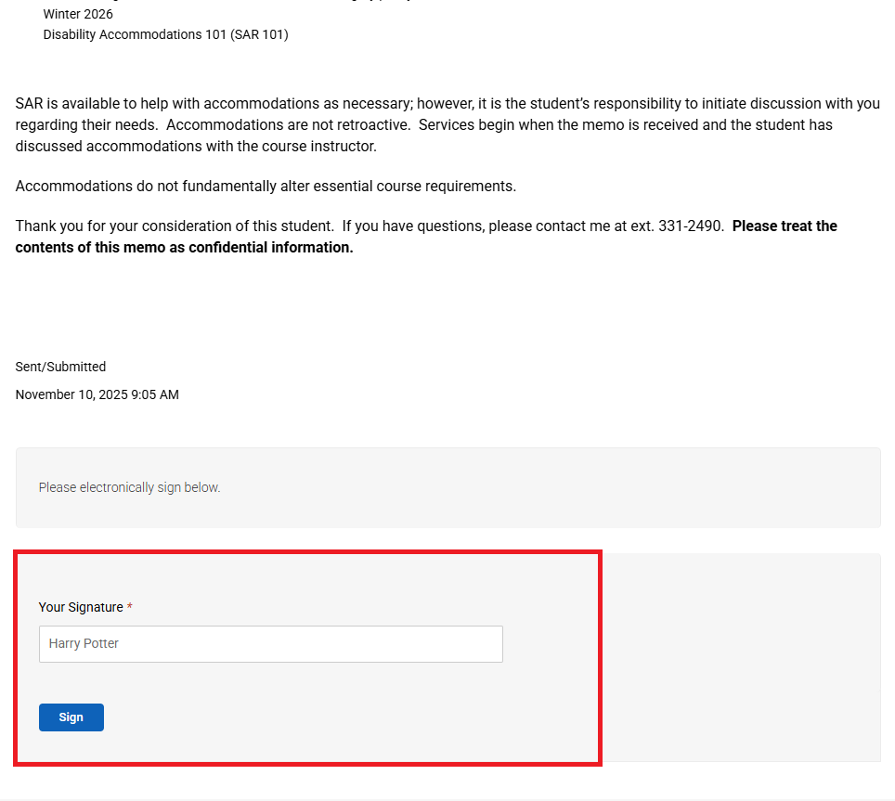
- Confirmation and Next Steps: A successful message will be displayed after signing. You can then click Next to review letters for other students in the same course, or Return to Home if all letters for that course have been reviewed.
- Repeat: Ensure this review and signing process (steps 2-6) is repeated for all the courses you are teaching in the semester.
If you have any questions, please reach out to the office by calling 616-331-2490, emailing access@gvsu.edu, contacting the advisor stated on the student’s accommodation letter, or scheduling a faculty consultation session via this URL Student Accessibility Resources: Accessibility Advising

