- Opening of Meeting: 1:33 pm
- Allocations Committee in attendance: Lourdes, Kamren, josh, Mara, Arianna, Malan
- Organization Roll Call: Model Entertainment, Delta Tau Lambda

Model Entertainment
- About
  - Modeling organization that specialized in model
  - They add routines into their modeling
  - They do a fashion show every semester
  - They also do photo shoots and collaborate with other organizations and businesses
  - Halloween show this year
- Event
  - The e-board creates the routine for the models
  - It is their interpretations of the sins and how they think about it
  - They are trying to put their own twists on the sins. They didn’t want to go the historical and religious route
  - They wanted one full theme
- Questions
  - Karamen
    - How did you come up with your expected student
    - They used previous shows to estimate their amounts and they have maxed out spaces before
  - Arianna
    - Tell me more about your decorations
    - It was hard to find decorations that fit the theme. So they just went with halloween decorations
  - Lourdes
    - Are there decorations that you plan to make or purchase
    - Yes they plan to use some from last year and makes some
  - malan
    - Two types of bat decor on request
    - One lights up and one doesn’t
  - Arianna
    - Could you make the bats at the creation station
    - No they do not have a ton of time to come in and make them
  - Arianna motioned for closed cabinet discussion
    - Lourdes seconds
    - All in favor
  - Arianna motioned to exit closed cabinet
    - Lourdes seconds
    - All in favor
  - Lourdes
    - Where are you planning on using the tapestries
      - More of a back drop
  - Karmen
    - How many members are apart of you org
  - Kamren motioned to strike the 3-D bats
    - Arianna seconds
    - All in favor
  - Malan
    - Asked where the decorations are going to go
    - They are going to put them on the wall with painters tape
  - Arianna motions to approve the adjusted budget of $177.95
    - Mara seconds
    - All yays
Delta Tau Lambda
- About
  - Get funding about annual event
  - Chapters across the nation host this event
  - Event is to celebrate women and women of color
  - The theme is to celebrate women of color and reflect on their own personal lives who have inspired them
  - They hope to have poetry there. The speaker is a founder of their org
  - They are to an event their where they will ask students to open up about women that have inspired them
- Speaker
  - The speakers father passed a week ago and they are trying to get the speaker to attend to talk to the individuals going
- Questions
  - Kamren asked how they came up with the number of students
    - They used past years numbers to estimate this year
  - Kamren asked if their is a food waiver
    - Yes it is submitted and approved
  - Kamren asked about what they have done for promotions
    - They posted about their scholarship that they have for the event. They posted on instagram as well and are going to be using lakerhub slides
  - Malan asked about the tri fold poster boards
    - It is for the activity where the individuals will write about people that have inspired them and then they can stick the sticky note on the board
  - Lourdes asked about the posted notes about the org provided the sticky notes
    - Yes they think they could get them
  - Josh asked about the scholarship
    - Yes
  - Mara asked about the speaker and the invoice
    - A portion is for her travel and stays
    - Any extra that is not included in that would go to support her father
  - Malan asked about the influence to the organization of the speaker
    - She is the founder of the organization
    - The founder has a close relationship with all the chapters and the individuals in the chapter
    - The founder works with universities across the united states
  - Kamren asked if you could get an itemized invoice from the speaker
    - Yes she can try to get that
- Kamren motioned to enter into a closed discussion
  - Malan seconds
  - Arianna abstained
  - 4 in favor
- Kamren motioned to enter closed discussion
  - Malan seconds
  - Arianna abstained
  - 4 in favor
- Josh entertains a motion to add speaker to the request
  - Kamren motions to add the speaking invoice for a total of
  - Mara seconds
  - All yays
- Kamren motioned to strike the tri fold board and posted notes
  - Mara seconds
  - Arianna abstained
  - 4 yays
Kamren motions to approve pending the itemized breakdown
- Mara seconds
- Arianna abstained
- 4 yays

- Adjournment: 2:03 pm

Org Name: | Model Entertainment
Title of the Program: | 7 Deadly Sins
Start date and time: | 10/24/2026 7pm
End date and time: | 10/24/2026 10pm
Location: | Cook Dewitt Center
Expected Student Attendance: | 200
Expected Non-Student Attendance: | 5
Total Requested Amount: | $181.94
Total Approved Amount:
Food Service:
Promotions
Promo Package B | $140
contracts
supplies
Bat Wall Decor | $19.99 | 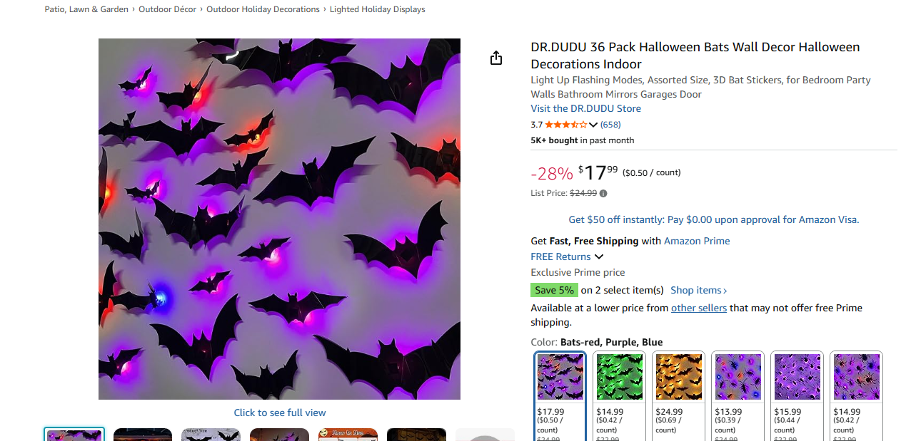
3D Bats Wall Decor | $3.99 | 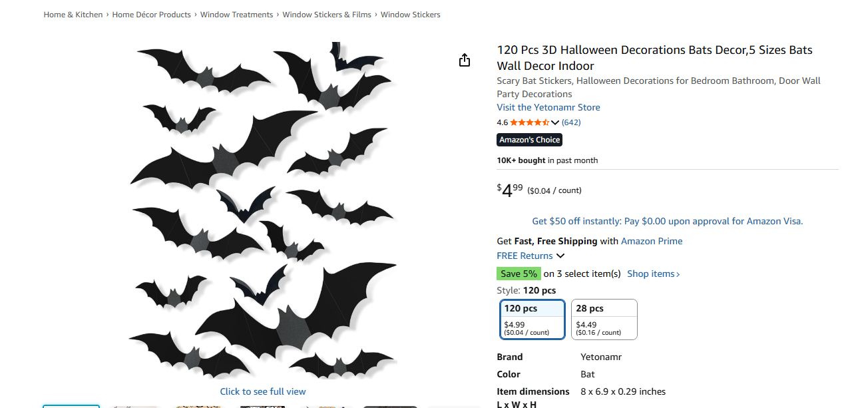
Cloth Fabric Tapestry Decor | $8.97 | 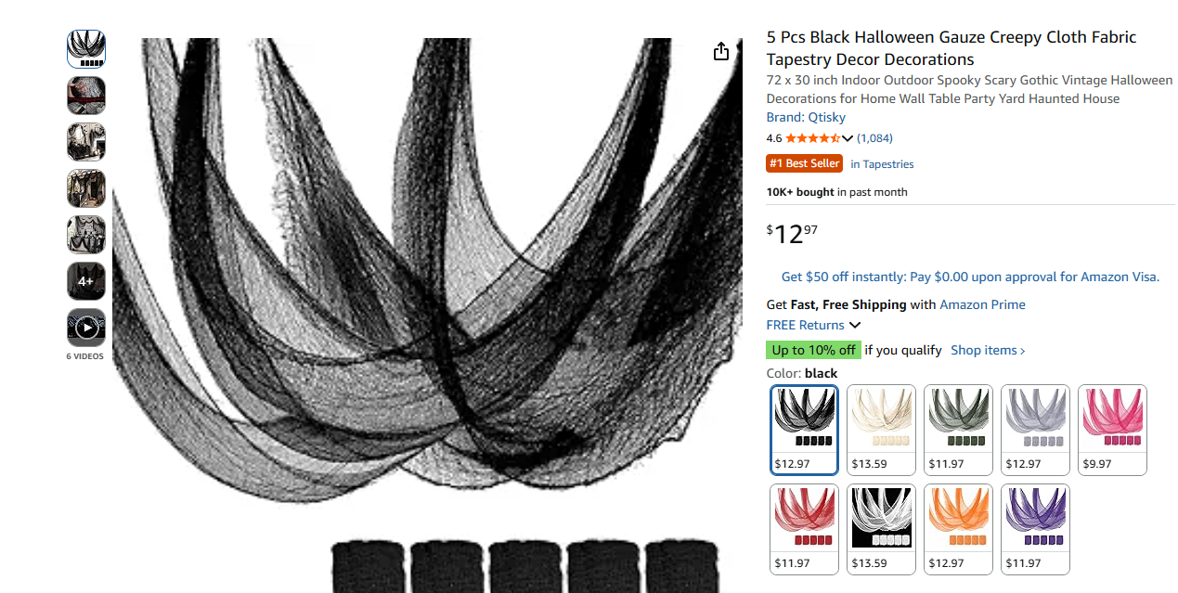
Laminated Poster Portrait Frames | $8.99 | 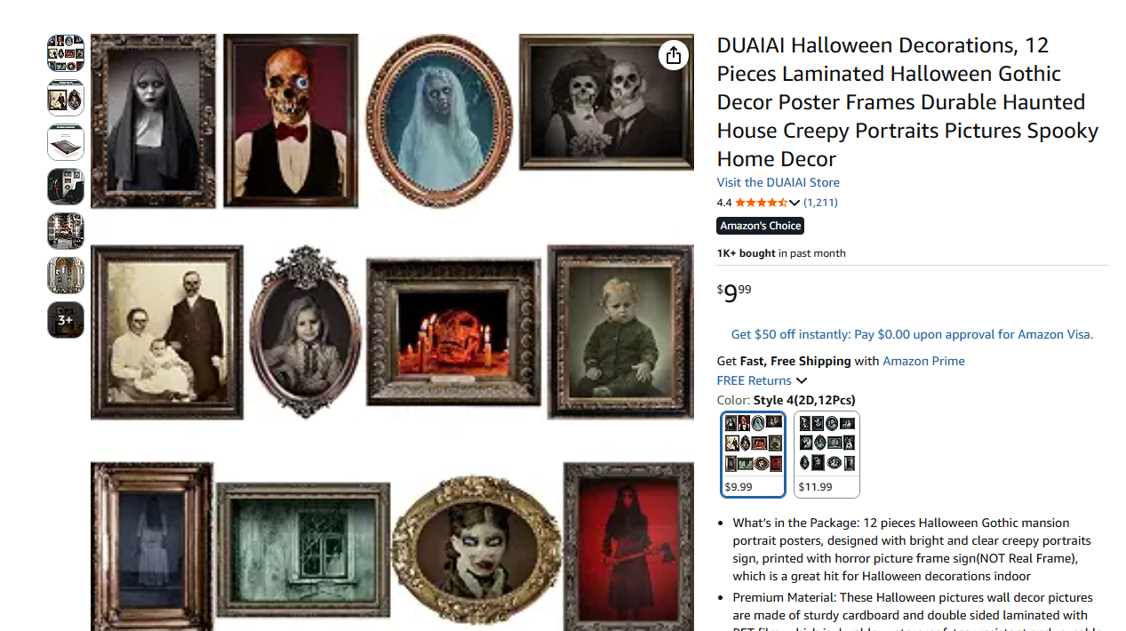
Org Name: | Delta Tau Lambda Sorority, Incorporated (DTL)
Title of the Program: | Salute to Latinas
Start date and time: | 11/8/2026 6pm
End date and time: | 11/8/2026 9pm
Location: | Kirkhof Center room 2250 Grand River room
Expected Student Attendance: | 100
Expected Non-Student Attendance: | 0
Total Requested Amount: | $1,324.81
Total Approved Amount:
Food Service:
Catering by Tacos el Cuñado | $967.78 | 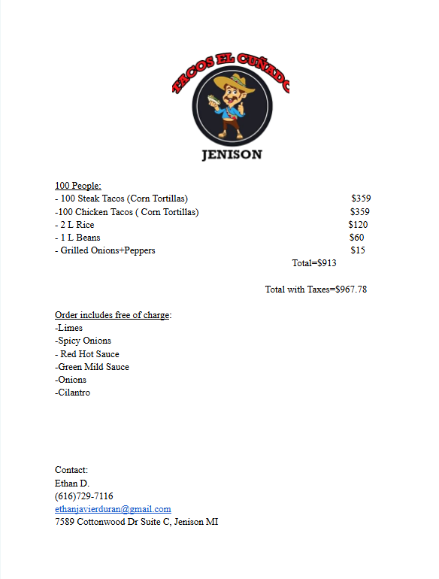
Promotions
Promotions posting | $17.60
Promotions Photos | $150
contracts
supplies
Table Clothes | $104
Tri-Fold Poster Boards | $12.99 | 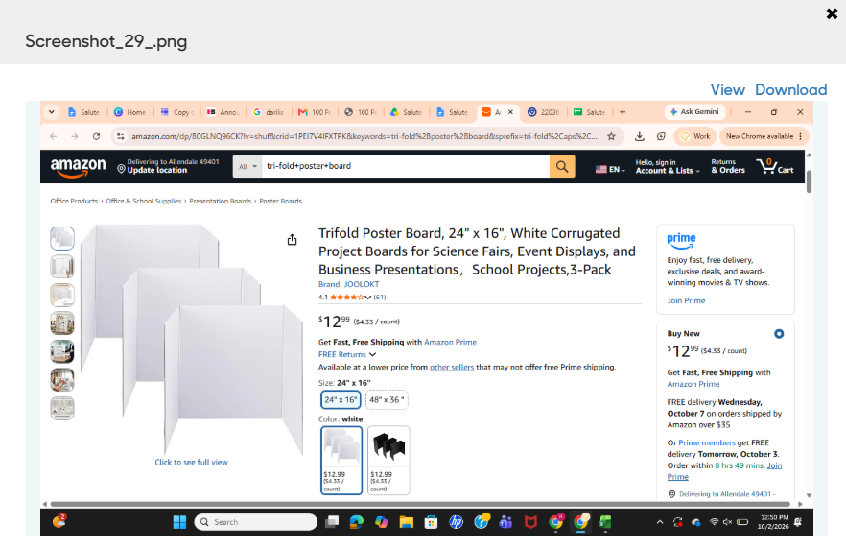
Post it notes | $8.99 | 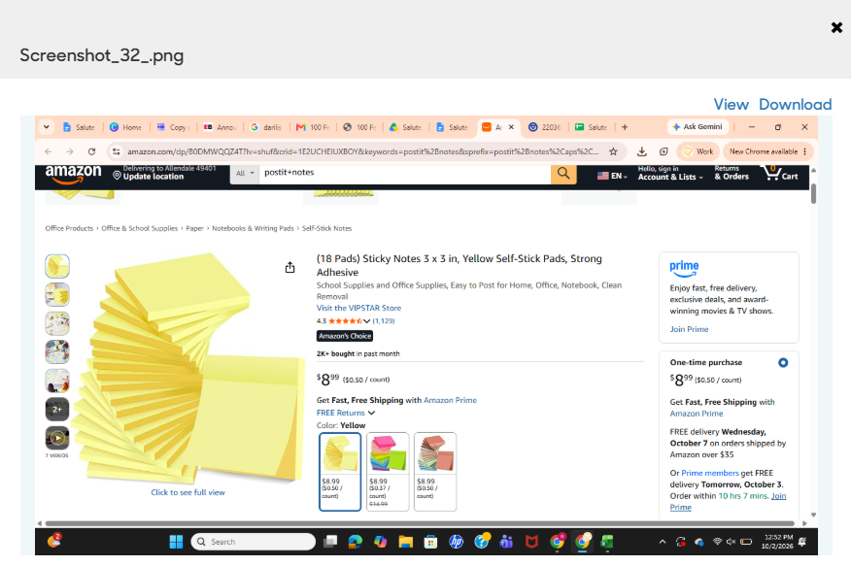
Canned Soda | $63.45 | 