  Start |   Stop | 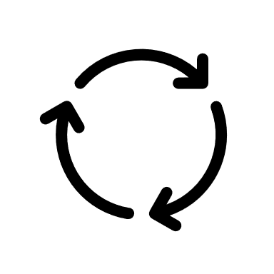  Continue
What are 1-2 new strategies that  you would like to implement? | What is currently not working that  you need to stop? | What is currently working that you would  like to continue doing?


