The Learning Process
Before Class
Preview:
Skim the chapter: note headings and boldface words, review summaries and chapter objectives. Come up with questions you’d like the lecture to answer for you.

During Class
Attend class.
Answer and ask questions and take meaningful notes.

After Class
Review after class as soon as possible.
Read the notes, fill in gaps and note any questions.

Study – Repetition is the key. Ask questions “why”, “how”, and “what if”.
Power Study Hour* - 3-5 short sessions per day.
Weekend Review – Read notes and material from the week to make connections.
Assess your Learning – Periodically perform reality checks. Use Deep Study Strategies *(See Back.) Ask yourself “Am I using study methods that are effective?” and “Do I understand the material enough to teach it to others?”

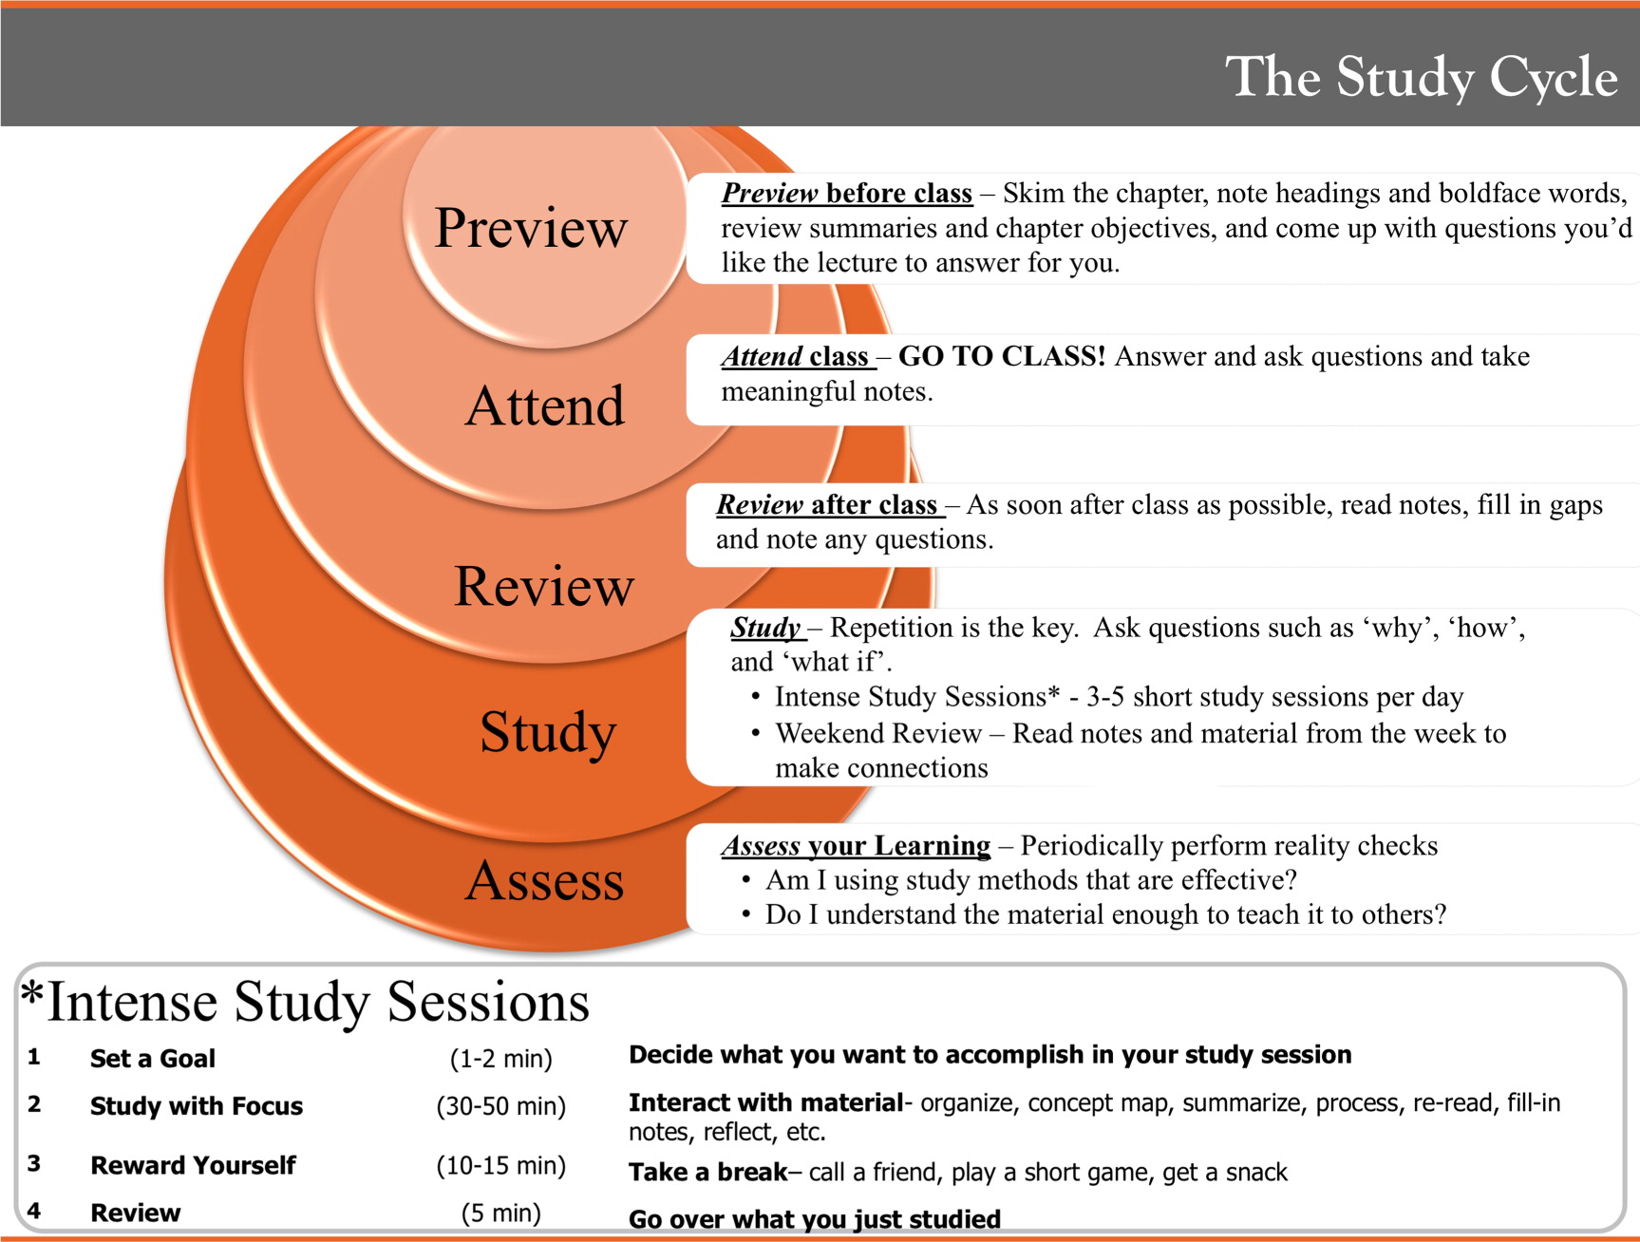
Power Study Hour
Published in: Elzbieta Cook; Eugene Kennedy; Saundra Y. McGuire; J. Chem. Educ. 2013, 90, 961-967. DOI: 10.1021/ed300686h
Power Study Hour

