
The POWER Study Hour
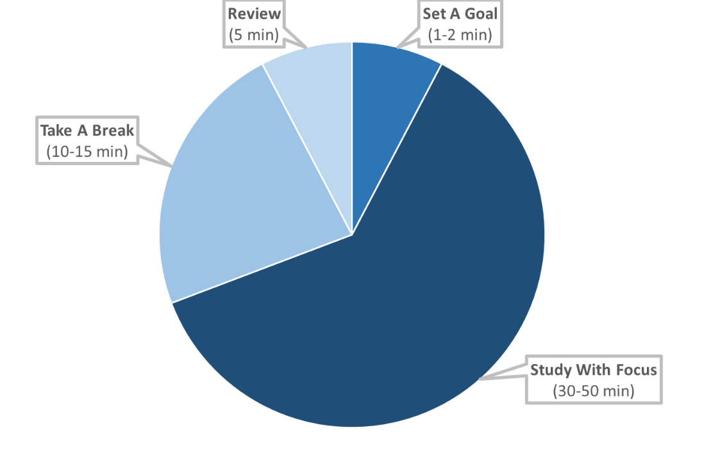

1. SET A GOAL ( 1-2 minutes )
Decide what you want to accomplish during your study session.
2. STUDY WITH FOCUS ( 30-50 minutes )
Set a timer for 30-50 minutes. Work on your goal without distractions for the set time.
3. TAKE A BREAK/REWARD YOURSELF ( 10-15 minutes )
Reward yourself for your hard work with a timed break. Set a timer for 10-15 minutes and enjoy yourself by taking a walk, having a snack, playing a short game, chatting with a friend, etc.
4. REVIEW MATERIAL ( 5 minutes )
Review what you previously studied.

The POWER Study Hour

1. SET A GOAL ( 1-2 minutes )
Decide what you want to accomplish during your study session.
2. STUDY WITH FOCUS ( 30-50 minutes )
Set a timer for 30-50 minutes. Work on your goal without distractions for the set time.
3. TAKE A BREAK/REWARD YOURSELF ( 10-15 minutes )
Reward yourself for your hard work with a timed break. Set a timer for 10-15 minutes and enjoy yourself by taking a walk, having a snack, playing a short game, chatting with a friend, etc.
4. REVIEW MATERIAL ( 5 minutes )
Review what you previously studied.

