Step 1: Open the GVSU website and choose the compass icon located in the top right-hand corner to open Navigate.
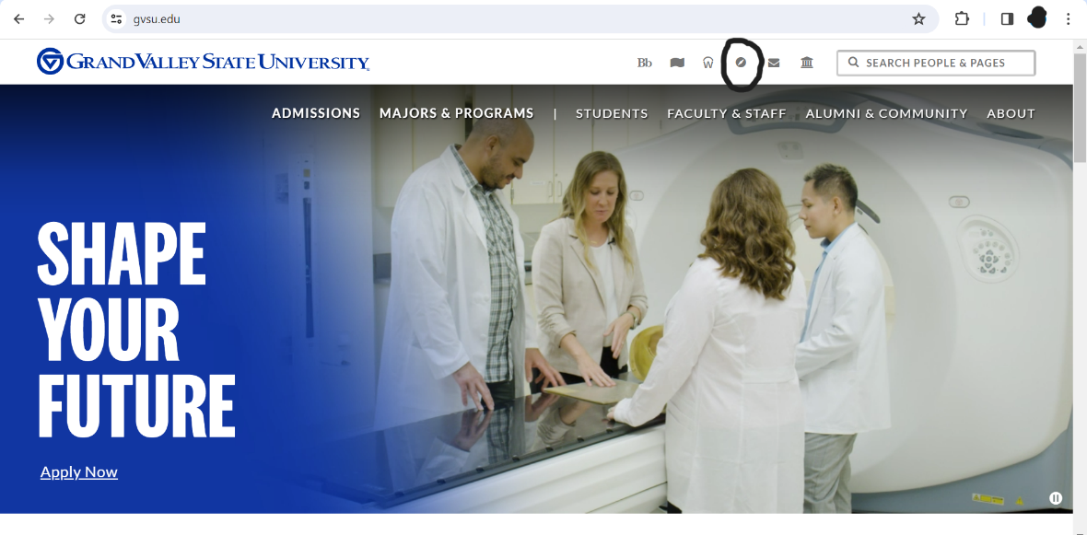
Step 2: Log into Navigate using your GVSU student information.
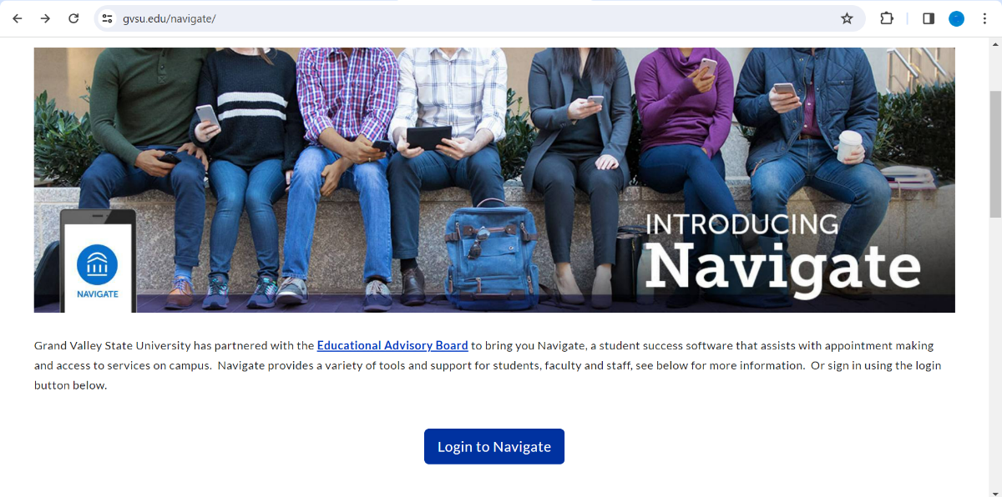

Step 3: On the home screen, select "Schedule an appointment" located on the right-hand side of the screen.
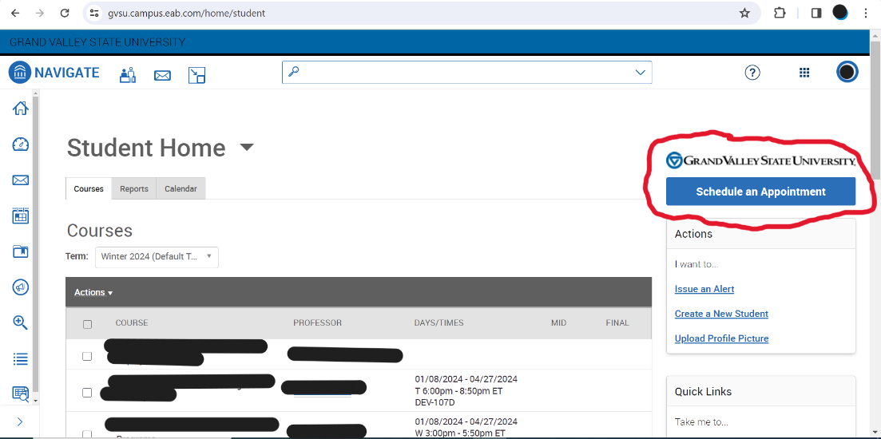
Step 4: When prompted with “What office would you like to meet with?” you will first select “Student Support Services”. On the next drop down menu you will select “SASC – Success Coaching” as your service.
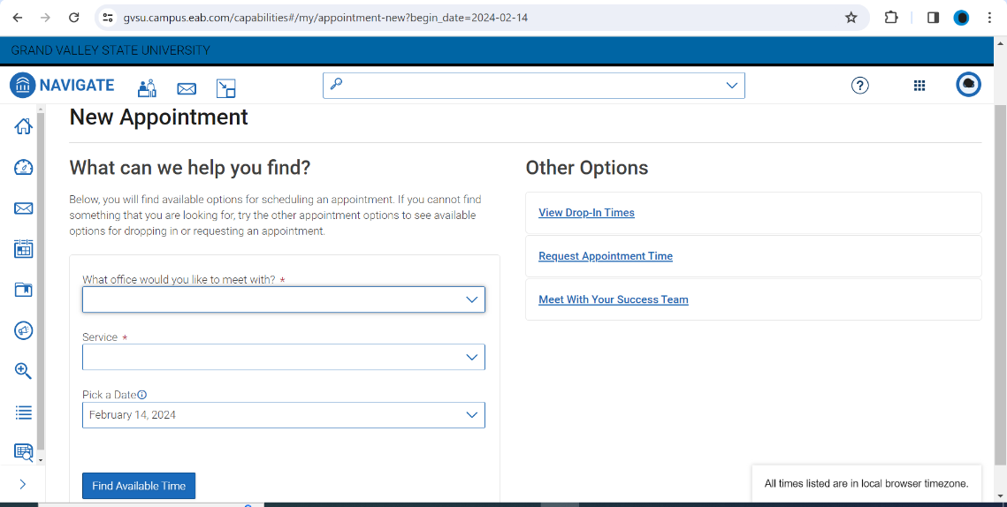

Step 5: From there, you will select a time that works best for you and a professional that you would like to meet with. You will also be prompted to select a virtual or in person appointment if you have not already.
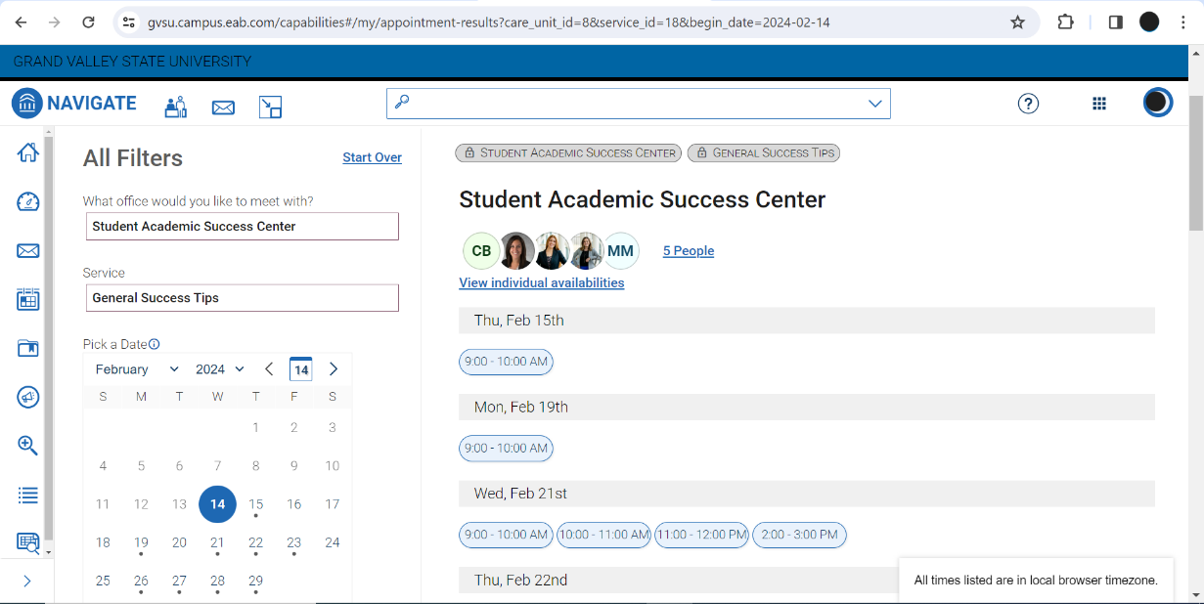
Step 6: After you complete making an appointment, you will get a confirmation email for your appointment.

