Weighted Grades: difference between Equally or Proportionally weighted grades

If you are going to weight grades, the point value within a category is easiest to understand if all the items in that category are of the same point value. However that is not always possible..
Blackboard offers 2 ways of computing a category in Weighted Totals. Equally or Proportionally
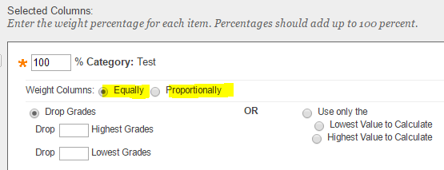

When Equally is selected each column is computed equally even if the items have different values. In this example there are 4 items all with different point values
- Because there are 4 items each item is worth .25 of the total grade. If there were 5 items each with be worth .20 of the total grade
- The formula is the amount the student received divided by the amount possible times the percentage of the number of items
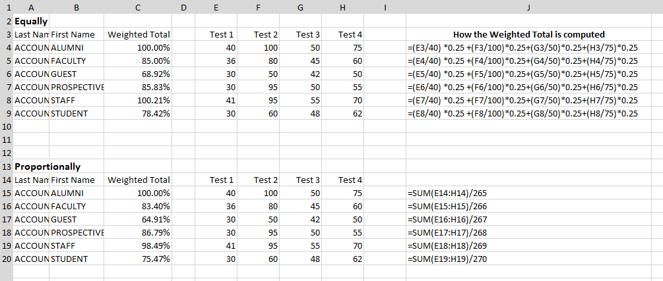

Proportionally adds up the accumulated scores and divides by the number of points possible. A test that is worth 40 points does not count equally with a test that is worth 100 points.
The above example is how one category is computed. In an average Grade Center there will be many category each worth a percentage of the grade.

