IMS STUDENT INSTRUCTIONS

Congratulations on your internship! Below are instructions on how to register this experience to receive academic credit. Please note that while this website is powered by the Career Center, your academic department oversees your internship, determining if it qualifies for academic credit, and issues the final grade.

STEP 1: Complete online Internship Agreement Form (please note this is to be done after you have been offered and secured your internship). It’s recommended to use FireFox or Google Chrome for your internet browsers.
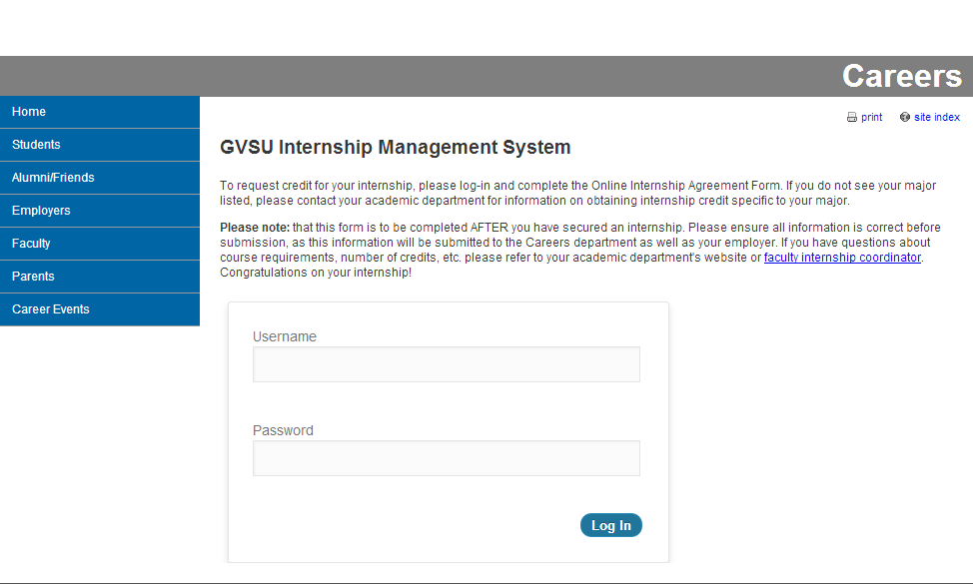
- Sign in to http://www.gvsu.edu/careers/ims-login.htm with your GVSU network ID and password

- Select New Internship if completing the form for a new internship experience.
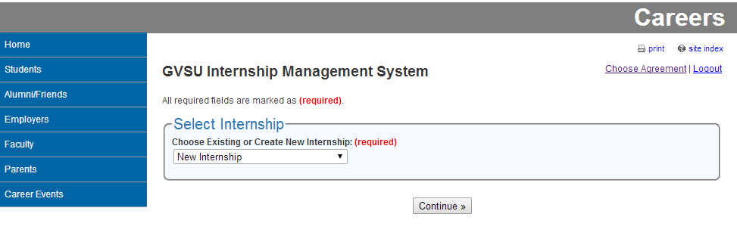

- Complete all required fields and submit. NOTE: YOU WILL NEED TO CONFIRM YOUR FORM AFTER YOU CLICK SUBMIT. (You will receive a confirmation email after the form has gone through.)

Here’s what happens to your form after it’s been submitted…
- It will be sent to the Faculty Internship Coordinator identified on your form to ensure this is an approved internship site.
- After your Faculty Coordinator provides initial approval, your completed form will automatically be emailed to your internship Site Supervisor for verification.
- After your Site Supervisor verifies your internship, your Faculty Internship Coordinator will provide final approval.
NOTE: You will receive emails throughout this whole process updating you on where your Agreement Form is and when it has been officially approved.

STEP 2: Register for your class in Banner (if you haven’t already done so).
- Your Faculty Internship Coordinator will have to enter a permit for you in order to register. This typically occurs after your Internship Agreement Form has received final approval. If you are having difficulty registering, please contact your academic department or the Registrar’s Office.

STEP 3: Inquire about any required assignments
- Academic departments require different assignments in order to receive credit. Please check with your Faculty Internship Coordinator to ensure you know what’s expected of you.

STEP 4: Complete end of semester Evaluations
- Two weeks prior to the end of the semester, you and your internship Site Supervisor (as indicated on your Internship Agreement Form) will receive an email with a link to your final evaluation. IT IS YOUR RESPONSIBILITY TO MAKE SURE YOUR SUPERVISOR RECEIVES AND COMPLETES THIS. If for some reason you or your supervisor does not receive the evaluation, please contact your academic department or the Career Center.

NOTE: If your Site Supervisor has changed over the course of your internship, please inform your Faculty Internship Coordinator or the Career Center so their contact information can be updated.

