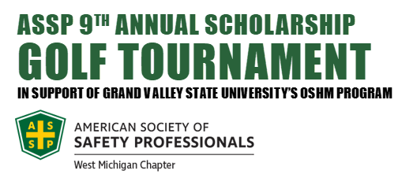
WHEN
Thursday, June 22nd, 2023
Registration 8:00 - 8:45am
Shotgun Start at 9:00am

WHERE

The Meadows Golf Club at GVSU
4645 West Campus Drive, Allendale, MI 49401

DETAILS

- 4 Person Scramble; $80 per golfer; $320 per team
- Includes 18 holes with cart & lunch buffet
- Single golfers welcome; you will be placed in an open 4-some
- Mulligans available day of event $5 each or 5 for $20; 10 max/team

DEADLINE

Sign up by Friday, June 9th, 2023

BENEFITING

American Society of Safety Professionals (ASSP) continues to provide development and support for GVSU students majoring in Occupational Safety & Health Management. One way of accomplishing this is by investing in students who best represent the future in our field and a business such as yours. After 112 years since years since its inception and with more than 37,000 members worldwide, ASSP continues to strive to be the premier safety and health organization.

PROMOTE YOUR BUSINESS

Sponsorship Opportunities Include:

- Event Sponsorship: $300
- Lunch Sponsorship: $200
- Beverage Sponsorship: $200
- Tee Sponsorships: $100
- Longest Drive: $100
- Longest Putt: $100
- Closest to the Pin: $100

Acknowledgement will be given during the event and signage will be provided during the event. Following the outing, all sponsors will be recognized on our chapter website.

Giveaway items and corporate swag is also desired!

READY TO SIGN UP?

Register online:

https://www.eventbrite.com/e/wmassp-annual-golf-outing-tickets-576451882097

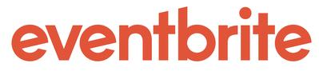® via registration

PAYMENT NOTIFICATIONS

After registration a confirmation email will be sent out with payment information.

If you have any questions or want to be a sponsor, contact Chapter President Rich DeLeau at:

rdeleau@bhsins.com or richard.deleau@gmail.com

