GVSU Exchange Programs
Australia
Macquarie University (MU), Sydney
Since 1998, GVSU and Macquarie University have had a solid relationship that had focused exclusively on the GVSU faculty-led program sponsored by the School for Public and Non-profit Administration and the Department of Criminal Justice. Over the past several years, the relationship has evolved and is now offering opportunities for semester-long study abroad, as well as faculty and staff exchanges. To learn more about Macquarie University visit the website at http://www.mq.edu/au.
University of the Sunshine Coast (USC), Sippy Downs
Established in 2005, the relationship with the University of the Sunshine Coast offers opportunities for students, faculty and staff to participate in meaningful educational exchanges. The University hosts three faculties including: Arts and Social Sciences, Business and Science. There are opportunities for GVSU constituents to learn about Australian society from historical, environmental, geographical, business, social and literary perspectives. To learn more about the University of the Sunshine Coast visit the website at www.usc.edu.au
Austria
FH Joanneum of Applied Sciences, Graz
Established in 2013, the FH Joanneum partnership is an agreement between the Padnos College of Engineering and Computing and FH Joanneum’s Faculty of Engineering and Applied Computer Sciences. GVSU students are currently able to complete an Engineering coop through the FH Joanneum exchange. www.fh-joanneum.at and www.fh-joanneum.at/int
Chile
Universidad del Bio Bio (UBB), Concepcion
Established in 2011, UBB offers opportunities for faculty, staff and students for both short and long-term opportunities. Each year, GVSU can host one or two faculty for 4-8 weeks during January and February as part of the faculty exchange program. Students can apply for a short summer opportunity or a full semester exchange at UBB.UBB also served as the site for the 2013 Partnership Delegation. http://www.ubiobio.cl/w/#
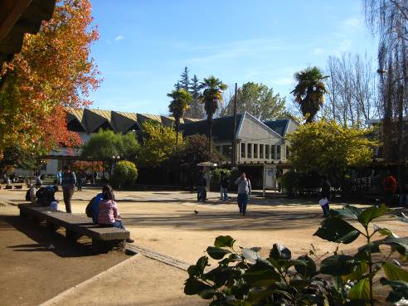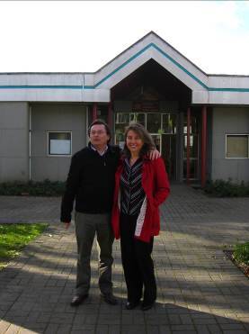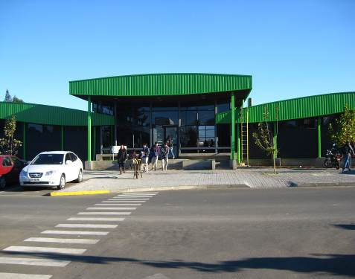
China
East China Normal University (ECNU), Shanghai
Established in 1999, this partnership has enabled GVSU students to study Chinese language and culture in Shanghai. In exchange, faculty from ECNU spend an academic year at GVSU conducting research. ECNU also serves as a host for the GVSU China Summer School program generally offered each summer. www.ecnu.edu.cn
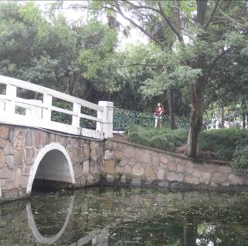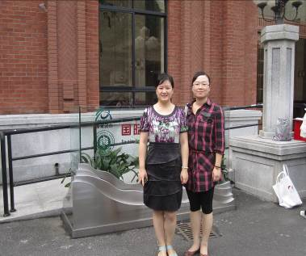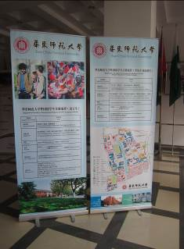

France
L’Ecole Superieure des Sciences Commerciales d’Angers (ESSCA), Angers
ESSCA was established many years ago through the Seidman College of Business. This
program has offered a rewarding experience to students from both GVSU and ESSCA. Each fall semester, GVSU hosts students from ESSCA and students from GVSU are able to attend programs available through ESSCA in either France or in Hungary. This program welcomes proposals for visiting scholar positions at ESSCA. For details, please contact the Padnos International Center. www.essca.asso.fr/

ESC-Groupe Grenoble, Grenoble
ESC-Groupe Grenoble is a program founded by the Seidman College of Business. This program was established in 1997 and offers several program options for both undergraduate and graduate students interested in studying business in France for a semester or a year. Each year, GVSU hosts several ESC-Groupe Grenoble students, who spend a full year at GVSU earning their MBA. This institution hosts a GVSU Faculty-led group summer program for business students in addition to the semester exchange student options. www.esc-grenoble.fr
Université Catholique de ĺ Ouest (UCO), Angers
The relationship with UCO comes as a result of many years of positive cooperation with the ESSCA exchange in Angers, France. The agreement with UCO is part of a tri-agreement between GVSU, UCO and ESSCA. The cooperation focuses primarily on student exchanges, but also allows for faculty and staff exchanges as well. The UCO program offers courses in French for students that are at an advanced standing in the French language. In addition, students are able to take a variety of French language courses offered through the Centre International D́ Études Françaises (CIDEF). For more information on this program, visit the website at www.uco.fr
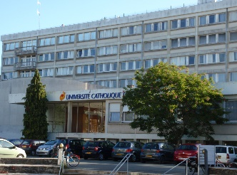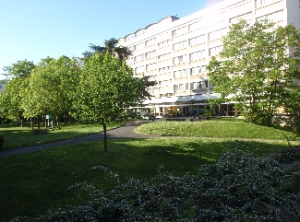

Germany
Pädagogische Hochschule Schwäbisch Gmünd Fakultaet I, Schwäbisch Gmund
This partnership, established by the Sociology Department, was signed in 2005. The partnership has now developed into a College of Liberal Arts and Sciences and College of Education partnership which offers opportunities for student and faculty exchanges. www.ph-gmuend.de
Duale Hochschule Baden-Württemberg (DHBW), Mosbach
The Duale Hochschule Baden-Württemberg (DHBW) exchange program is a Seidman College of Business program offering study abroad opportunities to both GVSU and DHBW students. The agreement with Duale Hochschule Baden-Württemberg was signed in 2006. For details, please contact Carol Sanchez in the Seidman College of Business. www.dhbw.de

Ghana
University of Cape Coast (UCC), Cape Coast
Established in 2002, the University of Cape Coast (UCC) exchange program offers a wide range of curricular offerings comparable to GVSU’s. The University is one of the premier institutions of higher education in Ghana offering degree programs at the bachelor, master, and doctoral levels. www.ucc.edu.gh

Italy
University of Perugia, Perugia
The exchange program with the University of Perugia in Perugia, Italy was established through the Department of Political Science in 2003. This program has primarily focused on faculty exchanges. For more information about this program, contact John Constantelos in the Department of Political Science. www.unipg.it
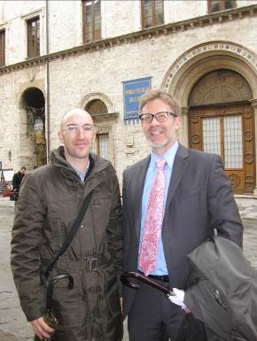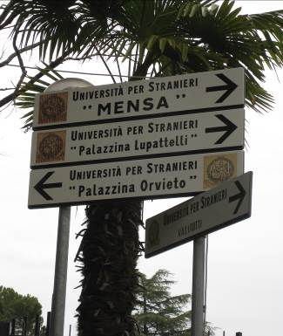

japan
International Christian University (ICU), Mitaka
Established in the early 1970’s, the partnership with ICU focuses primarily on the exchange of students. ICU has three principle commitments in its mission: academic, Christian, and international. ICU focuses on liberal arts education and is organized into six divisions: Humanities, Social Sciences, Natural Sciences, Languages, Education, International Studies, and Graduate School.
www.icu.ac.jp

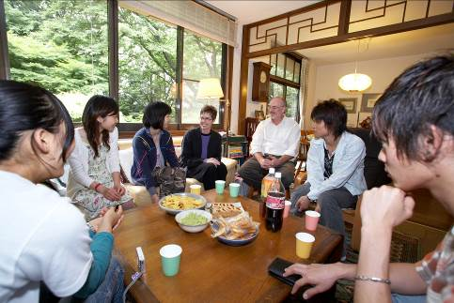
Ritsumeikan Asia Pacific University (APU), Beppu
Signed in 2008, the agreement with Ritsumeikan Asia Pacific University offers opportunities for students, faculty and staff. APU offers opportunities for students to study for a semester or a short summer program. Students will primarily take courses focused on Asian studies. www.apu.ac.jp
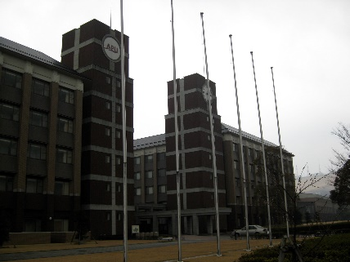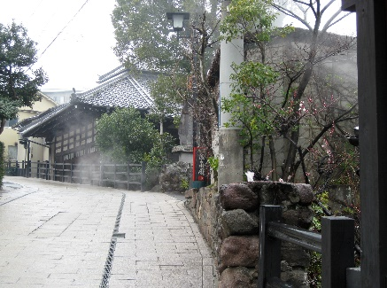
mexico
Universidad de las Americas - Puebla (UDLA-P), Puebla
Signed in 1997, the agreement with the Universidad de las Americas – Puebla offers opportunities for students, faculty and staff. The agreement opens the opportunity to negotiate specific initiatives of mutual benefit to both institutions. Currently, UDLA hosts a GVSU faculty-led group program through the College of Education. www.udlap.mx

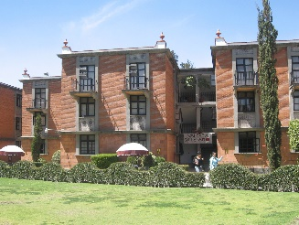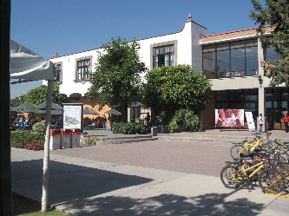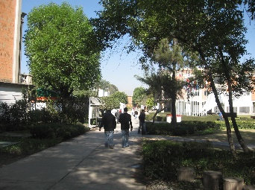

Poland
Cracow University of Economics (CUE), Cracow
Founded in 1974, the exchange with Cracow University of Economics in Poland has focused on semester student exchanges; short-term summer programs; and faculty exchanges. In addition, a variety of cooperative ventures have taken place over the years. During the Fall semester, GVSU receives faculty from CUE for research purposes. http://fetc.ae.krakow.pl
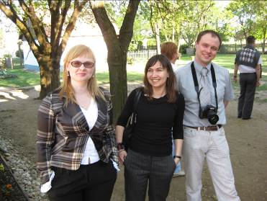
Romania
Universitatea Babes-Bolyai (UBB),Cluj-Napoca
Signed in 2015, the agreement with UBB offers substantial scholarship opportunities for students to studying journalism, business, political science, or the MBA. The scholarship program is part of the Erasmus + scheme which encourages student mobility between European institutions and non-European institutions. There are faculty exchange opportunities which also support collaborative academic activities. For more details on this program, visit the website at www.ubbcluj.ro
South Korea
Seoul National University of Technology (SeoulTech),Seoul
Signed in 2008, the agreement with SeoulTech offers semester and yearlong exchange opportunities for students studying in art and design, business or computer science. Most courses are SeoulTech are offered in Korean which limits the disciplines applicable to this exchange. The primary collaborative department is with art and design. For more details on this program, visit the website at: http://en.seoultech.ac.kr/

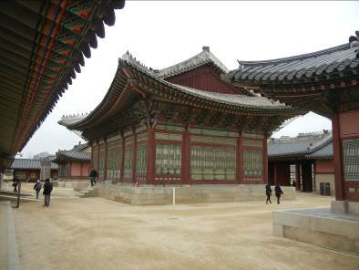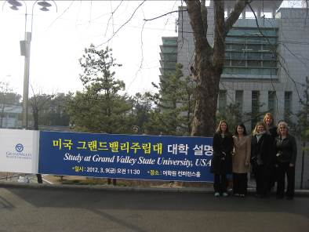

Spain
University of Deusto (UD), bilbao
Established in 2002, the partnership with the University of Deusto originally began as a one-way affiliation with the CIDE program. Over the years, this program experienced huge success with high student participation and excellent student reviews. In 2015, UD and GVSU expanded the program to include an option for student exchange. GVSU students are now able to apply to spend a semester in classes with local students.

Switzerland
Zurich University of Applied Sciences (ZHAW), Zurich
Established in 2012, the ZHAW partnership is a college-level agreement through the Padnos College of Engineering and Computing, and more recently the College of Business. This program offers opportunities for semester student exchanges. In addition, PCEC has also created a joint summer program for students in CIS. Faculty exchange opportunities are also available.
Taiwan
National Taiwan Normal University (NTNU), Taipei
Signed in 2008, the exchange with National Taiwan Normal University is a result of several years of educational cooperation. This cooperation offers opportunities for students to take language and culture courses through the Mandarin Training Center (MTC). Additionally, GVSU will serve as a host to NTNU students who will study here for a semester or year. For more details on this program, visit the website at www.ntnu.edu.tw
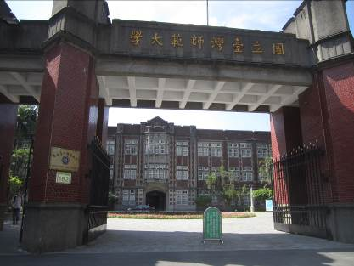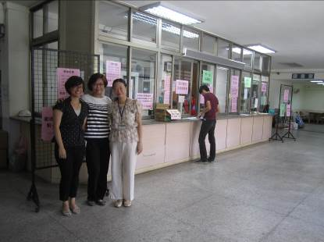
Turkey
Middle East Technical University (METU), Ankara
Signed in April 2005, METU is one of Turkey’s premier institutions of higher learning. METU offers a wide-range of curricular topics for students to choose from with courses taught in English. This agreement supports the exchange of students, faculty and staff. METU attaches great importance to the strengthening of international academic exchange and cooperation. In addition to the over 70 international partnership agreements, METU also serves as the host to over 900 international students from 65 countries. For more information about this program, visit the website at www.metu.edu.tr

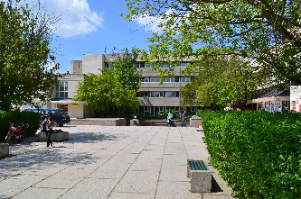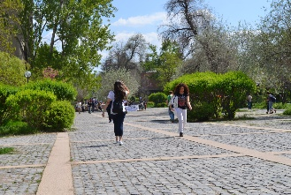

United Kingdom
Kingston University (KU), Kingston-upon-Thames
First signed in 1987, the Kingston Exchange Program actively promoted the exchange of students, faculty, and staff members from both institutions. Kingston University also hosts several GVSU faculty-led summer programs. www.kingston.ac.uk

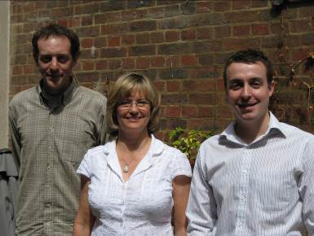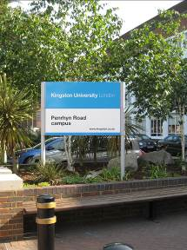

University of Brighton (UB), Brighton
The University of Brighton exchange program is a Seidman College of Business program offering study abroad opportunities to both GVSU and University of Brighton students. The agreement with the University of Brighton was signed in April 2007. For details, please contact Jennifer Pope or Carol Sanchez in the Seidman College of Business. www.brighton.ac.uk

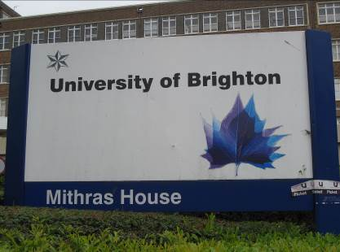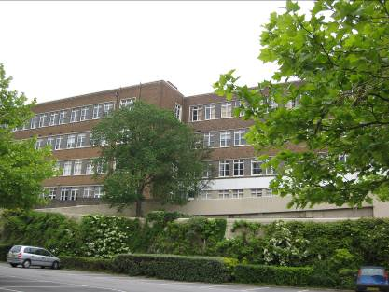

GVSU Consortia Memberships
Japan
Japan center for michigan Universities (JCMU)

The Japan Center for Michigan Universities is a unique consortium that brings together all 15 public Universities in the state of Michigan. This program is linked to Michigan’s sister state in Japan, Shiga Prefecture and offers many opportunities for both faculty and student involvement. Since GVSU is one of 15 members of this consortium, GVSU faculty are eligible for semester or year-long appointments as visiting faculty or on-site directors. Each semester, students can study Japanese language and a variety of other special topics courses at JCMU. During the Spring semester (January – May) students may pursuing the Environmental Studies in Japan program. For further information, see JCMU’s website at: http://www.isp.msu.edu/JCMU/

Various Locations
Consortium for Overseas student Teaching (COST)
The COST program is a consortium that brings a number of constituents together to offer opportunities for students to pursue their student teaching in an overseas classroom setting. Students work through the College of Education to request additional information.

GVSU Affiliations
Academic Programs International (API) (www.apiabroad.com)
American Institute for Foreign Study (AIFS) (www.aifsabroad.com)
Academic Programs International (API) (www.apistudyabroad.com)
Council on International Educational Exchange (CIEE) (www.ciee.org)
Cultural Experiences Abroad (CEA) (www.gowithcea.com)
Edge Hill University (EHU), Ormskirk, UK (www.edgehill.ac.uk)
European Study Abroad (EUSA) (www.eusa-edu.com)
Global Experiences (www.globalexperiences.com)
Global Semesters (www.globalsemesters.com)
Hellenic International Studies of the Arts (HISA), Paros, Greece (www.hellenicinternational.org)
International Studies Abroad (ISA) (www.studiesabroad.com)
John Cabot University (JCU), Rome, Italy (www.johncabot.edu)
University of Deusto (U of D), Bilbao, Spain (www.cide.deusto.es)
University Studies Abroad Consortium (USAC) (www.usac.unr.edu)

