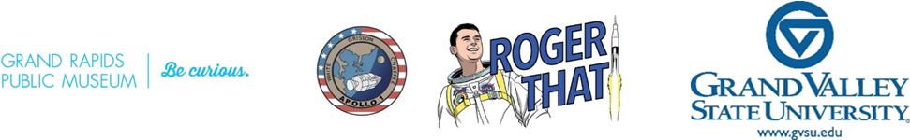
Hello!
Grand Valley State University and the Grand Rapids Public Museum are proud to bring you the seventh annual Roger That! symposium on the weekend of February 16-17, 2024. This event is a celebration of space exploration in honor of native Grand Rapidian and Michigan’s first astronaut, Roger B. Chaffee.
We will have free STEM kits available for distribution through April 2024; these kits are available on a first-requested, first-served basis and include instructions and equipment for hands-on exploration. They’re designed for 5th grade students, but any classroom can request and receive the kits.
We also invite interested 4th – 8th grade students in the greater Grand Rapids area to participate in Design That! - a design challenge that focuses on four major areas related to space exploration – Humans in Space, Communities in Space, Technology in Space, and Life in Space.
Details about the presentation format and schedule and instructions for posting the videos will be available on the Roger That! Website by mid-February. In-person projects will be displayed at GVSU’s Seidman Center (new location!) on Friday, February 16 from 4:30 pm – 7:30 pm, and the top ten will be displayed at GRPM on Saturday, February 17 from 10 am – 5 pm. (Note: separate awards will be given for 4th – 6th and 7th - 8th grades.)
Participation in Design That! can align with the following K-12 Standards:
- Michigan K-12 Science Standards Performance Expectations: MS-PS2-1. Forces and Interactions; MS-PS3-3. Energy; MS-LS2-5. Interdependent Relationships in Ecosystems; MS-ESS1-2. Space Systems; MS-ESS3-3. Human Impacts; MS-ETS1-1 through MS-ETS1-4. Engineering design.
- NGSS Science and Engineering Practices: Defining Problems, Developing and Using Models, Constructing Explanations and Designing Solutions, Engaging in Argument from Evidence, Obtaining, Evaluating, and Communicating Information
- ELA Common Core Standards by Domain: Comprehension and Collaboration, Presentation of Knowledge and Ideas, Production and Distribution of writing, Research to Build and Present Knowledge
On Friday, the events at GVSU are free and open to the public and will feature an astronaut as the keynote speaker. On Friday and Saturday, STEAM-related activities at the GRPM associated with the conference are free for Kent county children (included with general admission for all others).
Please feel free to contact us via email at rogerthat@gvsu.edu or via phone at 616-331-2319 with any questions you may have. More information at www.gvsu.edu/rogerthat.
Full details are provided in the main flyer, which is suitable for sharing directly with your students.
There are a variety of ways that students can participate – via building physical models, creating a webpage, or writing a story, to name a few. They can present their work in person and/or via a short (3-5 min) Flip video describing their project.
Dr. Samhita Rhodes, GVSU Engineering and Dr. Karen Gipson, GVSU Physics

