SHWM-CME-NCPD

To access the portal page

Go to https://spectrumhealth.cloud-cme.com/default.aspx
- Click on the sign in tab
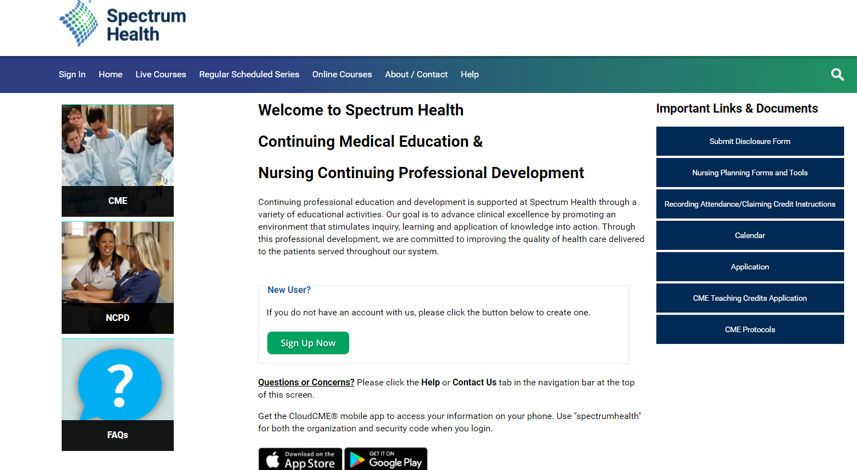

- Choose the second option to sign in using your email and password. (If you don’t remember your password, click on the sign in with your email and password button, then look for the password reset.)
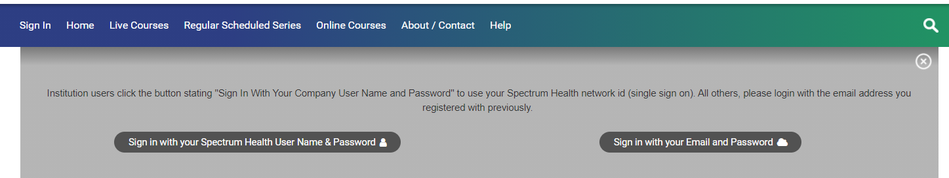

To get to the password reset. Click on the Sign with your email and password. Then at the bottom you will see Forgot Password. It will send a new password to your email.
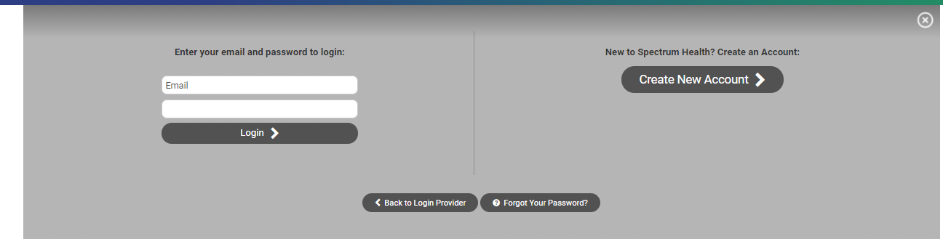

- Update your profile. (An updated profile must be completed before being able to text ID codes to the system)

To access the Phone App
- Download the free CloudCME App from your play store
- Organizational Code: spectrumhealth
- Log into the App by choosing the second option (Sign in with your Email and Password).
The app allows on the go access for all your CME needs. (Evaluations, Certificates, Transcripts. Etc.)

Texting ID Codes
- Pair your cell phone with the system: Create a text message to 844-420-1171. (CME suggests saving the number as a contact “CME Attendance”)
- In the body of the message type in your email and hit send. You will receive a message back saying you have paired your phone. This is a onetime set up.
Once you have done the above steps for any event you attend you will be given an ID code to text in to record your attendance at the session. You have 30 minutes before, anytime during, and 720 minutes (12 hours) after a session to record your attendance. This step opens the evaluation under your profile.

Evaluation and Credit
Computer:
- After recording your attendance your evaluation will appear in your evaluation tab.
- To complete and evaluation by portal page go to https://spectrumhealth.cloud-cme.com/default.aspx and log in.
- Go to your MY CE tab on the tool bar.
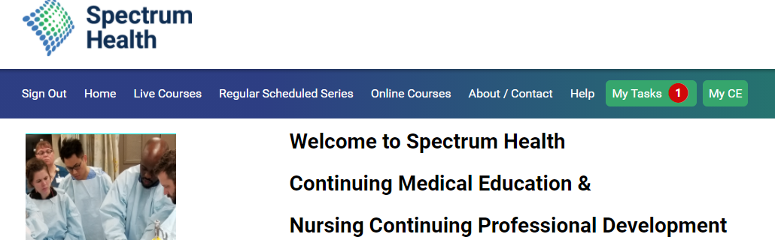
- Choose evaluation and certificate. This will open the list of evaluations that need to be completed. You have 30 days to complete an evaluation for an event.
- Click on the evaluation you want to completed fill it out and submit. Once you submit the evaluation you will receive credit for the session and a certificate will appear. You can download or print.
App:
- Go into the App choose evaluation tab. Pick the evaluation you want to complete. Fill out the evaluation and submit for credit.

