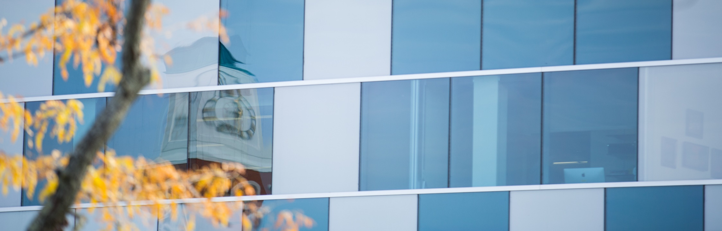

GRADUATE INTERNATIONAL STUDENT ORIENTATION SCHEDULE

FALL 2018

Saturday, August 18, 2018
6:00 p.m. Meet and Greet Tents near Lake Ontario Hall, Allendale Campus
Sunday, August 19, 2018
6:00 p.m. Opening Dinner and Informal Reception Tents near Lake Ontario Hall, Allendale Campus
Monday, August 20, 2018
11:00 a.m.-12:00 p.m. Immigration Registration and ID Cards Hager -Lubbers, DeVos, Grand Rapids
Please bring your Passport, Visa, I-94, I-20 or DS 2019 (You should have already completed the online forms at: www.gvsu.edu/istudents)
12:00 p.m.- 1:45 p.m. Lunch with Returning International Students 122E DeVos, Grand Rapids
2:00 p.m.- 4:00 p.m. Library Information/Research Assistance Knowledge Market, DeVos
4:00 p.m.-5:00 p.m. Tour of Grand Rapids with Mentors 124 Kennedy, Grand Rapids
5:00 p.m. - 7:00 p.m. Dinner Downtown Market, 435 Ionia Ave SW
Tuesday, August 21, 2018
9:30 a.m.- 10:30 a.m. Regulation Overview Cook DeWitt Center, Allendale
10:30 a.m.-11:00 a.m. Sexual Assault Prevention Training Cook DeWitt Center, Allendale
11:00 a.m. -12:00 p.m. Campus Resources Discussion Cook DeWitt Center, Allendale
12:00 p.m. – 1:30 p.m. Lunch Fresh Food Company, Allendale
1:30 p.m. – 3:00 p.m. Cultural Adjustment Cook DeWitt Center, Allendale Campus
3:00 p.m. – 5:00 p.m. Open Job Interviews for Campus Dining Commons Building
5:00 p.m.- 8:30 p.m. Dinner and Bowling Hudsonville Lanes
Bus will leave promptly at 5:00 from in front of Lake Ontario Hall
Wednesday, August 22, 2018
10:00 a.m.- 11:00 a.m. Social Security Administration The Connection, Allendale
(Optional but highly recommended: please bring your passport, I94, I-20)
10:30 a.m. Head downtown Bus departs from Kirkhof Center
11:45 a.m. Meet Dr. Potteiger for lunch by Starbucks in DeVos DeVos Building C, Grand Rapids
12:00 p.m.- 1:00 p.m. Lunch with Dr. Potteiger, Dean, Graduate Studies Bobarinos
2:00- 4:00 p.m. Graduate Student Orientation Loosemore Auditorium ,DeVos
1:00 p.m. – 9:00 p.m. Possible meetings with academic advisors Please check with your program

Thursday, August 23, 2018
All day Possible meetings with academic advisors Please check with your program

Friday, August 24, 2018
11:30 a.m. Convocation (official start of the academic year) Fieldhouse, Allendale
2:30 p.m. Simulation Center Training (optional) Sim Center, Health Science Building
4:00 p.m. – 6:00 p.m. Intercultural Student Reception 2250 Kirkhof Center, Allendale
Please note that there is typically a mandatory training for those students who have received a graduate assistantship on Friday, August 24
*Please note that the cost of this mandatory orientation is $150.00. It will be billed to your student account in September

