Division and Reaction:
Democracy in Peril

The 48th Great Lakes History Conference

October 5th – 7th, 2023
Grand Valley State University
Grand Rapids, Michigan

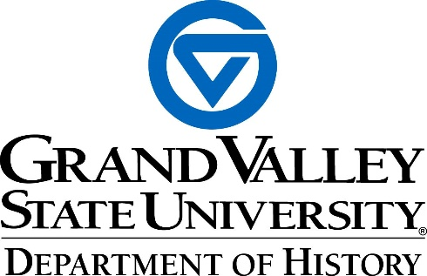

Special Thanks To Our Sponsors

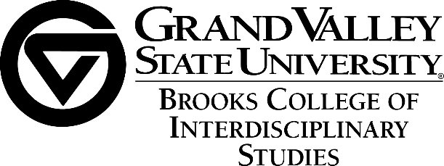


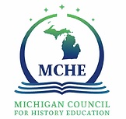


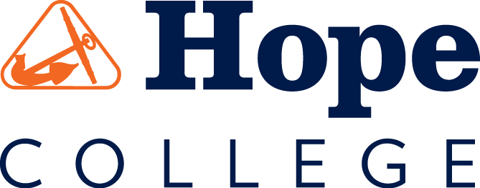

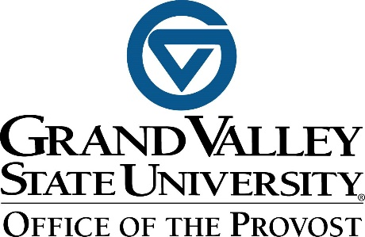

Overview

Thursday, Oct 5

7 PM Keynote Presentation: Dr. Heather Ann Thompson, “The Attica Prison Uprising of 1971 and Why it Matters Today”

Book Signing - Credit card sales only.
Friday, Oct 6

7 PM Keynote Presentation: Dr. Kevin Boyle, “Blood Ties: An Intimate History of Political Violence in Twentieth Century America”

Book Signing - Credit card sales only.

Free Reception at Holiday Inn Downtown Thornapple/Muskegon Meeting Room, 8-11PM

Saturday, Oct 7

12 PM Free Lunch at Hager-Lubbers Exhibition hall

1 PM Keynote Presentation: Dr. Randal Maurice Jelks, “The Foundation of Democracy, Creative Maladjustment”

Book Signing - Credit card sales only.

SCHEDULE OF EVENTS

Keynote: 7 pm, Thursday, October 5th, Loosemore Auditorium, GVSU Pew Campus
Dr. Heather Ann Thompson, “The Attica Prison Uprising of 1971 and Why it Matters
Today”
Introduction by Dean Jennifer Drake (GVSU)

Session One: Friday, October 6th

PANEL 1.1: (2:45-4:15 PM) Room DEV 223E
Not Included in the Narrative: Looking at Women in Male-Centric Discourse

Chair/Comment: Gordon Andrews (GVSU)

- Christine Cook (Wayne State University), “The Scheme to Keep the Military Face Male: The Pentagon’s Attempts to Limit the Percentage of Women in the US Military During the 1970s”
- Katie Parks (Wayne State University), “The Representation of Women’s Experiences in Holocaust Museums Across the United States”
- Maria S. Wendeln (Wayne State University), “Applying Timothy Snyder’s On Tyranny: Twenty Lessons from the Twentieth Century in Women’s History & Gender Studies Classroom”

PANEL 1.2: (2:45-4:15 PM) Room DEV 225E
Finding Unity and Belonging During Wartime: The Religious Work of the USO During WW2

Chair: Marcy Sachs (Albion College)

- Jeanne Petit (Hope College), “This Experience of Interfaith Cooperation: The Religious Work of the YMCA in the USO”
- Carolyn Thornbury (Hope College), “Holiday Seders and Dietary Observation as Vital Jewish Practices During Wartime”

Keynote: 7 pm, Friday, October 6th, Loosemore Auditorium, GVSU Pew Campus

Dr. Kevin Boyle, “Blood Ties: An Intimate History of Political Violence in Twentieth
Century America”
Introduction by Martin Hershock (U of M Dearborn)
There will be a free reception following the Friday Keynote at the Holiday Inn Downtown. Please join us! Thornapple/Muskegon Meeting Room, 8-11PM

Session One: Saturday, October 7th

PANEL 2.1: (10:00–11:45 AM)_Room DEV 223E
Conservatism and the Cold War

Chair/Comment: Jason Duncan (Aquinas College)

- Kobby Barda (Haifa University), “Planting a Movement: Jerry Falwell”
- Michael Webster (GVSU), “E.E. Cummings’ Response to Finland’s Conflict with the USSR”
- Scott Grau (Northeast Iowa Community College), “Spotlight on Loyalties: The Hollywood Ten vs. HUAC & the Question of Commitment”

PANEL 2.2: (10:00–11:45 AM)_Room DEV 225E
Midwestern Struggles with the Perils of Democracy

Chair/Comment: Joel Wendland-Liu (GVSU)
- Jeff Smith (Grand Rapids Institute for Information Democracy), “People’s History of Grand Rapids”
- Hannah McBride (GVSU), “Experiences of Women in Homes for Unwed Mothers”
- Natalie Albrecht (University of Michigan), “Pandemic As Portal?”

PANEL 2.3: (10:00–11:45 AM)_Room DEV 303E
The Perils of Democracy in American Civil Rights

Chair/Comment: Fred Johnson (Hope College)

- Jessie Dunbar (University of Alabama at Birmingham), “Democracy, Diaspora, and Disillusionment: Black Itinerancy and the Propaganda Wars”
- Chris Bruno (Millikin University), “The Legacy of John Brown”
- Isaac Tuttle (Baylor University), “Thomas Dixon Jr. and the ‘New Negro’”
- Secret Permenter (Purdue University), “Building Connections: Separation and the Emergence of Deaf Subcultures”

PANEL 2.4: (10:00 – 11:45 AM)_Room DEV 305E
National History Day Program

Presenter: Sean O’Neill (GVSU)

- A rewarding way to teach Historical Thinking, motivate students to study history, and empower them to pursue their own learning. In this session we will present the National History Day program to teachers who would like to inspire their students to study history.

Noon to 1PM: Free Lunch at Hager-Lubbers Exhibition hall

Keynote: 1 pm, Saturday, October 7th, Loosemore Auditorium, GVSU Pew Campus
Dr. Randal Maurice Jelks, “The Foundation of Democracy, Creative Maladjustment”
Introduction by Fred Johnson (Hope College)

Session Two: Saturday

PANEL 3.1: (2:45-4:15 PM)_Room DEV 223E
The Story from Latin America

Chair/Comment: Nikki Magie (University of Olivet)

- Michael Huner (GVSU), “A Civics Lesson from Nineteenth-Century Paraguay? Republicanism, Religion, and War in the Heart of South America, 1800-1870”
- Liz Shesko (Oakland University), “Democracy in the Streets? Bolivia’s Revolutionary Nationalist Movement from 1951 to 1969”
- Bridget Chesterton (SUNY Buffalo State University), “Failing to be Heard: Women’s Suffrage in Stroessner’s Dictatorial Paraguay”

PANEL 3.2: (2:45-4:15 PM)_Room DEV 225E
Transitions of Identity in American Democracy
Chair/Comment: Paul Murphy (GVSU)

- Noelle Charbonneau (GVSU), “Triple Oppression: Intersectionality and Marginalization in Radical Movements”
- Jason Rose (Western Michigan University), “Rooted Cosmopolitanism and Nativism in the Jazz Age”
- Keith Snedegar (Utah Valley University), “A Liberal Belittled: Violaine Junod in South Africa and the United States, 1953-1963”
PANEL 3.3: (2:45-4:15 PM)_Room DEV 303E
Muslim Placemaking in the Midwest: The Intersection of Political and Religious Values

Chair/Comment: Chad Lingwood (GVSU)

- Ashley J. Bavery (Eastern Michigan University), “Resisting Respectability: Islam, Vice, and Violence in Postwar Chicagoland”
- Alisa Perkins (Western Michigan University), “Neighbors Into Heirs: Islamic Relationality and Black Muslim Place-Making in Detroit”
- Rose Wellman (University of Michigan), “Pious Action, Kin Work, and the Aftermath of Imperial Violence in Arab Detroit”
- Sally Howell (University of Michigan), “Right on the Margin: Yemeni Struggles for Influence and Inclusion in Dearborn”

Map

