Open SAS Enterprise Guide
Open New Project
Open New Program

To open an Excel file, use PROC IMPORT. Code for our Excel file is:

Proc import datafile='N:\SAS Workshop 1 Folder\Workshop file.xlsx'
out=OUT1
replace;
sheet='First file';
run;

Comments:
- Datafile = the file containing the Excel File
- Out = Out1 creates a file in the SAS Work Library
- REPLACE allows you to overwrite a previous version of OUT1
- Sheet = ‘First File’ tells SAS to read the sheet called “First File”. If this is not given, the default is “Sheet1”.

To add some labels and formats to the variables in OUT1:

First we create the formats:

proc format;
value $sex 'M'='Male'
'F'='Female';
value $rank 'FR'='Freshman'
'SO'='Sophomore'
'JR'='Junior'
'SR'='Senior';
value $dist 'A'='Within 50 miles of GVSU'
'B'='Over 50 miles from GVSU but in MI'
'C'='Outside of MI';
value Q1_ 1='Strongly Disagree'
2='Disagree'
3='Neutral'
4='Agree'
5='Strongly Agree';
run;

- Value is used for each format that is created.
- The formats that are created are $sex, $rank, $dist, and Q1_
- $sex, $rank and $dist have dollar signs because the format is for character variables.
- Q1_ has an underscore because a format cannot end in a number.

We now apply the formats to the values of the variables. We also create labels for the variable names themselves:

data out1;*output data set;
set out1;*input data set;
label Rank='Class Rank'
high_school='How far is your High School from GVSU?'
speed='Fastest speed ever driven a car'
seed='How far did you spit the sunflower seed? (ft)'
Q1='Likert Scale responses to Question 1';
format sex $sex. rank $rank. high_school $dist. Q1 Q1_.;
run;

Remaining code is below. Title and Footnote statements are used to document the code:

title 'Lists all variables in the data set';
title2 'Labels created above are not applied';
proc print data=out1;
run;

title 'Lists only the variables after VAR';
title2 'label statement applies the labels to the variables';
proc print data=out1 label;
var CASEID rank speed;
run;

title 'default summary statistics';
proc means data=out1;
var speed seed;
run;

title 'Must sort data set BY the variable';
title2 'before using PROC MEANS with the BY variable';
proc sort data=out1;
by rank;
run;

title 'Speed separated by class rank';
title2 'Specific statistics are specified';
footnote 'clm=confidence interval for mean';
footnote2 'alpha = 0.10--90% CI';
footnote3 'maxdec= 2 means 2 decimal places in printout';
proc means data=out1 clm mean std alpha=0.10 maxdec=2;
var speed;
by rank;
run;

title 'default frequency table for rank';
proc freq data=out1;
tables rank;
run;

title 'tables for rank and Q1';
title2 'nocum and nopercent suppresses percents';
proc freq data=out1;
tables rank Q1/nocum nopercent;
run;

title '* creates a crosstabs table';
proc freq data=out1;
tables Q1*sex;
run;

title 'norow, nocol, nopercent suppresses percents';
title2 'chisq gives chi square numbers';
proc freq data=out1;
tables Q1*sex/norow nocol nopercent chisq;
run;

title "Gives 'kitchen sink' statistics";
title2 'normal gives normality tests';
title3 'plot gives some descriptive plots';
proc univariate data=out1 normal plot;
var seed;
run;

title 'vertical bar chart for seed-default';
proc gchart data=out1;
vbar seed;
run;

title 'sets classes for vertical bar chart';
title2 'classes: 0-40, 40-80, etc.';
proc gchart data=out1;
vbar seed/midpoints=20 to 220 by 40;
run;

title 'vertical bar chart with 6 levels';
proc gchart data=out1;
vbar seed/levels=6;
run;

title 'horizontal bar chart for Q1';
title2 'discrete tells SAS to treat Q1 as categorical variable';
proc gchart data=out1;
hbar Q1/discrete;
run;

title 'default pie chart';
PROC GCHART DATA=out1;
PIE Q1;
RUN;

title 'pie chart with extras';
PROC GCHART DATA=out1;
PIE Q1/ DISCRETE VALUE=INSIDE
PERCENT=INSIDE SLICE=OUTSIDE;
RUN;

On Exporting Results

Click on the Results tab for options. We will talk through these.

To copy tables or graphs into Word:
- Right click on the desired graph and choose “Copy”.
- Go to a blank Word document, right click, under Paste choose “Keep Source Formatting” (the first logo).
- To save the graph as a JPEG item, right click to “Save as”, find a location to save it, and then save the JPEG document.
- Finally, open and paste your JPEG document into Word.
The Seed graph is below.

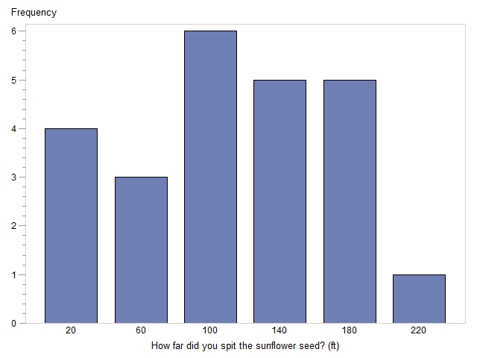
Next is the fancy pie chart for Q1.

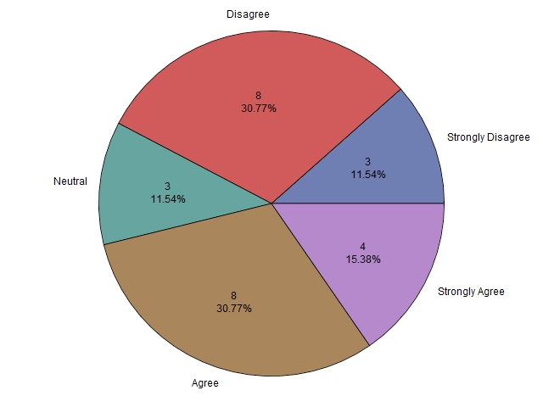

Some Help Resources

- https://support.sas.com/documentation/: Has a lot of stuff, but sometimes hard to use.
- http://www.lexjansen.com/: Has over 27,000 SAS User Group papers and SAS Proceedings. Many of these are tutorials on various components and tools in SAS, from beginning level to advanced level.
- http://www.ats.ucla.edu/stat/sas/ From the UCLA Institute for digital research and education. This is a great resource for those wanting good, clear examples of code and printout. Often when I have to recall something or want a simple example, one of their websites is the place to go.
- Google in general: Google some words related to what you are looking for, and then start digging through web pages.

Books
There are many good SAS books out there. The three I list below are what I would consider to be “must
haves” for a beginner.
- Learning SAS by Example: A Programmer’s Guide, Ron Cody, SAS Institute. I have used this book before in my classes, and still use it for examples. Some of the material about the SAS output
file is out of date since SAS went to HTML as the default.
- SAS Statistics by Example, Ron Cody, SAS Institute. A good resource for doing much of the
material you’d do in the first two college-level statistics courses, plus logistic regression.
- The Little SAS Book, A Primer, 5th Edition, by Delwiche and Slaughter. I am using this book in my 616 and have used it in 318 (the undergraduate SAS programming course). It is a good source of instruction for a SAS beginner.

