- Turn on paragraph marks/formatting symbols (Ctrl+*) to make the section breaks (and other symbols) visible.
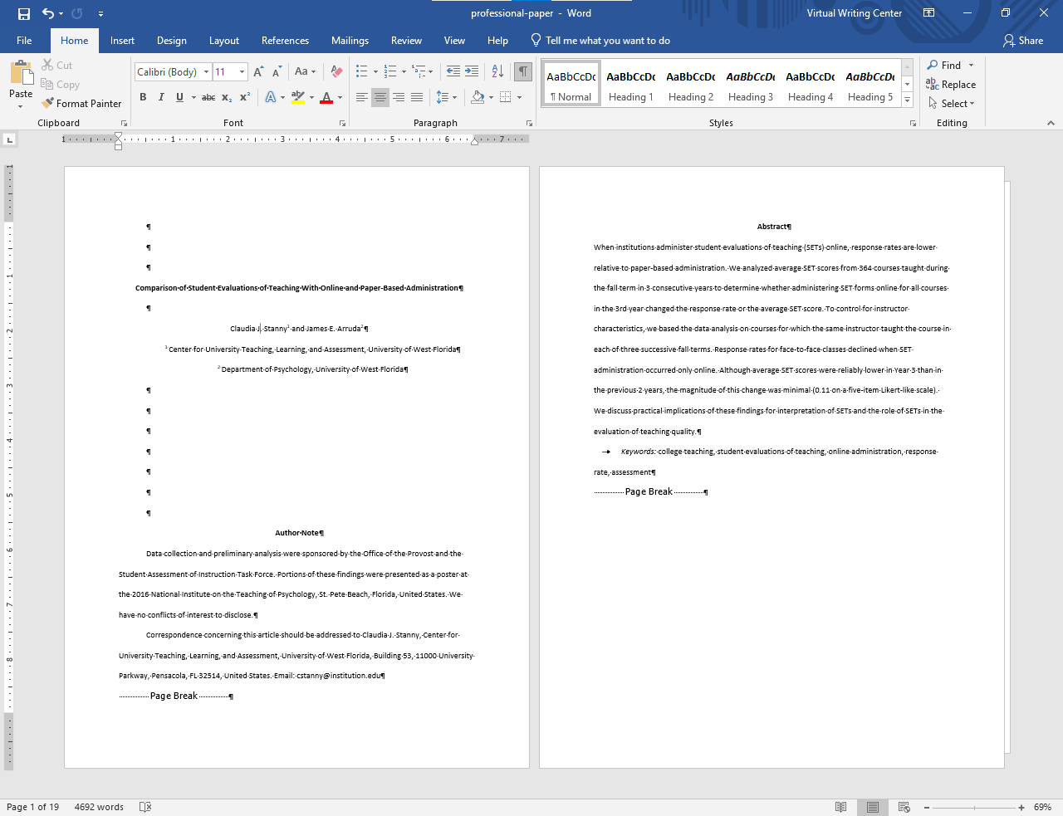
- Choose a type of section break:
- “Next Page” inserts a section break and starts the new section on the next page. This is useful to start new chapters in a document.
- “Continuous” inserts a section break and starts the new section on the same page. This is useful if your sections are already on the pages you want them to be on.
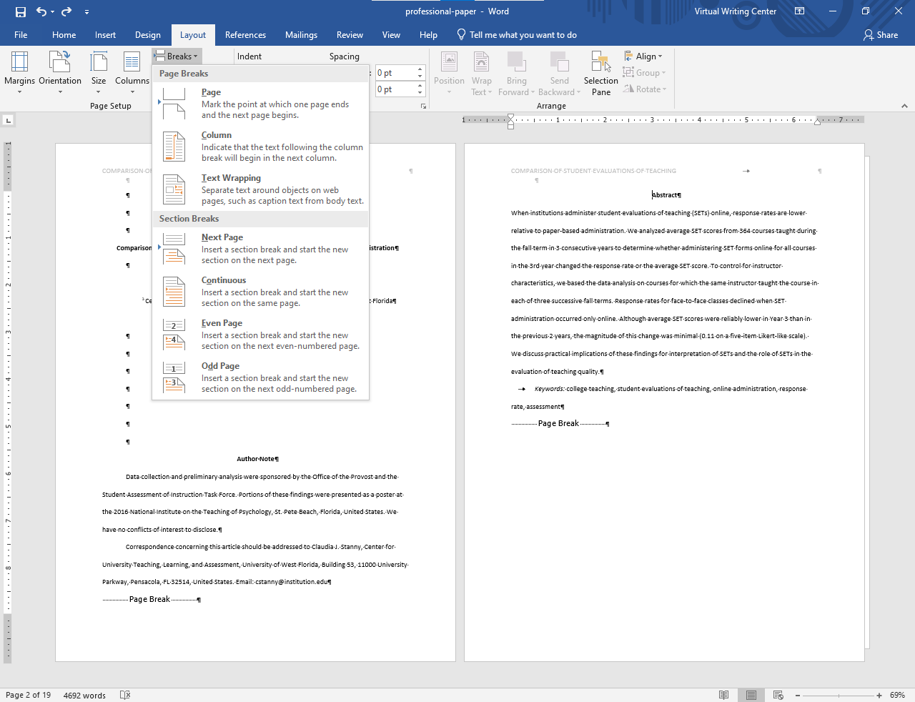
- Add a section break at the beginning of the section you want to create (and/or at the end of the previous section)
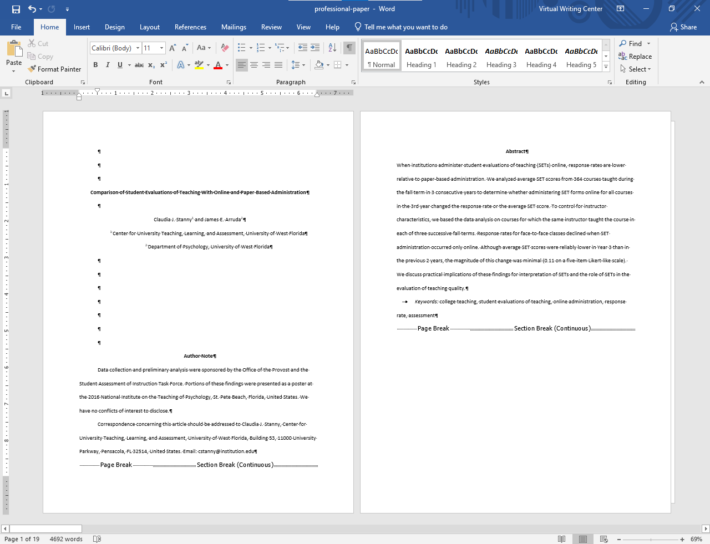
- Double click at the top or bottom of the document to open the header. The section number is now listed next to Header/Footer.
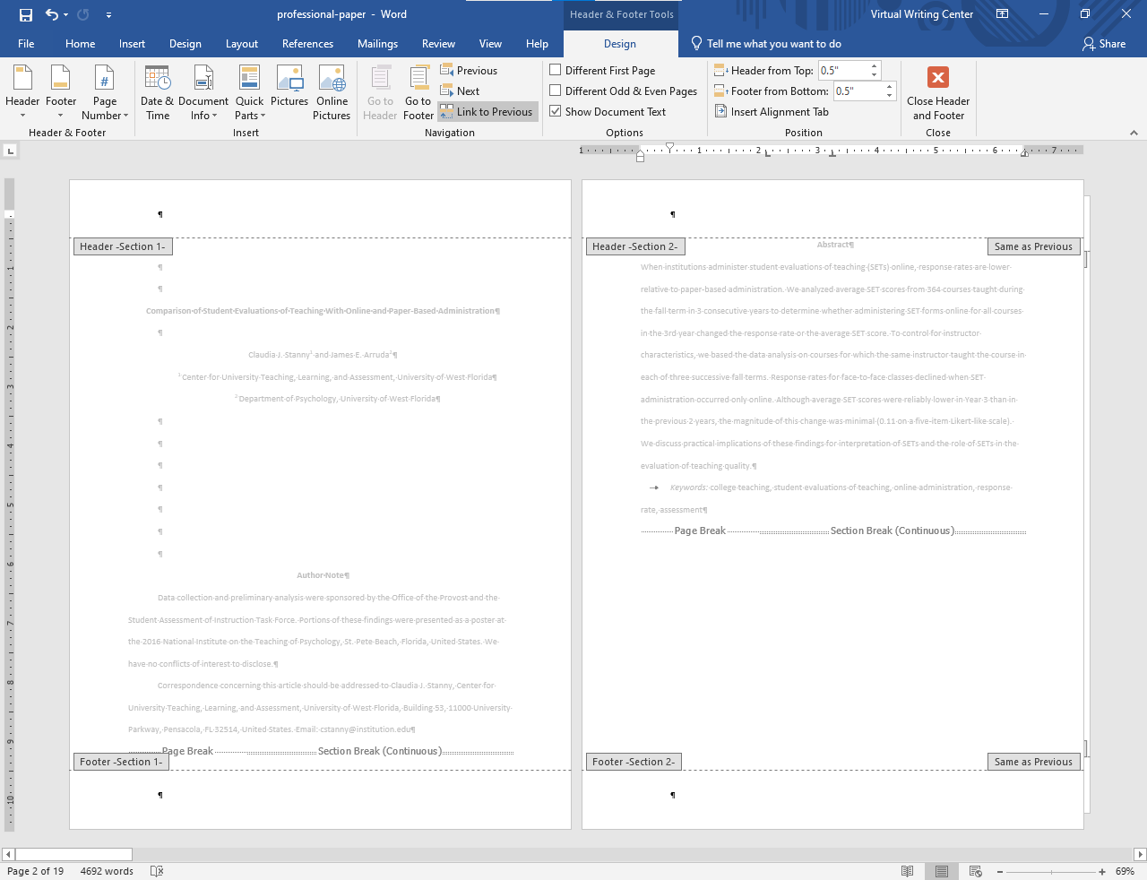
- In order to unlink (separate) the sections, select the header on any page in the section you are working in and de-select “Link to Previous”.
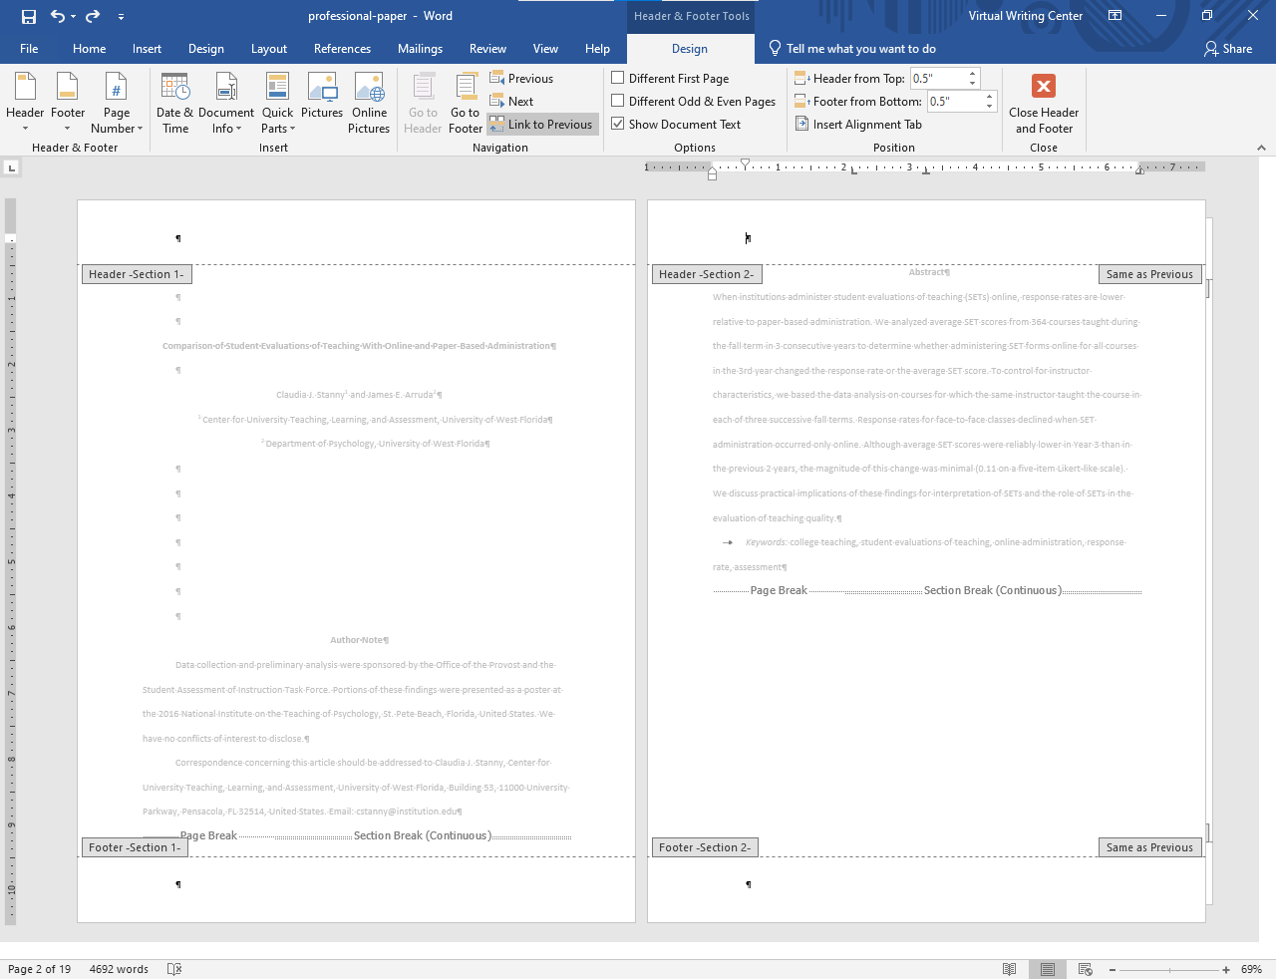
The section 2 header is now unlinked from the section 1 header. You can now independently number these sections using Word’s “Page Number” function.
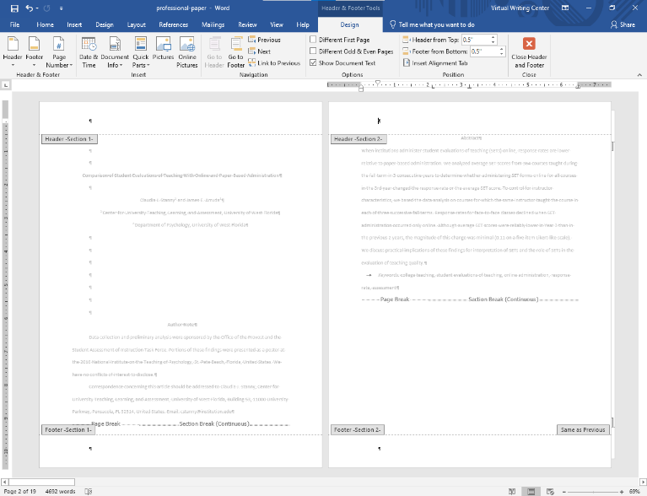
- In this situation the section 1 and 2 headers have been unlinked, but the section 2 and 3 headers are still linked. If you wanted sections 2 and 3 to have different numbering formats, you would have to repeat the same process (steps 1 - 5) on section 3.
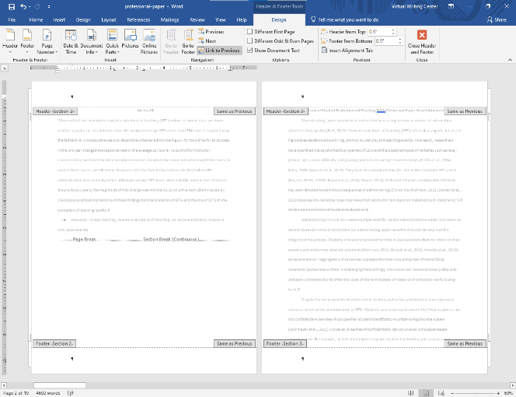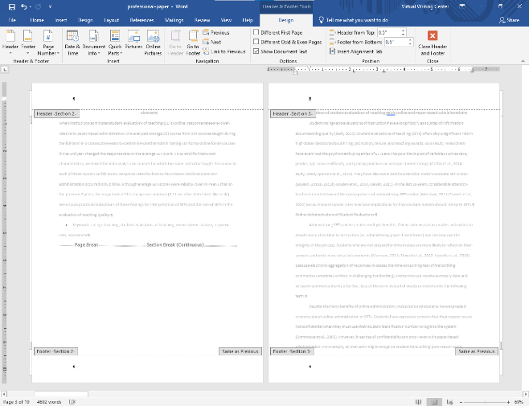
- When using “Page Numbers” to add numbers to the sections, they may begin at a number other than one. To change this, go to “Format Page Numbers”, select “Start at:” instead of “Continue from previous section”, and choose the number you would like that section to begin at.
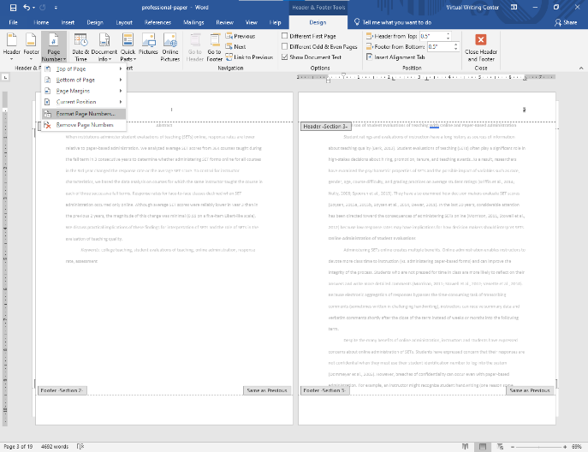
In the “Format Page Numbers” pop-up, you can also select from several different formats of numbering (ex. i, ii, iii …)
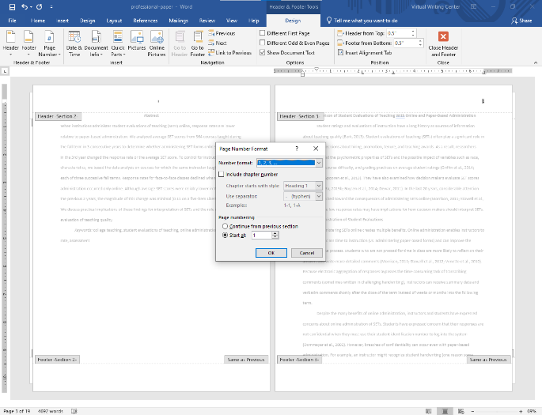
For further information on using section breaks to format documents, see:
https://support.microsoft.com/en-us/office/use-section-breaks-to-change-the-layout-or-formatting-in-one-section-of-your-document-4cdfa638-3ea9-434a-8034-bf1e4274c450
For further information on page numbering, see:
https://support.microsoft.com/en-us/office/page-numbering-in-word-5a12ea00-be26-4c88-8802-797bd53f71a9

