Book It student walkthrough - Appointments

- Login to Book It using your GVSU login/password (www.gvsu.edu/bookit/)

- Once logged in, you will see your currently scheduled appointments (past and future) and can make new appointments with any Knowledge Market service.
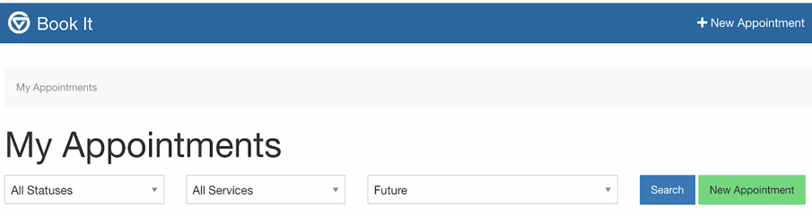

- Following the green “new appointment” link takes you to the main scheduling page (pictured below). Using the “new appointment” link in the top navigation bar takes you to the general Knowledge Market page with descriptions of each service. After completing the new appointment form, you will be prompted to confirm and schedule your desired appointment date/time.

- At the time of your appointment (or up to 15 minutes before) you can “check in” for your appointment under the “My Appointments” tab.

- At your scheduled start time, your consultant will set a Google Meet link for your session on this page. As soon as the consultant is ready, you can join them by selecting “enter appointment.”

- If you have any issues or questions with this process you can email the Writing Center at virtualwc@mail.gvsu.edu and/or speak with a Knowledge Market receptionist at: https://gvsu.edu/library/km/dropin

