February, 2018
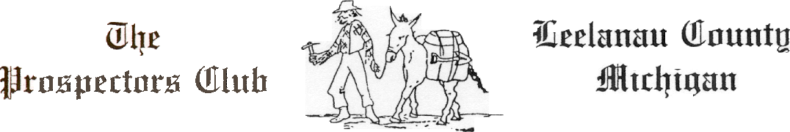
Dear NMC or University Center Student:

The Leelanau County Prospectors Club is pleased to announce its third Northwestern Michigan College\University Center scholarship program in memory of Jim Harris, Joan Rutherford and Bryan Borchardt. The 2018 scholarship program will consist of one $1,500 scholarship that will be awarded to an eligible college student from Leelanau County, to assist in his/her continuing education. The winner will be notified prior to the Prospectors dinner meeting on May 31, 2018, and the actual check will be presented at the dinner meeting to which the winner will be invited.

The applicant must be a resident of Leelanau County. The recipient will be chosen following individual interviews by an independent selection committee comprised of local citizens on the basis of scholastic achievement, financial need, and potentially a personal interview.

To apply for the scholarship, simply provide the following information:

- A one page background cover letter
- College Transcripts
- A completed FAFSA (financial aid) application

Completed applications are to be submitted by April 16, 2018, to the Leelanau County Prospectors Club, c/o Timothy L. Haring, P.O. Box 293, Suttons Bay, Michigan 49682, or if you prefer by e-mail, to tharinglaw@gmail.com. All applications will be submitted to an selection committee the week of April 23, 2018.

Please feel free to contact me for more information or questions concerning the NMC\University Center Scholarship.

Sincerely,

Chet Janik
Scholarship Committee Member
The Prospectors Club
231-256-8100
cjanik@co.leelanau.mi.us

