Installation Instructions – MAXQDA 2020
for Windows 8.1

The MAXQDA 2020 Client software is located here \\office.ads.gvsu.edu\dfs\GVSU-Labdata\Social-S

Open folder “MAXQDA 2020 Client for Windows”
Copy MAXQDA2020_Setup to your Desktop.
Right-click on MAXQDA2020_Setup and select “Install”.
Accept “License Agreement” and “Privacy Policy”.
Destination Folder – Accept default.
Click on “Install”.
If prompted for “User Account Control”, click on “Yes”.
Click on “Finish” and MAXQDA 2020 will launch.

Select “Connect to your institution’s network license”.

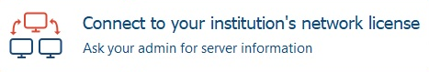

In the opening window enter the following…

Server Address: maxqda2020.gvsu.edu
Port: 21989
Under “License Name”, select “Please enter license name (case sensitive)” and enter MAXQDA2020 and click on “Connect”.

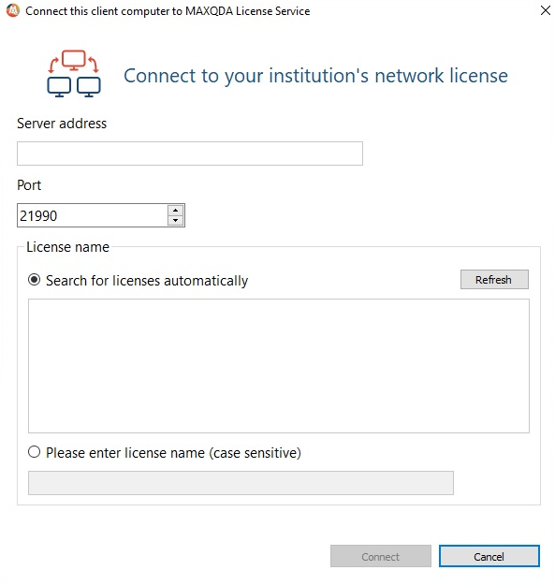
The MAXQDA 2020 License will expire on 7/21/2021 and there are 100 Client licenses.

