Turning a Box commented submission into an Annotated PDF

If your teacher uses the box tool to add comments right on the document itself you can download that file as an annotated PDF.

1. Go To do the Assignment submission screen
2. Click on the dropdown next to the file name
3. Select download annotated PDF

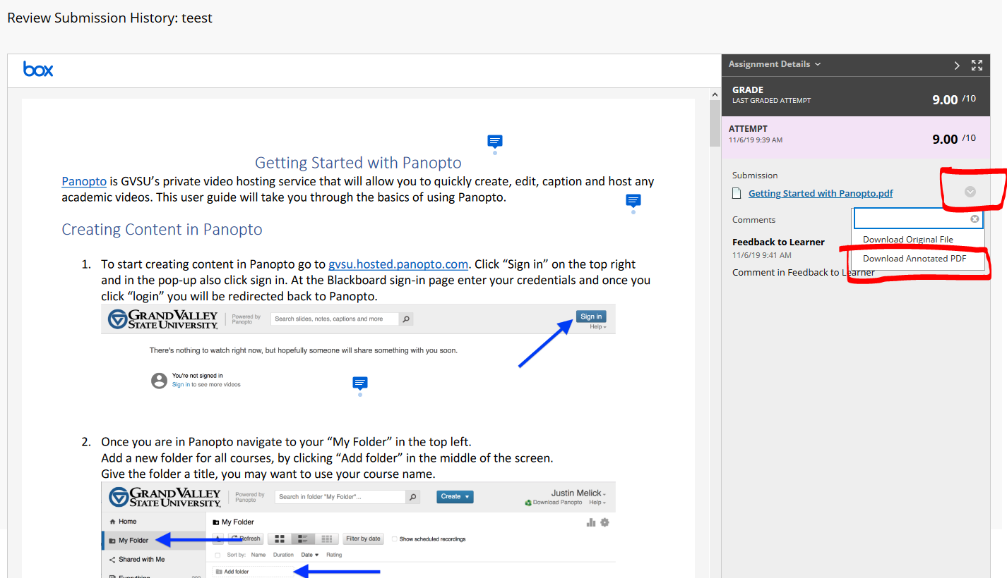

1. The file will download as a PDF. Note: The name of the file will be the name that is on blackboard followed by a string of numbers.

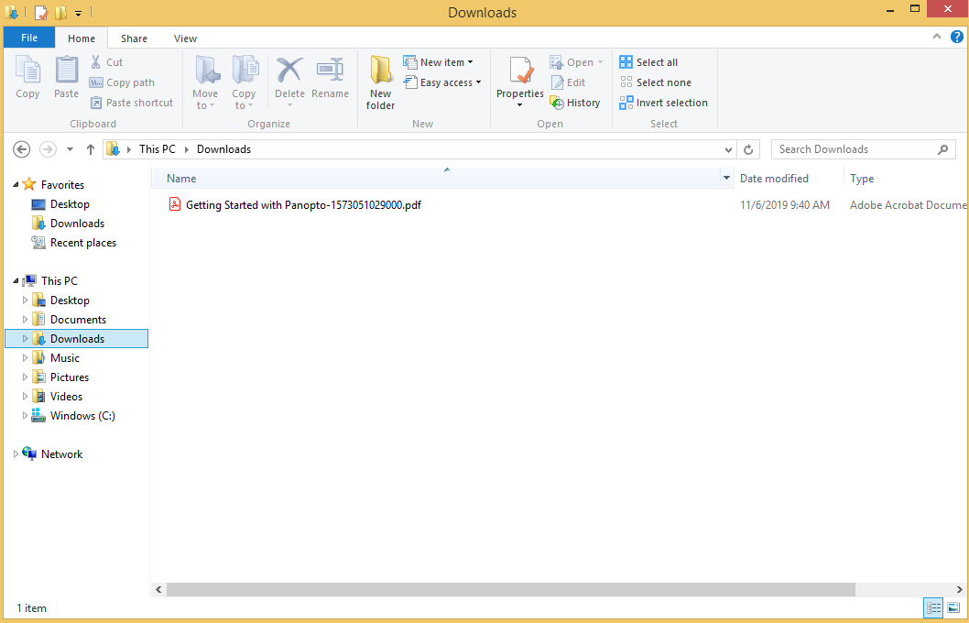

1. Open the PDF with any PDF reader (Adobe Acrobat, Chrome, Firefox etc.)
2. Hover over or click the comment icons to see the message left by the instructor

