Blackboard & Accessibility Quick Guide

Instructors, ELearning Technologies, and Disabilities Support aim to:
Create accessible course content used for both in class and online courses
Collaborate to identify and practice problem solving solutions to items
Communicate the effectiveness and benefits of accessibility resources to students and faculty

Disability Support strives to comply with Americans with Disabilities Act (ADA) by:
Making online posted documents screen-reader friendly
Captioning media to display on-screen text
Providing accessible marketing materials without the use of institutional marketing (IM)
Assesses all options of providing accessible content such as HTML, tagging PDFs, etc.
Disability Support (DS)

The eLearning and Emerging Technologies team is dedicated to:
Supporting faculty
Contributing to teaching excellence
Enhancing student success through:
Exemplary Instructional Design – IDeL
Effective Application of Instructional technologies
Learning Management System Enhancement
Interactive Digital Media Development
Innovative Emerging Technologies
ELearning

Instructing faculty develop courses by:
Designing consistent content navigation
Writing alt text descriptions
Creating accessible documents
Retaining original document files (PowerPoint, Word, etc.)
Using close captioning where applicable
Checking content accessibility through Word and Blackboard Ally’s accessibility checker
Supplying DS course material accommodations as needed
Preparing plans to correct non-compliant accessibility content
Instructor

FORMAT | BUILDING ACCESSIBILITY | HOW TO CHECK
Video | https://www.gvsu.edu/elearn/accessibility-video-and-audio-70.htm | Use the TAB key to check function accessibility
MS Word  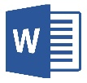 | https://www.gvsu.edu/elearn/accessibility-microsoft-word-67.htm | Run MS Word accessibility check to check accessibility of document
MS PowerPoint  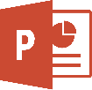 | https://www.gvsu.edu/elearn/accessibility-microsoft-powerpoint-68.htm | Run MS PowerPoint accessibility checker to check accessibility of document
MS Excel | - Specify column headers  - DO NOT use blank cells for formatting | Run MS Excel accessibility checker to check accessibility of document
Google Docs  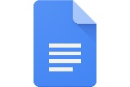 | - Use heading styles  - Use read-only versions of a Google Doc to export into MS Word  - DO NOT create PDFs from Google Docs | Convert into MS Word document to enforce accessibility
Web Pages | https://www.gvsu.edu/dsr/making-documents-accessible-90.htm  Use free tools to test page accessibility | Use the WAVE Toolbar
PDF Documents  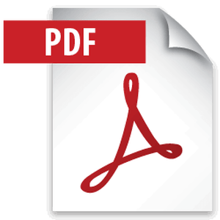 | https://www.gvsu.edu/elearn/accessibility-adobe-acrobat-and-pdfs-69.htm  - Use software that creates accessible PDFs such as MS Word  - Run OCR software on scanned items | Use “Full check” under view in Adobe Acrobat
Blackboard Collaborate | Most content is accessible  Note: Some content will require textual repurposing for visually impaired users | Collaborate possess an accessible interface  Check document formatting and test live captioning for users with impairments

