Psychology of Language (PSY 357), Syllabus and Lab Manual, Spring ‘23
Online and Asynchronous
May 8-June 21, 2023

Instructor: Jennifer Gross, Ph.D.

How to reach me:
- Correspond via email (recommended): grossj@gvsu.edu.
- Meet on Zoom. Contact me via email to set up a meeting time.
- Call my cell phone: 616-648-4512

Drop-in virtual office hours via Zoom: Days and times announced on Blackboard.

Course Description: Language plays a central role in our lives. We chat with friends, read novels, enjoy the lyrics of music, convey our feelings, teach our children, and transmit scientific discoveries to future generations via language. Your ability to read these words is just one example of language in action. Most of us, however, don’t stop to ponder our linguistic prowess. In this course, we shall scientifically investigate our linguistic feats and foibles by exploring these topics and more:

- What distinguishes language from mere communication?
- How are gestural (sign) languages similar to, and different from, spoken languages?
- How did the human mind develop the capacity for language?
- Is language uniquely human, or do nonhuman animals or insects have language?
- How do children learn to speak and read their mother tongue?
- Why do children say funny things like ‘she giggled me’ and ‘I breaked the toy’?
- Where does language reside in the brain, and is there such a thing as being “right-brained” or “left-brained”?
- Does short-term memory have a visual store and a verbal store? How is information stored in long-term memory?
- What interventions might help the 21% of U.S. adults (per the U.S. Dept. of Education) who read below the 5th-grade level?
- What do tips of the slongue (oops—slips of the tongue) reveal about the mind?
- Although equipped with voice activation, why can’t our cell phones reliably converse with us?
- Are there risks associated with simultaneously driving and talking on a cell phone?
- Is ‘wag’ an entry in your mental dictionary? What about ‘wug’? How can you make these decisions within fractions of seconds considering the vast number of words you know?
- Why do we hear discrete words even though speakers do not pause between words when speaking (a phenomenon best observed by listening to someone who speaks a language foreign to the listener)?
- Do the Inuit have several hundred words to describe snow? Do skiers?
- Can we think independently of language, or does language constrain our reality?
- Can leading questions compromise the accuracy of eyewitness testimony? Can the choice of words influence our buying preferences or health practices? Can language be ‘loaded’? For example, should words like ‘chairman’ and ‘freshman’ be replaced respectively with gender-free terms?
- Are there gender differences in mental aptitude?

Indeed, such fascinating questions deserve compelling, scientific explanations—the highest standard of evidence available. Although we may take our language-savvy minds for granted, we shall explore how language dominates our social and cognitive processes. Simply stated, language may be the essence of humanity.

This course is subject to the GVSU policies listed at http://www.gvsu.edu/coursepolicies/

Objectives: Upon successful completion of this course, students will be able to:
- Describe theories and research on the linguistic representation of language.
- Describe theories and research concerning the cognitive processes that foster language
acquisition and enable skilled language production and comprehension.
- Evaluate and explain the scientific study of human language, including critically evaluating psycholinguistic theories and experimental results.
- Explain the biological, social, and cultural influences on language processes.

Prerequisite: PSY 101

Course Homepage on Blackboard: lms.gvsu.edu
Class information (e.g., syllabus, announcements, lectures, laboratory assignments, required readings, & grades) will be posted on Blackboard.

Required eBook: Available for free via the GVSU Library and our Blackboard site
Trevor A. Harley (2017/2010). Talking the Talk: Language, Psychology, and Science (Second Edition). New York, NY: Psychology Press (ISBN 978-1138800458)

Required Software License: Purchase a new license only
Francis, G. & Neath, I. (2015). CogLab (5th Edition), Instant Access (for one semester; ISBN 9781285461083). Available via GVSU bookstore (approx. $65) and online ($50) (https://www.cengage.com/c/coglab-5-5e-francis/9781285461083PF/).

Required Readings: See “course documents” on Blackboard.

Required Laboratory Participation via:
1) CogLab 5 (https://coglab.cengage.com/; license fee)
2) Project Implicit for Lab #16 only (https://implicit.harvard.edu/implicit/; free)

Course Grade Formula:
Course grades will be based on scores from the following, weighted activities:
Exam #1 22%
Exam #2 22%
Exam #3 22%
Laboratory Participation and Reports 34%

Letter Grades will be calculated according to the following scale:
A 93-100%
A- 90-92%
B+ 87-89%
B 83-86%
B- 80-82%
C+ 77-79%
C 73-76%
C- 70-72%
D+ 67-69%
D 60-66%
F Below

Forms of Evaluation:

- Exams: To formally assess your understanding of course material, there will be three exams including a noncumulative final exam. Exams will be administered via Blackboard and will be "open book", so you can refer to your class notes and readings. Questions on the exam will be based on the material covered in the: 1) lectures, 2) assigned readings, and 3) laboratory assignments covered in the lecture. While taking the exam, you may pause, and when ready, resume taking the exam during its window of availability. Be careful—only one question will appear at a time on your screen, and you will be unable to return to previously answered questions. Your score (total number correct) will be automatically furnished upon completion. A curved grade will be computed after the exam closes. See the Schedule for exam dates. Make-up exams will be given for the following circumstances: Official university activities (e.g., participating in sporting events), illnesses, and extenuating circumstances. Please email the professor as soon as possible to explain the situation and request permission for an alternate exam date.

- Laboratory Participation and Reports: The primary goal of the laboratory component is to foster your understanding of the scientific process in Psychology. Outside of class time, you will participate in 18 web-based, experimental investigations of classic experiments in Cognitive Science via CogLab 5 (license fee) and Project Implicit (free). You may complete the experiments by using the GVSU computer labs or your computer. Take time to read the background material for each lab at the host site. For the experiments, you are expected to understand the theoretical underpinnings motivating the investigation; the procedures and methods of investigation, including the independent and dependent variables; the predicted experimental outcome (i.e., hypothesis); the results of the experiment expressed in statistics and graphs; potential limitations of the investigation; and how each experiment is related to material covered in class and the assigned readings.

To foster your scientific literacy, you are expected to prepare 18 laboratory reports. Laboratory reports should provide the required 8 pieces of content (or explanations for missing content). Your answers should be numbered. Each lab requires a unique critique (#7) and a unique suggestion for future direction (#8). Write clearly, concisely, and with complete sentences. Check your grammar and spelling. I recommend preparing your responses in Word or another word-processing program. Submit lab assignments to Blackboard by the due dates. Late submissions are penalized. Please see the Lab Report Format, Lab Report Grading Rubric, and Sample Lab Report.

The Last Date Lab Reports can be Submitted Without Penalty Follow:

Before the first day of Exam 1 (by midnight on May 19)
- Memory Judgment
- Statistical Learning
- Monty Hall
- Categorical Perception
- Categorical Identification

Before the first day of Exam 2 (by midnight on June 5)
- Memory Span
- Word Length Effect
- Phonological Similarity Effect
- Modality Effect
- Mental Rotation
- Stroop
- Word Superiority

Before the first day of Exam 3 (by midnight on June 19)
- Lexical Decision
- False Memory
- Implicit Association Test of your choice at Project Implicit https://implicit.harvard.edu/implicit/
- Operation Span
- Change Detection
- Brain Asymmetry

Lab Report Grading Rubric:

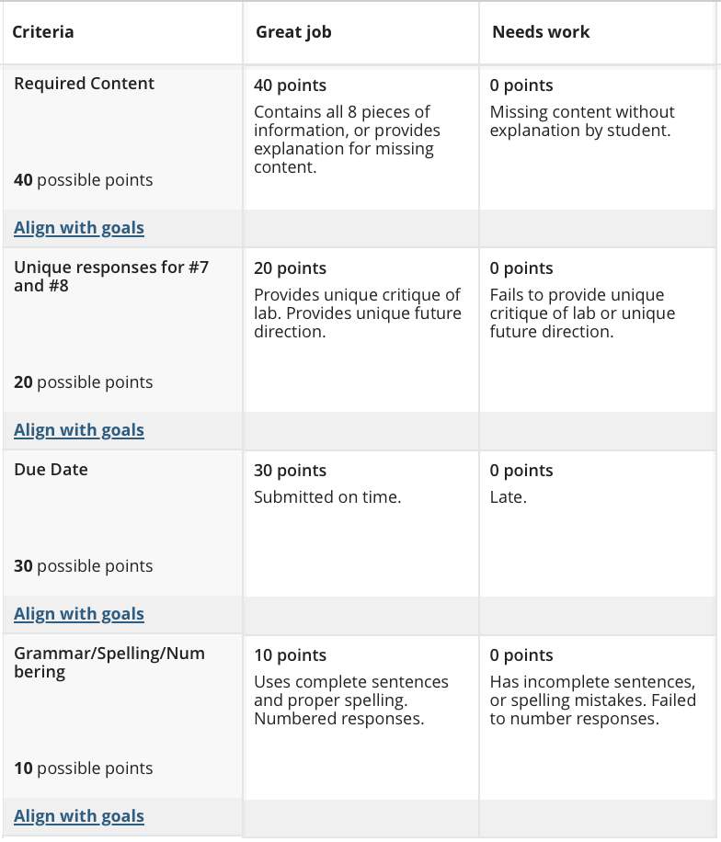
Lab Report Format:

- State the name of the lab and the date of your participation

- Find, copy, and paste your summary data.
  - CogLab automatically provides your summary data upon completion of the experiment.
  - Project implicit typically provides a statement (“your data suggest…”).

- Identify and explain how the independent and/or predictor variable(s) was/were measured. Hint: Independent and predictor variables are found on the X-axis (horizontal line) of a graph.

- Identify and explain how the dependent variable(s) was/were measured. Hint: Dependent variables are found on the y-axis (vertical line) of a graph.

- State the experimental hypothesis.

- Determine if your data are consistent with the predicted outcomes.

- Critique the experiment. Offer potential, alternative explanations for the phenomenon observed that the researchers may have failed to consider. Consider the role of methodological limitations, variables not taken into consideration, or other weaknesses of the experiment. Be careful not to suggest the same “critique” for every lab.

- Suggest future directions, such as how the experiment might be modified to improve the investigation. Future directions arise out of the research limitations identified for a specific lab and may include building on a finding; addressing a conceptual flaw in the design; or examining the theory in a new context, location, or culture. Be careful not to suggest the same “future direction” for every lab.

Sample Lab Report:

1. The experiment was named Risky Decisions and was completed on 12/02/2021

2. My summary data for the lab follow.

Data Summary for PsyLangW21-36

Less Risky
The proportion of Gamble Trials
Small Gain Large Gain Small Loss Large Loss
0.750 0.750 0.750 1.000

More Risky
Small Gain Large Gain Small Loss Large Loss
0.500 1.000 0.500 1.000

(Insert Graph Here)

- The experiment had three independent variables. The first independent variable was if one’s chances of winning were less risky or riskier (based on the odds of winning). The second independent variable was if the trial outcome would result in a gain or loss of money. The third independent variable was the size of the potential winnings, a small gain versus a large gain in terms of the dollar amount on each trial.

- The experiment had one dependent variable, which was the proportion of gambling trials that one engaged in for each experimental condition.

- The experimental hypothesis predicted more risk-taking (e.g., higher rates of gambling) when 1) there was less to lose, or 2) when there were large gains. By contrast, participants were expected to be less likely to engage in risk-taking when there was substantially more to lose.

- Some of my data was consistent with the experimental hypothesis. For example, I was more likely to gamble in riskier conditions when there was the prospect of a large loss. I was also more likely to gamble when conditions were less risky. However, my data was inconsistent with the experimental hypothesis when it came to large gains. According to the hypothesis, I should be more risk-averse (reluctant to gamble). Yet, I engaged in a proportion of gambling in the risky condition when there was the possibility of a large gain.

- The experiment had weaknesses. I feel if there was an actual incentive, or competition to end up with the most money, the results may be more accurate. Personally, I made some decisions I normally wouldn’t just to see what would happen. Because this is all hypothetical with no real reward or incentive, I believe that people may make decisions they normally wouldn’t.

- A future direction for this experiment would be to add a group (e.g., class) competition to it. At the completion of the experiment, participants/classmates could compare how much money they won in the experiment. This competition among classmates would be a great incentive to make more realistic, careful decisions in the experiment, rather than simply playing around with fake money.

Instructions for getting started with CogLab 5:
- Open your web browser (Google Chrome recommended) and go to https://coglab.cengage.com/help/register.shtml
- Towards the bottom of the page is a form that asks for three pieces of information. If you do not see the form, your Web browser probably has JavaScript disabled. Please enable JavaScript and reload the page to continue.
- Enter the requested information:
  - In the Group Name text field, enter the Group ID PsyLangSpring23
  - In the Group Password text field, enter noamchomsky
  - could be in one of several formats. It may be on a sticker on the inside front cover of your CogLab Student Manual. It may have been bundled with your textbook on a postcard. Or, you may have purchased a registration code electronically (sometimes this is also called an e-Pin). There are two types of codes:
    - A CogLab2 code: This is made up of 11 letters and numbers, and will look something like this: yij2d9v6fu0
    - A CogLab5 code: This is made up of 16 letters and numbers, and will look something like this: sjkq8b632dvhd4u0
Both are valid on this website. However, do not purchase used CogLab registration codes! If the registration code has already been used, it will not work for you. Each valid registration code can be used only once.
- After filling in all the text fields, click or tap on the Start Registration button.
- Your Web browser will connect with the CogLab server to verify your information. If the information is correct, a new window will appear. The first line, highlighted in yellow, is your User ID. You should write this down because you will need to access CogLab.
- The second line is your registration code.
- The next two lines ask for your first name and your last (family) name.
- Next, enter a password. You'll use this when you log in. The password must be at least 8 characters long. It is best not to enter a password you use on other websites. The next line asks you to re-enter the password.
- The next two lines ask for your email address and then confirmation of this address. This email address will be used if you forget your password.
- Next, enter a security question and answer. Make sure to use a question that only you can answer correctly. Also, remember whether you use uppercase or lowercase letters in your answer: you'll need to enter your answer exactly the same if you forget your password.
- If necessary, select your keyboard layout (for keyboard help, see https://coglab.cengage.com/info/keyboards.shtml).
- Finally, decide if you want CogLab to remember you so that you don't need to log in each time. If not, uncheck the box next to Remember Me.
- After filling in all the text fields, click or tap on the Complete Registration button.
- Your CogLab account is now ready to go! See the weekly schedule below (or Bb calendar) for assigned labs and their due dates.

Instructions for getting started with Project Implicit for Lab #16:

- Open your web browser (Google Chrome recommended) and go to https://implicit.harvard.edu/implicit/
- You have the option of registering “to gain access to dozens of studies and tests on a wide variety of topics” or participating as a guest in a “limited array of demonstration studies”. Choose between: implicit social attitudes or health attitudes. Then, select the menu option: “take a test”.
- Upon completion, your summary data (#2 on the lab report) is typically a statement provided upon completion of an experiment (e.g., your data suggest….).

Schedule:

Exam 1 Preparation: Monday, May 8 – Thursday, May 18

- Exam 1 opens on Friday, May 19

Topics:
- The nature of language and metacognition.
- Is language innate?
- Smart, albeit alingual animals and insects.
- No formal instruction is necessary for early language acquisition.
- My teacher ‘holded’ the rabbits.

Lab Assignments for Exam 1 are due by midnight on Thursday, May 18.
Lab #1: Memory Judgment
Lab #2: Statistical Learning
Lab #3: Monty Hall
Lab #4: Categorical Perception – Identification (Requires headphones/earbuds)
Lab #5: Categorical Perception – Discrimination (Requires headphones/earbuds)

Required readings:

Harley, Chapter 1, Language, pp. 1-26 in 2017 (pp. 1-29 in 2010)

Putnam, A. L., Sungkhasettee, V. W., & Roediger, H. L. (2016). Optimizing learning in college: Tips from cognitive psychology. Perspectives on Psychological Science, 11(5), 652–660.

Fenn, K. M., Nusbaum, H. C., & Margoliash, D. (2003). Consolidation during sleep of perceptual learning of spoken language. Nature, 425, 614-616.

Aslin, R. N., & Newport, E. L. (2012). Statistical learning: From acquiring specific items to forming general rules. Current Directions in Psychological Science, 21(3), 170-176.

Goldin-Meadow, S. & Mylander, C. (1998). Spontaneous sign systems created by deaf children in two cultures. Nature, 391, 279-281.

Petitto, L. A., Holowka, S., Sergio, L. E., & Ostry, D. (2001). Language rhythms in baby hand movements. Nature, 413(6851), 35-36.

Senghas, A., Kita, S., Ozyurek, A. (2004). Children creating core properties of language: Evidence from an emerging sign language in Nicaragua. Science, 305, 1779-1782.

Harley, Chapter 2, Animals, pp. 26-42 in 2017 (pp. 31-48 in 2010)

Herbranson, W. T. (2012). Pigeons, humans, and the Monty Hall dilemma. Current Directions in Psychological Science, 21(5), 297-301.

Ladewig, J. (2007). Clever Hans is still whinnying with us. Behavioural Processes, 76(1), 20-21.

Pepperberg, I. M. (2002). Cognitive and communicative abilities of grey parrots. Current Directions in Psychological Science, 11(3), 83-87.

Ramus, F., Hauser, M. D., Miller, C., Morris, D., Mehler, J. (2000). Language discrimination by human newborns and by cotton-top Tamarin Monkeys. Science, 288, 349-351.

Riley, J. R., Greggers, U., Smith, A. D., Reynolds, D. R., & Menzel, R. (2005). The flight paths of honeybees recruited by the waggle dance. Nature, 435(7039), 205-207.

Wynne, C. D. L. (2007). What the ape said. Ethology, 113(4), 411-413.

Harley, Chapter 3, Children, pp. 42-67 in 2017 (pp. 49-76 in 2010), up to “Is there a critical period for language acquisition”.

Kuhl, P. K. (2004). Early language acquisition: Cracking the speech code. Nature Neuroscience, 5, pp. 831-833 only.

Exam 2 Preparation: Monday, May 22 – Monday, June 5

- Exam 2 opens on Tuesday, June 6

Topics:
- Role of working memory in language.
- The ‘bottleneck’ of information processing.
- The science of reading.
- The myths and mysteries of dyslexia.
- Psychological science informs the teaching of reading.

Lab Assignments are due by midnight on Monday, June 5
Lab #6: Memory Span
Lab #7: Word Length Effect
Lab #8: Phonological Similarity Effect
Lab #9: Modality Effect
Lab #10: Mental Rotation
Lab #11: Stroop
Lab #12: Word Superiority Effect

Required readings:

Kuhl, P. K. (2004). Early language acquisition: Cracking the speech code. Nature Neuroscience, 5, pp. 834-843 only.

Jusczyk, P. W. (1997). Finding and remembering words: Some beginnings by English-learning infants. Current Directions in Psychological Science, 6(6), 170-174.

Baddeley, A. (2003). Working memory and language: An overview. Journal of Communication Disorders, 36(3), 189-208.

Boutla, M., Supalla, T., Newport, E. L., & Bavelier, D. (2004). Short-term memory span: Insights from sign language. Nature Neuroscience, 7(9), 997-1002.

Harley, Chapter 6, Words, pp. 129-164 (pp. 145-185 in 2010)

Treiman, R. (2000). The foundations of literacy. Current Directions in Psychological Science, 9(3), 89-92.

Anthony, J. L., & Francis, D. J. (2005). Development of phonological awareness. Current Directions in Psychological Science, 14(5), 255-259.

Grainger, J., Bouttevin, S., Truc, C., Bastien, M., & Ziegler, J. (2003). Word superiority, pseudoword superiority, and learning to read: A comparison of dyslexic and normal readers. Brain and Language, 87, 432-440.

Exam 3 Preparation: Wednesday, June 7 - Monday, June 19

- Exam 3 will be available on June 20-21

Topics:
- Meaning in network theories: Connotation, denotation, and false memory.
- Language’s influence on the brain.
- Asymmetry, plasticity, and critical periods in language acquisition.
- Assorted language facts and fallacies for language lovers.

Lab assignments are due by midnight on Monday, June 19
Lab #13: Lexical Decision
Lab #14: False Memory
Lab #15: Implicit Association Test (IAT) of your choice at Project Implicit: https://implicit.harvard.edu/implicit/
Lab #16: Operation Span
Lab #17: Change Detection
Lab #18: Brain Asymmetry

Required readings:

Harley, Chapter 5, Meaning, pp. 103-129 (pp. 117-143 in 2010)

Landauer, T. K. (1998). Learning and representing verbal meaning: The Latent Semantic Analysis Theory. Current Directions in Psychological Science, 7(5), 161-164.

Harley, Chapter 7, Understanding, pp. 164-193 (pp. 187-220 in 2010)

Harley, Chapter 4, Thought, pp. 79-103 (pp. 89-116 in 2010)

Davidoff, J, Davies, I, Roberson, D. (1999). Color categories in a stone-age tribe. Nature, 398, 203-204.

Harley, Chapter 8, Speaking, pp. 191-221 (pp. 221-253 in 2010)

Strayer, D. L., & Drews, F. A. (2007). Cell-phone-induced driver distraction. Current Directions in Psychological Science, 16(3), 128-131.

Harley, Chapter 3, Children, pp. 67-78, begin at “Is there a critical period for language acquisition” pp. 77-87 in 2010)

Mayberry, R. I, Lock, E., & Kazmi, H. (2002). Linguistic ability and early language exposure. Nature, 417, 38.

Newman, A. J., Bavelier, D., Corina, D., Jezzard, P., & Neville, H. J. (2001). A critical period for right hemisphere recruitment in American Sign Language processing. Nature Neuroscience, 5(1), 76-80.

Wagner, L. (2001). Acquiring languages—two for the price of one? TRENDS in Cognitive Sciences, 5(12), 509.

Marcus, G. F., Vouloumanos, A., & Sag, I. A. (2003). Does Broca's play by the rules? Nature Neuroscience, 6(7), 651-2.

Halpern, D.F. (2004). A cognitive-process taxonomy for sex differences in cognitive abilities. Current Directions in Psychological Science, 13, 135–139.

“Talk is cheap, but understanding how and why is priceless.”

Brian Bartek, Psychology Major, Honors College, Grand Valley State University, ‘04

