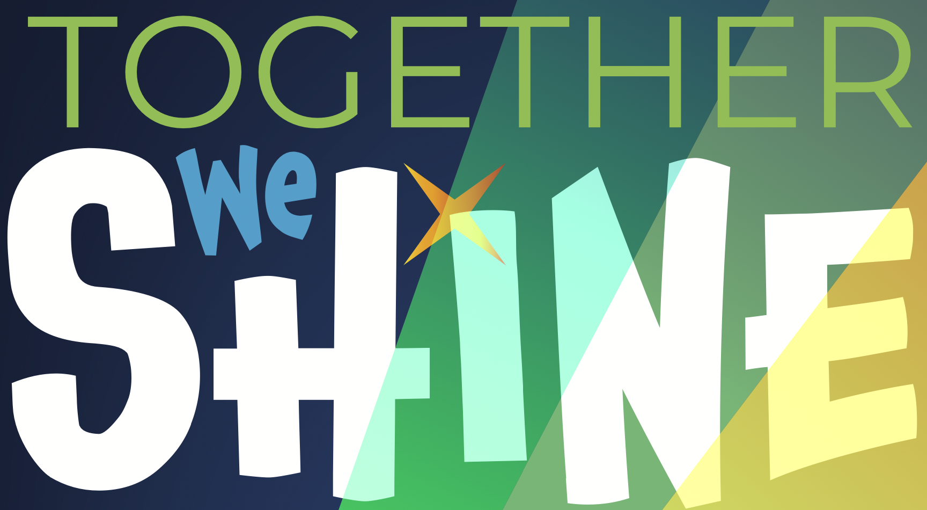

School-Based Intervention and Consultation

Table of Contents
Course Description………………………2
Grading………………………………………3
Assignments……………………………….4
Policies……………………………………….6
Schedule…………………………………….11
Course Description:

An overview of the theories and processes of psychological and educational consultation at the individual and group level. Students will learn and apply consultation skills within a problem-solving model of service delivery. Students will learn to attend to cultural factors, values, and community context during consultation.

NASP Domain 2: Consultation and Collaboration
School psychologists understand varied models and strategies of consultation and collaboration applicable to individuals, families, groups, and systems, as well as methods to promote effective implementation of services. As part of a systematic and comprehensive process of effective decision making and problem solving that permeates all aspects of service delivery, school psychologists demonstrate skills to consult, collaborate, and communicate effectively with others.

Course Information:
CRN: 22540
Location: Au Sable 1117
Tuesdays 8:30 am-11:15 am

Instructor Information:
Jen James, Ph.D., NCSP
Pronouns: she/her/hers
Office: 2140 ASH
Email: jamesje1@gvsu.edu
Phone: 616-331-2406
Office Hours: T 11:30am to 1 pm or by appointment through email.

Dr. Jen James Blackboard Activity Folder Textbook
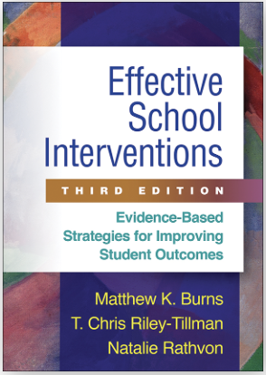

Pre-requisites:
Course Information
Admission to the school psychology program or instructor permission.

Course Objectives
Upon successful completion of this course students will be able to:
- Compare and contrast the various consultation theories and models.
- Identify individual and systems-level barriers to consultation and implement procedures that can be used to reduce such barriers.
- Conduct assessments of systems and individuals (behavioral, academic, social-emotional) that lead to intervention development within a problem-solving model of service delivery.
- Implement individual and systems-level interventions to address academic, social, emotional, and behavioral concerns.
- Collect data to evaluate effects of interventions and use progress monitoring data to provide feedback to intervention implementers.
- Collect data to evaluate fidelity of implementation and implement strategies to increase intervention adherence.
- Implement a collaborative consultative process with parents, individual educators, and educational teams in working together to develop effective interventions.
- Apply knowledge of ethnicity and culture as significant parameters in understanding the school consultation process.
- Evaluate the consultant’s own background, experiences, attitudes, values, and biases as possible influences in the school consultation process.
- Contrast the ways in which the backgrounds of the consultee and community influence problem-solving.
- Demonstrate knowledge and adhere to the ethical and legal standards that apply to school-based consultation

Required Textbook:
Burns, M., Riley-Tillman, C., & Rathvon, N. (2017). Effective School Interventions – Third Edition. Guilford Press: New York, NY. (Available online at GVSU)

Lane, K., et al. (2015). Supporting Behavior for School Success: A Step-by-Step Guide to Key Strategies. Guilford Press: New York, NY. (Available online at GVSU)

Newman, D.S, & Rosenfield, S.A. (2018). Building Competence in School Consultation: A Developmental Approach. Routledge: London.

Optional:
Codding, R.S., Volpe, R.J, & Ponce, B.C. (2017). Effective Math Interventions: A Guide to Improving Whole-Number Knowledge. Guilford Press: New York, NY.

Hosp, J.L., Hosp, M.K., Howell, K.W., Allison, R. (2014). The ABCs of Curriculum-Based Evaluation: A Practical Guide to Effective Decision Making. Guilford: New York. (Available online through GVSU)

Kilpatrick, D.A. (2015). Essentials of Assessing, Preventing, and Overcoming Reading Difficulties. Wiley: New Jersey.

Grading:
93% and above A
90% - 92% A-
87% - 89% B+
83% - 86% B
80% - 82% B-
77% - 79% C+
73% - 76% C
70% - 72% C-
67% - 69% D+
60% - 67% D
60% and below F
Note: You must earn a B or better in the course to remain in good standing in the School Psychology program. According to Graduate School Policy, a grade of C- or lower is considered not passing and the course must be retaken and passed to earn your degree.

Class Engagement:
Discussion and peer feedback are an integral part of this course. Seminar courses should encourage candidates to actively engage in an exploration of issues in a particular area and the exchange of ideas and information. While random discourse and discussion can be interesting, the goal of this course is to begin the process of critically examining the nature of schools and the provision of psychological services to children, families, and school personnel.

Our weekly meetings will be devoted to discussing issues, concerns and ideas raised by the assigned readings. You are expected to come to class weekly, arrive on time and be prepared to actively participate in all discussions. Various viewpoints, experiences and questions are encouraged and will be respected by all class members. Disagreement, while welcome, should be framed within the context of respectful dialogue, a positive exchange of ideas and constructive and supportive feedback will enhance skills develop among each class member.

I urge all students to be self-reflective about behaviors or comments that have been identified as racist, homophobic, transphobic, ableist, etc. This self-reflection applies to be as well. We are all in the process of learning and unlearning these logics that dominate our society. There is no expectation here that anyone is perfect- all I ask is that you are mindful of how what you think, say, and/or the way in which you interact with others is circumscribed by these forces.

Academic Consultation Case: 25 pts
Assignments
Due April 25
For most of you, this will be a continuation of the case study you completed for PSY 622. You will be utilizing the CBE data collected on your case study student to consult and collaborate with the student’s teacher to develop an intervention plan and implement the intervention. You will also be collecting progress monitoring data and measuring fidelity of implementation. Please see the detailed assignment description on Blackboard for more information.

Classroom Check Up (CCU) Observations and Intervention Plan (15 points)
Due March 28
You will be learning elements of the Classroom Check Up in class, including opportunities to respond (OTRs) and Behavior Specific Praise (BSP). You will need to use the CCU observation forms in Blackboard to complete observations of your classroom and gather data regarding information such as the number and types of OTRs, Behavior Specific versus General Praise, and a Classroom Management Checklist. You will need to submit:

- Completed Observation Forms (5 points)
- Written Summary (1-2 pages) of what you observed (5 points)
- Intervention Plan based on observed needs (10 points)

A more detailed assignment description will be posted on Blackboard.

Practice Consultation Video Feedback (10 points)
Due March 28
Once you have completed an intervention plan based on your Classroom Check Up observations, you will work with a partner from class to videotape a practice consultation session with your teacher. During this session, you will be providing the “teacher” with the data you collected through the CCU observations, gathering their input, and presenting intervention ideas based on the data. You and the “teacher” will then determine together which intervention they will implement and come up with a plan for starting and monitoring progress. More information will be provided on Blackboard.

Teacher Consultation Feedback Video (15 points)
Due April 11
Utilizing your academic consultation progress monitoring results, hold a feedback session with the student’s teacher. You will need to record this interview (video) to analyze and reflect on it. With your teacher, you will review the assessment results, summarize the intervention and progress monitoring data. Consult WITH your teacher to determine how the student is progressing and whether to continue the intervention as is or with modifications, end the intervention, or start a new intervention. I will not be scoring your video itself, but how well you reflected on the session. You will need to share the video with me along with your paper. You will write a paper including:

- Completion of the self-reflection rating form (in assignment description)
- A reflection of your feedback meeting and how you could improve in the future.

Case Study Presentation (10 points)
Presentation date TBA
At the end of the semester, you will present your full case study to a small group of your classmates. More detailed information about the case study presentation can be found on Blackboard.

Additional Application Assignments (Points range)
You will have the opportunity to earn points during class time completing application activities based on the class content. These will typically be individual or small group assignments and will either be shared during class or on Blackboard under weekly content.

Attendance: Attendance is required at all class sessions, unless excused by the instructor. I have great respect for students who are balancing their pursuit of education with the responsibilities of caring for children or other family members. If you run into challenges that require you to miss class or are interfering with your ability to engage in class, please contact me. There may be instances we can offer flexibility to support your learning.
Course Policies

Assignments: All assignments are due at the beginning of class on the date listed in the syllabus. Please submit an electronic copy on Blackboard and turn in a hard copy to me in class. I understand that life gets busy, sickness happens, and extensions may be needed. Late assignments will receive a 15% reduction and will be accepted up to 3 days late unless approved by the instructor prior to the due date.

Posting Presentation: Presentation slides will be posted on Blackboard before class starts when applicable. Please be aware that this may not occur until the morning before class starts. I will make every effort to post notes the evening before class, but it is likely that they will not become available until the morning before class. Also, the lecture notes do not contain all the relevant information – please take additional notes.

Canceled Classes: If I must cancel a class, I will notify you ASAP via email. If classes are canceled at the university, this class will not meet. Please check your university email regularly, as I may have directions for an alternative activity.

Accommodations for Students with Disabilities: If there is any student in this class who has special needs because of a learning, physical, or other disability, please contact me or Disability Support Services (DSS) at 331-2490. Although students with disabilities are held to the same academic standards as all other students, accommodations will be provided for you, as appropriate. Where warranted, accommodations will also be provided to students without a diagnosed disability if that student discusses the specific need with me and the accommodation appears to be justified. Furthermore, if you have a disability and think you will need assistance evacuating this classroom and/or building in an emergency, please make me aware so I can develop a plan to assist you.
Academic Integrity: Students are expected to adhere to the university’s policies on Academic Honesty. These policies are described in the catalog and in the Student Code. Cheating and plagiarism will be dealt with as per the procedures described in the Student Code.

Plagiarism: As described in Section 223.01 of the Student Code, “any ideas or material taken from another source for either written or oral presentation must be fully acknowledged. Offering the work of someone else as one's own is plagiarism. The language or ideas taken from another may range from isolated formulas, sentences, or paragraphs to entire articles copied from books, periodicals, speeches, or the writings of other students … Any student who fails to give credit in written or oral work for the ideas or materials that have been taken from another is guilty of plagiarism.” In sum, copying the work of any other individual, whether that of another student, researcher, author, or editor is considered plagiarism. This is not acceptable and will be dealt with according to the policies set forth in the

Student Code, which may include receiving a 0 on the assignment, failing the course, and/or other university
consequences. If you have questions regarding the appropriate use of citations and plagiarism, please contact the instructor BEFORE turning the assignment in. Please note that taking extensive content word-for-word from a journal, book or website is considered plagiarism.

University Policies

Please follow this link to the University’s policies: www.gvsu.edu/coursepolicies.

Instructional Policies: https://www.gvsu.edu/policies/policy.htm?policyId=AD248F32-B518-70C6-98F1C451D2CBF2E1&search=SG+3.04

Religious Inclusion Policy: https://www.gvsu.edu/policies/policy.htm?policyId=129535EB-9F42-2683-61E9033594C870D2&search=PC+9.6

Title IX, Sexual Misconduct Policy, and Gender- and Sexual-Based Harassment Policy: Title IX makes it clear that violence and harassment based on sex and gender are Civil Rights offenses subject to the same kinds of accountability and the same kinds of support applied to offenss against other protected categories such as race, national origin, etc. Title IX’s sex discrimination prohibition also protects students from discrimination based on gender identity or failure to conform to stereotypical notions of masculinity or femininity. If you or someone you know has been harassed, assaulted, or denied services on the basis of sex or gender, you can find the appropriate resources at www.gvsu.edu/titleix or contact the University’s Interim Director and Title IX Coordinator, Ann James at (616) 331-9530 or v_jameann@gvsu.edu.

Disabilities Support Resources: If you have special needs because of a learning, physical or other disability, please contact the instructor as well as Disability Support Resources (DSR) at (616) 331-2490 for assistance as soon as possible. Even if you have already documented your disability with DSR, please make an appointment with your faculty member to discuss your specific needs. Furthermore, if you have a disability and think you will need assistance evacuating the classroom and/or building in an emergency during in-person meetings, please make your instructor aware so that the university can develop a plan to assist you. You may also access resources at https://www.gvsu.edu/dsr. The university is eager to work with you to meet your learning goals. All discussions related to disabilities will remain confidential.

Gender Expression and Identity: At Grand Valley State University we recognize that an individual may wish to be identified by a professional, personal, preferred, display or use name without making an official legal name change. Students, faculty, and staff may use the myName process to update Banner and some related systems with such a name. The myName process will allow students, faculty, and staff to have the chosen name appear anywhere a legal name is not required.

Bias Incidents or Harassment: Anytime you or anyone in the GVSU community feels belittled, disrespected, threatened, or unsafe because of who you are, the entire university community is diminished. That's why it’s important to report all bias incidents--even those intended as jokes. While Grand Valley safeguards individuals’ constitutional rights and protected speech, the university is also committed to inclusion and equity. Grand Valley exercises the right to engage in educational dialogue and seeks constructive responses to address bias incidents. Go to https://gvsu-advocate.symplicity.com/public_report/index.php to report bias incidents or for more information. In addition, for faculty/staff related complaints, you can file an informal complaint with the Division of Inclusion and Equity at inclusion@gvsu.edu or (616) 331-3296. For student related complaints, you can also contact the Dean of Students office at (616) 331-3585.

Student Well-Being: As a student, you may experience a range of issues that can negatively impact your learning, such as anxiety, depression, interpersonal or sexual violence, difficulty eating or sleeping, loss/grief, and/or alcohol/drug problems. These mental health concerns or stressful events may lead to diminished academic performance and affect your ability to participate in day-to-day activities. In order to support you during such challenging times, GVSU provides a number of confidential resources to all enrolled students, including the University Counseling Center (https://www.gvsu.edu/counsel/ or (616) 331-3266) and the Student Ombuds, Takeelia Garrett (garrettt@gvsu.edu).

Readings are due the date of the lecture topic. It is possible that this schedule will change, as some weeks we will move more rapidly, and some more slowly. However, general deadlines will remain the same unless otherwise indicated by the professor.
Course Schedule
Week | Topic | Readings | Task/Submit
 |  |  | Note: This column is for formal assignments that you will submit by the day/date listed. Assignments will be due by the “End of the day”, meaning 11:59pm EST. Unless otherwise stated, go to “Assignments” in Blackboard to find assignment details and how to submit.
Week 1: 1/10 | Overview of Course  Selecting Evidence-Based Interventions in Reading and Math | Review Syllabus  Evidence Based Interventions Manual on Blackboard  (Read pages 1-10 before class and preview the manual. We will use this as a resource in class)  Burns Chapter 1  Best Practices Systems 3 | Match baseline data to intervention for case study student.  Collect baseline data if you have not yet.
Week 2: 1/17 | Goal Setting and Individual Student Progress Monitoring: Is the intervention working?  Problem Solving Process | Burns et al Ch 2, 3  Best Practices DB 4  Best Practices Student Level 4
Week 3: 1/24  START Virtual Training on 1/25 (Wednesday) | FAPE in the LRE on January 25 from 8:30 am – 11:00 am
Week 4  Week 4: 1/31 | Consulting using the Science of Reading  Guest Speaker: Jason Glerum | Reading Development and Difficulties: Bridging the Gap Between Research and Practice Chapter 3, 4, and 8 (on Blackboard)
Week 5: 2/7  Asynchronous Activities  (NASP Week) | On your own: Intensifying interventions Webinar & Activities  Attend Speaker Series at 6 pm on 2/7  Jordyn Zimmerman: https://thisisnotaboutme.film | Burns, M (2021) Intensifying reading interventions through a skill by treatment interaction: What to do when nothing else works. NASP Communique, 50(4).  Best Practices Foundations 26
Week 6: 2/14 | Consultation in the Schools: The Basics  Practicing your consultation skills | Newman Ch 1-4 | Intensifying Interventions Activities Due 2/14
Week 7: 2/21 | Classroom Consultation/  Classroom Check-Up | Lane et al chapter 1 (the rest of the book will be used as a resource)  Reinke, Lewis-Palmer & Merrel, 2008 (on Bb)  BP Student Level Chapters 2 & 3
Week 8: 2/28 | Consulting Math Difficulties | Burns et al ch 4: Math intervention  BP Data Based Ch 14 & 15  VanderHeyden, A., et al (2021). The science of math and class-wide math interventions. NASP Communique, 50(4).
March 7 | SPRING BREAK! | NO! | CLASS!
Week 9: 3/14 | Motivational Interviewing | Herman et al, 2014  Ch. 1-3 (online)
Week 10: 3/21 | Motivational Interviewing part 2 | Herman e al, 2014  Ch. 4-6 (online)
Week 11: 3/28 | The Consultative Problem-Solving Process | Newman, Ch. 5-8 | CCU Classroom Observations AND Practice Video Consultation Due 3/28
Week 12: 4/4 | Watch online webinars on Reading and Math Consultation Case studies  Online Activities |  | Complete application activity
Week 13: 4/11 | Case Study Presentations Round 1 |  | Video Feedback Consultation with Teacher Due
Week 13: 4/18 | Case Study Presentations Round 2
Week 15: 4/25  Finals Week |  |  | Academic Case Study Report due April 25

