Workday Job Aid:
‘Personal Information Change’
Tip: This job aid can be used to change the following Personal Information fields:
- Legal Sex
- Marital Status
- Race/Ethnicity
- Citizenship Status
- Sexual Orientation
- Gender Identity
- Pronoun
- Disability (self-reported status)
Of this list, only Pronouns will be publicly viewable on your personal profile in Workday. All other personal information fields are kept confidential and are used for internal reporting purposes only.
The example below demonstrates how to add your pronouns to your profile.
1. Navigate to the GVSU Workday homepage.
2. Click the profile (person) icon in the top right of your screen.
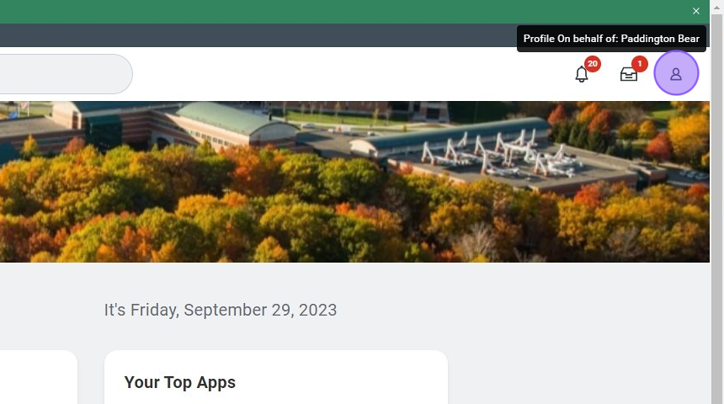
3. Click "View Profile".
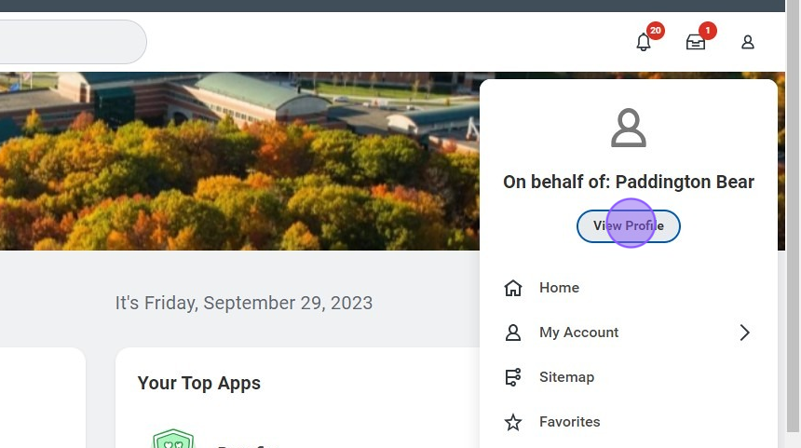
4. From the left side menu, click "More".
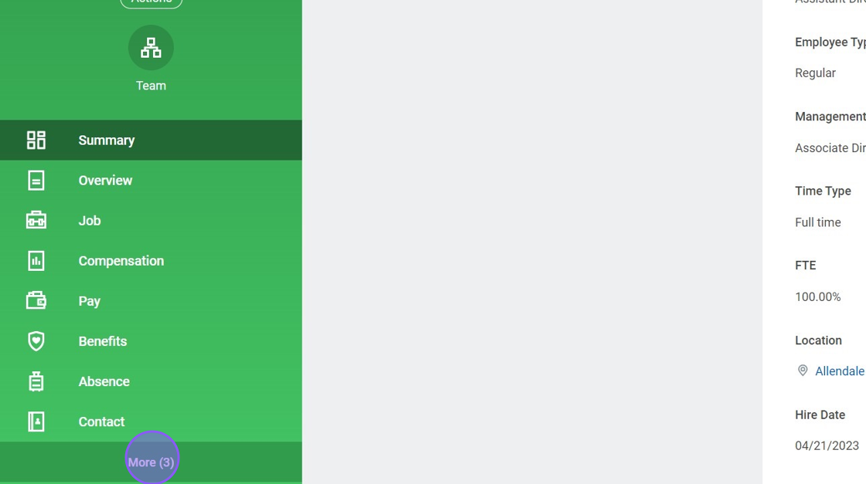

5. Click "Personal".
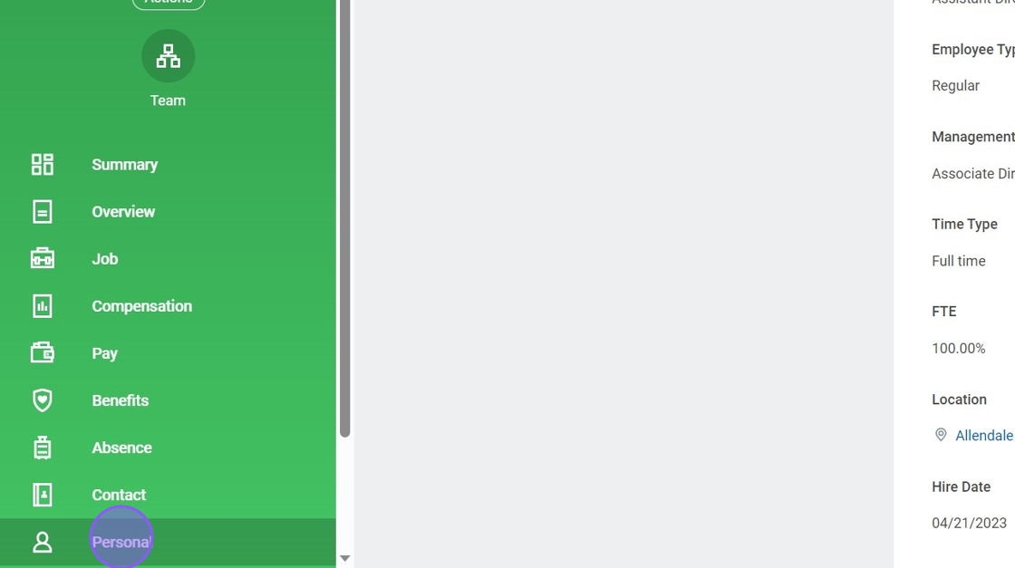
6. Click "Edit".
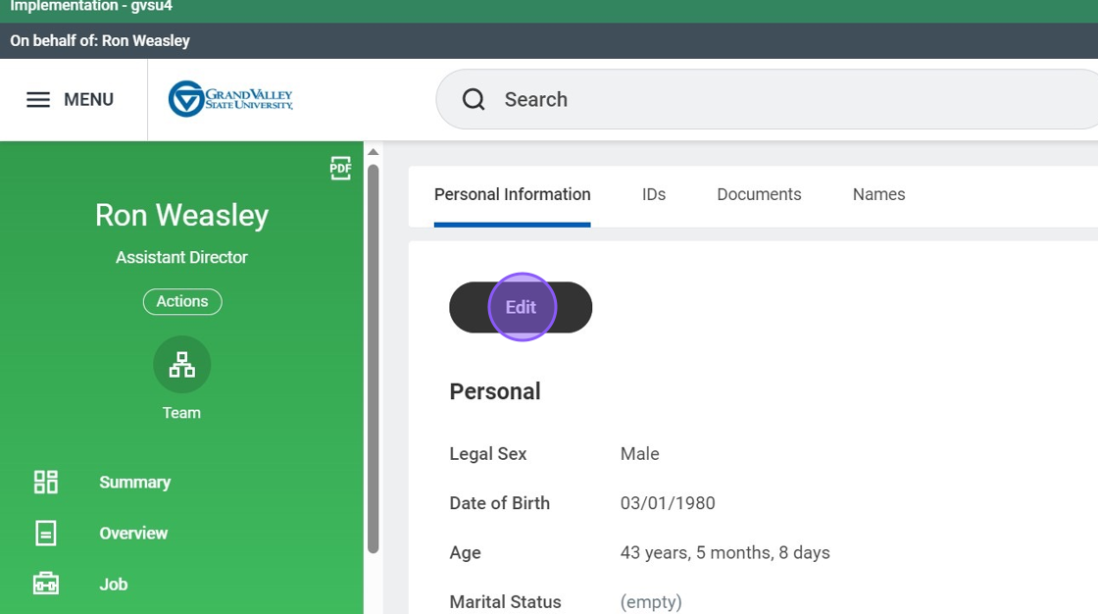

7. Click the pencil icon to edit.
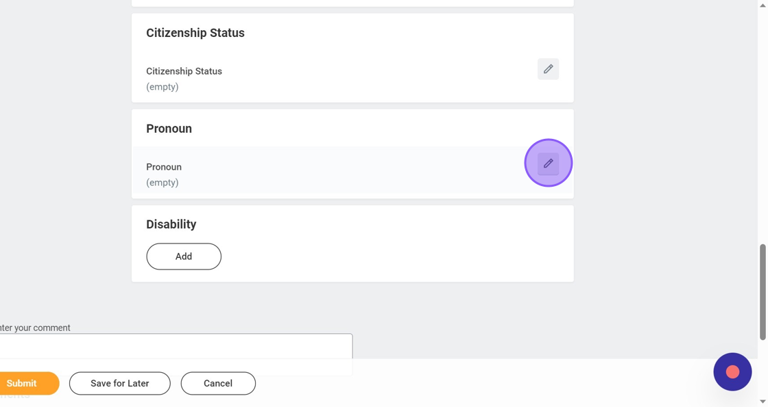
8. Select the "Pronoun" field.
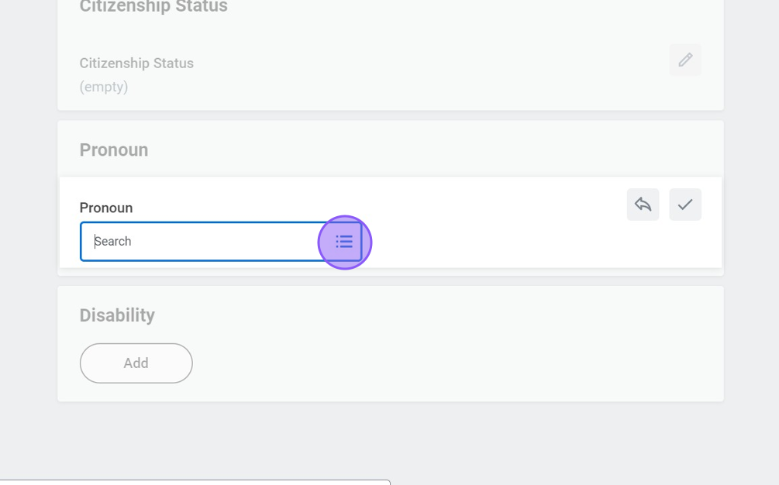

9. Select which option fits best for you.
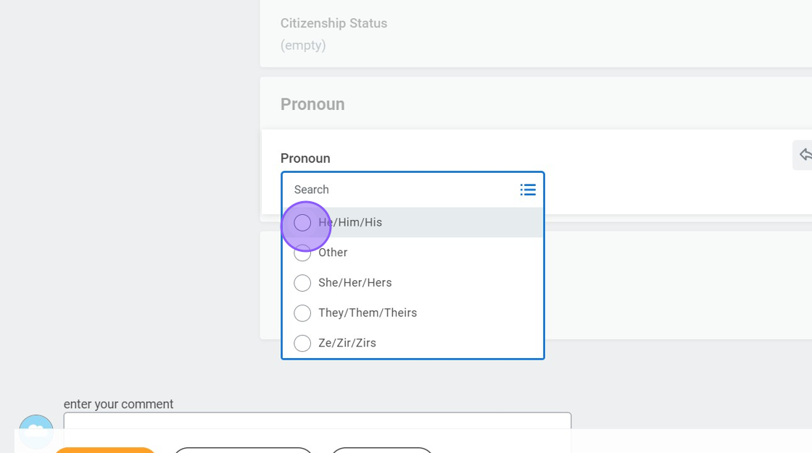
10. Click "Submit".
