Course Information

Class Name: ________________________________________________________
Time: ______________________ Day(s) (circle): M T W TH F
Class Structure (circle):
Traditional (in-person) Hybrid Online (synchronous) Online (asynchronous)
Technology (circle):
Blackboard Zoom Other: ______________________
Textbooks, Course Materials & Supplies (if required): _________________________________
_____________________________________________________________________________
Instructor

Professor: ______________________ Teaching Assistant: ______________________
Office Hours (circle): In-Person Virtual
Days/Times: _________________________ By Appointment Only □
Communication (circle): Email Phone Blackboard Discord Other
Contact Information: ___________________________________________________________
_____________________________________________________________________________
Looking Ahead

My files and assignments will be saved here: ______________________________________
I can track my progress in this course here: ________________________________________
Are there tutors available? Yes / No Info: ________________________________________
Who is one person in this course you could ask informal questions, if needed?
Name: ____________________________ Contact Info: ____________________________

SMART GOAL SETTING WORKSHEET
SMART GOAL CHECKLIST
Is my goal…?
- SPECIFIC
- MEASURABLE
- ACTIVE
- REALISTIC
- TIME-BOUND
GOAL #1 WITH A DEADLINE:
POSSIBLE OBSTACLES IN ACHIEVING YOUR GOAL:
1.
2.
3.
SMART GOAL CHECKLIST
Is my goal…?
- SPECIFIC
- MEASURABLE
- ACTIVE
- REALISTIC
- TIME-BOUND
POSSIBLE OBSTACLES IN ACHIEVING YOUR GOAL:
1.
2.
3.
ACTION STEPS:
1.
2.
3.
4.
GOAL #2 WITH A DEADLINE:
ACTION STEPS:
1.
2.
3.
4.

Time Management Weekly Schedule

TIME MANAGEMENT WEEKLY SCHEDULE
Hours | Monday | Tuesday | Wednesday | Thursday | Friday | Saturday | Sunday
5-6 am

6-7 am

7-8 am

8-9am

9-10am

10-11am

11am-12pm

12-1pm

1-2pm

2-3pm

3-4pm

4-5pm

5-6pm

6-7pm

7-8pm

8-9pm

9-10pm

10-11pm

11pm-12am

12-1am

1-2am

2-3am

3-4am

4-5am

TIME MANAGEMENT WEEKLY SCHEDULE DIRECTIONS

Follow these steps to organize your week hour-by-hour:
- Fill in your class schedule
- Fill in both meal and sleep schedules
- Fill in extracurriculars and/or any other weekly activities (e.g. getting coffee with roommates)
- Schedule in study/homework time for each course (2-3 hours per credit hour is recommended)
- Place the schedule in an area that will be visible to you daily
- Adjust as needed

Pro Tip: New habits don’t develop overnight. Try to follow the schedule a little bit more each week and you’ll be a time management expert in no time!

The POWER Study Hour

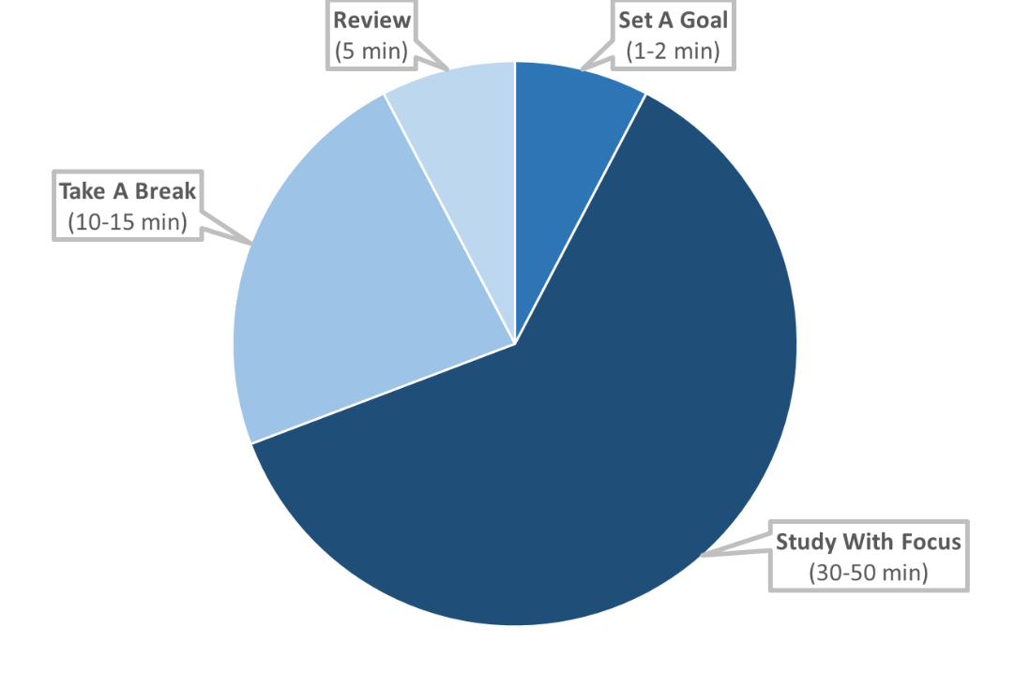

1. SET A GOAL ( 1-2 minutes )
Decide what you want to accomplish during your study session.
2. STUDY WITH FOCUS ( 30-50 minutes )
Set a timer for 30-50 minutes. Work on your goal without distractions for the set time.
3. TAKE A BREAK/REWARD YOURSELF ( 10-15 minutes )
Reward yourself for your hard work with a timed break. Set a timer for 10-15 minutes and enjoy yourself by taking a walk, having a snack, playing a short game, chatting with a friend, etc.
4. REVIEW MATERIAL ( 5 minutes )
Review what you previously studied.

SCHEDULE AN APPOINTMENT WITH A SUCCESS COACH
Do you need more assistance with these materials? Do you wish to discuss more academic strategies for a successful semester? Make an appointment with a Success Coach!
Success Coaches work with students to provide tools, strategies, and resources to help them in their academic journey here at Grand Valley. Using a holistic approach, in addition to providing academic strategies, Success Coaches utilize a network of campus partners to assist with each student’s individual situation. Success Coaching sessions are designed to help students improve academic performance and position students to take an active role in their own success.
Success Coaching is offered to all students at Grand Valley State University. When meeting with a Success Coach, students can discuss a variety of topics including:
Time Management
Organization
Test-taking Strategies
Study skills
Academic Procrastination and Motivation
Deep-processing Study Techniques
Apps/Technology
Goal-setting
Other campus resources

SCHEDULING AN APPOINTMENT ON NAVIGATE
- Sign in to Navigate using your student email and password
- Select “Schedule an Appointment” on the top right of the screen
- Select “Student Academic Success Center” for the office you would like to meet with
- Select a Service (select “General Success Tips” if you are unsure)
- Select a date to meet and then click “Find Available Time”
- Select the “in-person” or “virtual” time that works best for you
- Look out for an email confirmation once you have made the appointment

