Step 1: Log onto the GVSU website, www.gvsu.edu, and click on the flag icon in the top right-hand corner
Step 2: Select “Login to Banner Self-Service” on the left-hand side of the page.
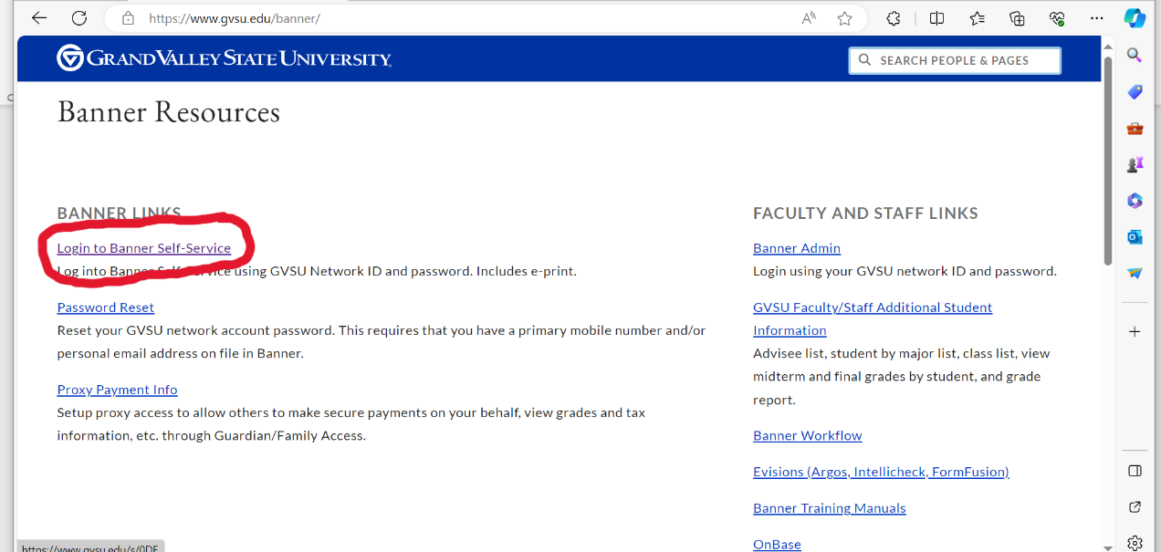

Step 3: Select “Student Registration Self-Service” on the left-hand side of the page.
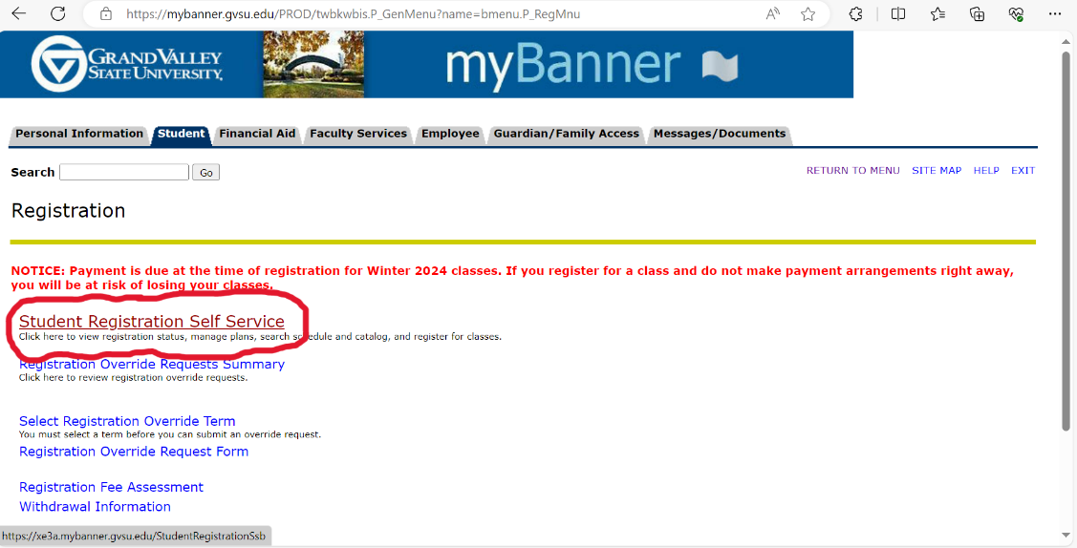
Step 4: Select “Student” on the left-hand side of the page.
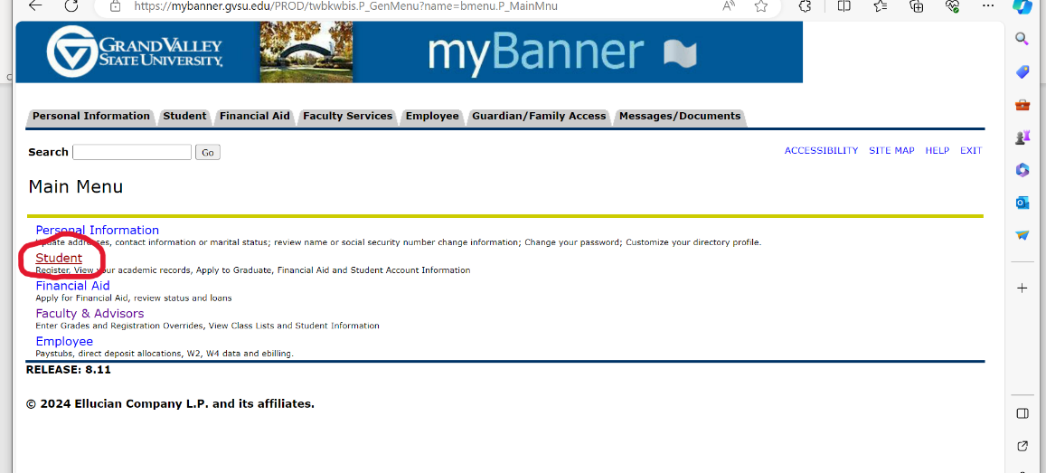
Step 5: Select “Registration” on the left-hand side of the page.
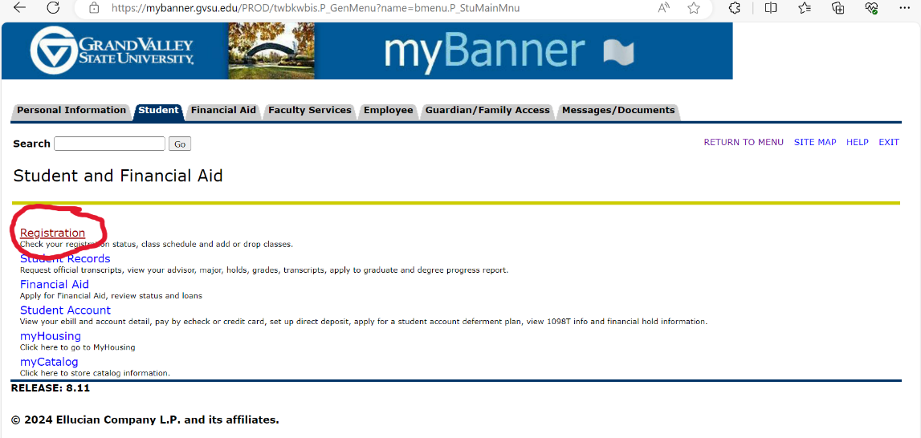

Step 6: Select “Register for Classes”
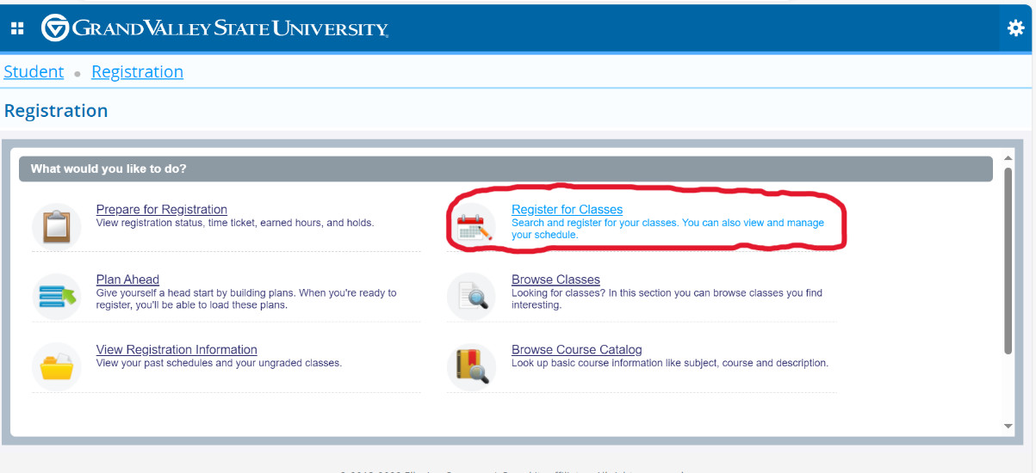

Step 7: Choose which semester you would like to drop classes. Then hit “continue.”
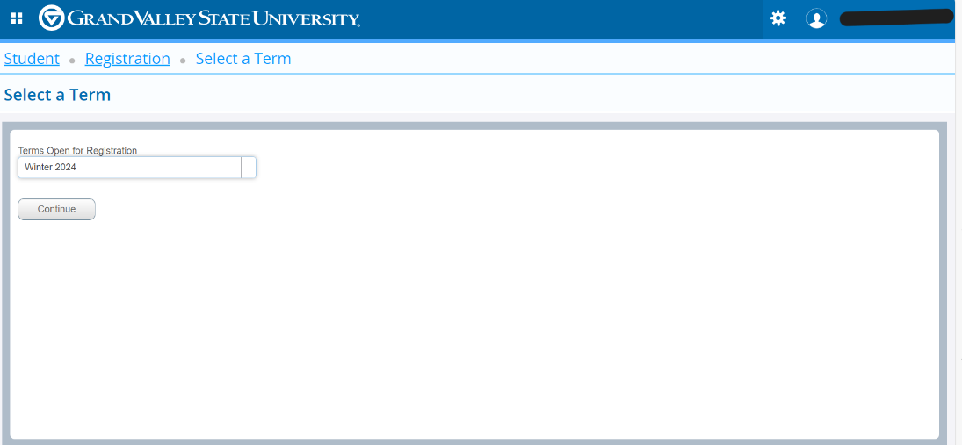

Step 8: On the right-hand side of the page, there will be a summary section with all your classes for that semester listed. Under the “Action” column, you will find the desired class you would like to drop and choose “Web Drop Course ‘W’ Grade.” 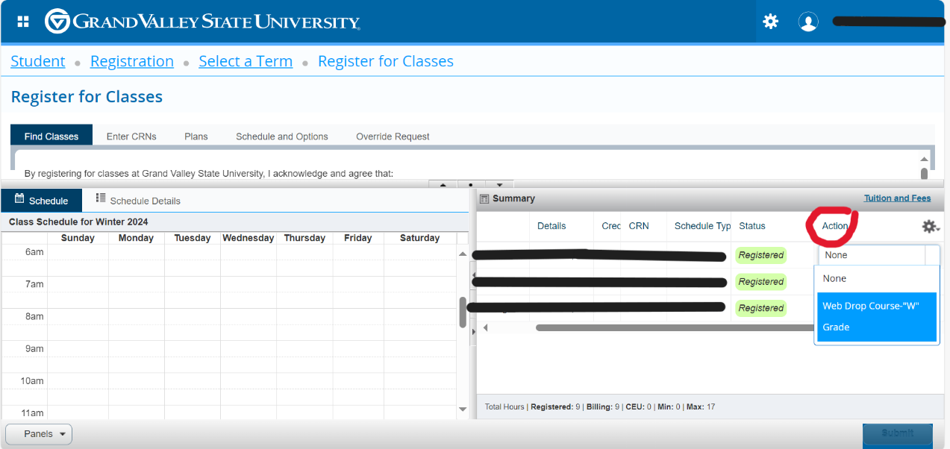
Step 9: Once the correct class you would like to drop is selected, then hit “Submit.”
