

Webinar using Zoom - During

Starting Webinar and Managing the Webinar – Regular/ In-Class
1. Change the name from “Seidmanwebinars” to “Host.”
Note: Make sure that Gallery View is selected, Non-video Participants are hidden, and the Host is muted (both audio and video).
2. Once all the mics and cameras of the panelists are checked, and all notifications are turned off, mute the mics and cameras of the panelists and start the slideshow. (Note: Every slide runs for 15 seconds.)
Make sure it is recording. You may stop and start the recording here so that a separate video file is generated which may require less editing.

In-Class Webinar: Ensure the Camcorder – “Cam 4K Link” is connected and selected to record the webinar session. Classroom microphones should be disconnected to avoid disturbances. Microphones on the panelists' tables must be directed towards them correctly to ensure good quality audio is recorded.

3. Share the slideshow using the “Share Screen” option:


4. Now select “Start Webinar” as you are still in the Practice Session. This starts the broadcast!
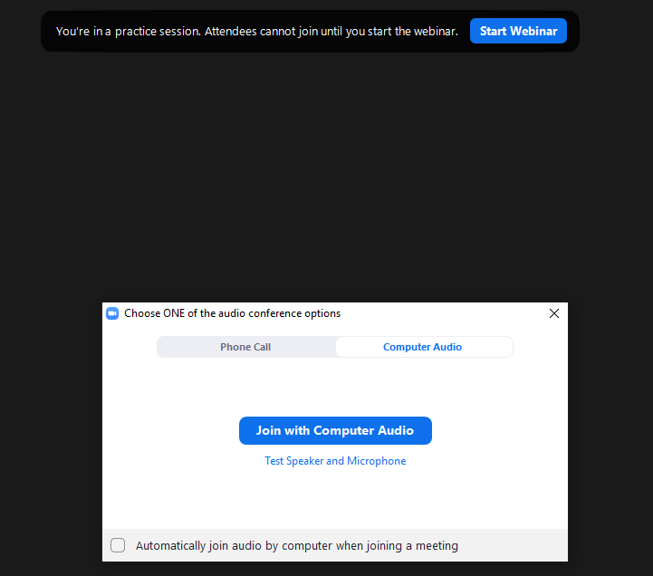
5. Click on the slideshow for the presentation to resume.
6. Unmute panelists’ mics and cameras.
7. Click “Stop Share” to end the screen-sharing of the slides and automatically start the Webinar:
Note: You may have to remind the moderating panelist through private chat that they may start. (Note: When on second last slide, inform the moderator)
8. Select “Allow panelists to share video” under the participants' list.
9. Monitor the chat (double-check what messages will be sent to in the chat box before sending a message). The chat must be enabled between the panelists only. Chat between panelists and attendees must be disabled.
10. Share the closing slide in the same way when the moderator concludes the webinar.
11. Mute all panelists’ cameras and mics.
In-Class webinar: Advice everyone present in the room to exit silently.

12. “End” meeting and wait for the video to convert:
