Webinar using Zoom- After

Editing the Recording
- Save the slideshow as JPEGs.

- Open “Da Vinci Resolve 17”

- Copy slides and webinar recording file into the “New Project Window”.

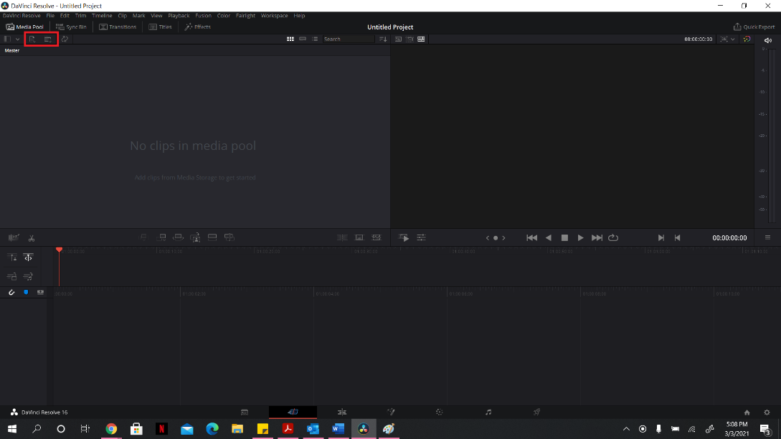

- Edit/Split the webinar recording such that all other parts ie initial presentation and any other clips are deleted. Follow the steps written in the image. The clips can be edited by using the blade option and the frames can be zoomed in and out by using the 2nd option
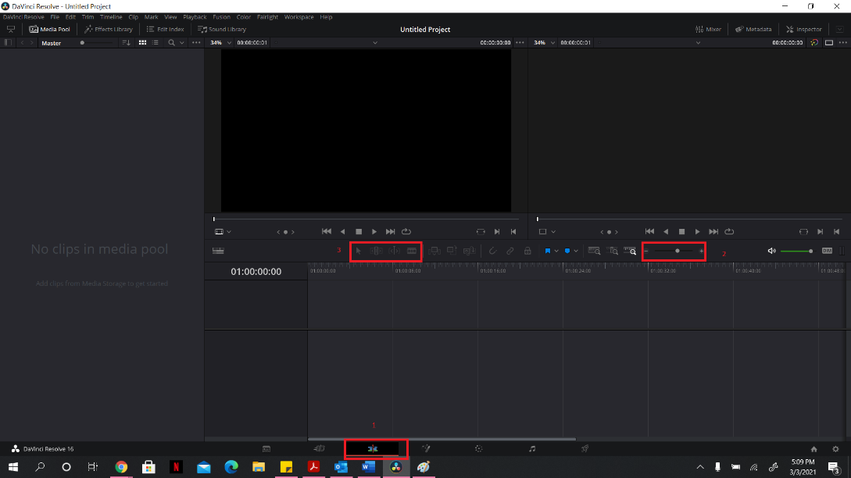
- Set duration for each of the JPEGs. Duration must be set to 15 seconds.
- The video is saved in Da Vinci extension. It has to be rendered in mp4 format.
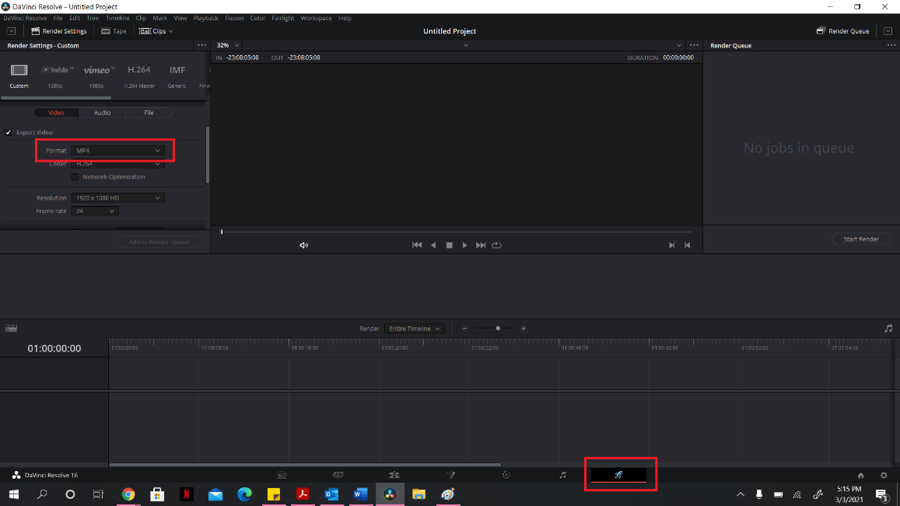
- Export the video.
- Upload the video to the YouTube Channel. ( follow the steps mentioned in the other document)

