Wacom FAQs

- Customize Pen function
Customize your pen functions by assigning settings to pen buttons, adjusting the pen tip feel and pressure, and selecting how you perform a right-click.
Note: Some pens do not have buttons or an eraser.
- Assign settings to the pen button and pen tip
Note: The options available in Wacom Tablet Properties will vary depending on your device.
If there is a Tool row, select your pen.
- Select the Pen tab.
- For each of the pen buttons, select the setting you want from the drop-down menu next to the pen.
- For the pen tip, double-click the pen tip in the image to display a drop-down menu. Then, select a setting for the pen to perform when you tap the tablet surface with it.
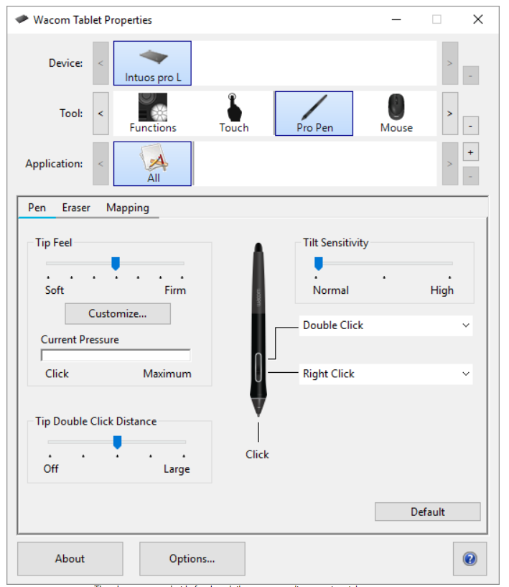

Customize other pen properties
- Tip Double Click Distance: To change the distance between your pen and the tablet surface during a double-click, move the slider.
- Current Pressure: To see how hard you need to press with the pen, check your Current Pressure by pressing down with the pen tip or eraser in an empty area of the Wacom Tablet Properties window.
- If you want to change the amount of pressure you need to use the pen tip or eraser, move the Tip Feel and Eraser Feel sliders.
- Options: To select the way you right-click with the pen, click Options and select a different Pen Button Mode.
- Tilt Sensitivity: To change how much the tilt of your hand affects your pen strokes, drag the slider. Open an application that supports tilt to test while you are adjusting, so you can see how your changes affect your strokes.
- Pen Feel Details: To change the tip sensitivity, click Customize and adjust advanced pen and eraser options.

- Fix Pen Pressures
The following steps will help you determine if any of the above issues are causing your pressure sensitivity problem:
- First, make sure that the current driver is installed from the Wacom Driver page, and that your tablet is connected correctly to the computer.
- Reset the driver preferences to ensure that a specific setting isn’t causing your pen issues. Please follow the steps here.
- Follow the steps to uninstall and reinstall the Wacom Driver found below
    - Windows
    - Mac OS
- Next, try to test the pen in a different software. Is the issue is only found in the one program, try resetting the preferences for that program.

- Disable Press and hold for right-click
On a Windows OS, when pressing the pen to screen, a white circle will begin to form a ring around the cursor, which activates the 'Press and Hold' feature to bring up the right-click menu.
This is a 'Pen and Touch' feature that may work better with Touch screens but not so much with Pen Tablets/Displays.
Go into your Control Panel and search for "Pen and Touch". Select the "Press and Hold" settings, then disable the "press and hold for right-clicking".
Also, when you click/tap normally on the screen with the Pen, an annoying ripple effect might animate around the cursor.
This can be removed by going to "Pen & Windows Ink" settings and turning off "Show Visual Effects".
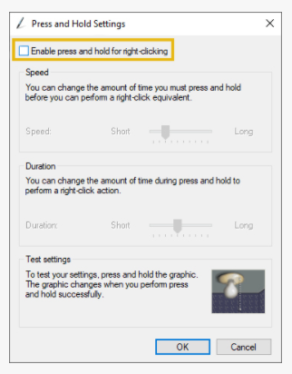

- Update/ change Wacom driver
If troubleshooting an issue does not work, or when upgrading to a newer OS or Cintiq, it’s best to completely wipe and reinstall the Wacom drivers.
When troubleshooting your device, you could first try to narrow down the issue by testing the tablet on a different computer (if available). Even trying on a new user could help answer some questions.
For Mac OS (abridged) :
1. Disconnect Tablet/Cintiq and open Wacom Tablet Utility.
2. Click 'uninstall' and restart computer.
3. Download newest drivers and restart again.
4. Reconnect Tablet/Cintiq, check Tablet Properties, and test before reinstalling your user prefs.
For Windows (abridged) :
1. Disconnect Tablet/Cintiq then open your 'Control Panel' and access 'Programs and Features'.
2. Uninstall any Wacom entries listed and restart computer.
3. Download newest drivers and restart again.
4. Reconnect Tablet/Cintiq, check Tablet Properties, and test before reinstalling your user prefs.
- or -
1. You could also try uninstalling from 'Device Manager'.
2. Under Device Manager, click View>Show Hidden Devices.
3. Find any Wacom Drivers in each section and uninstall them.

- How to clean Wacom Intuos
Clean your device using an anti-static cloth or slightly damp cloth and light pressure. Warning: Do not use alcohol or detergent to clean your device. Do not wrap the cables around the device when storing it. Replace your pen nibs frequently to avoid scratching the surface with worn pen nibs.

- How to Fix “No tablet detected” – Restart Devices
If you are having issues with your Wacom driver, and you don't want to reinstall your drivers quite yet, all you might need to do is restart the Drivers! This fix is most commonly used when you get an error that says something to the effect of "Tablet Not Found/Connected", but could fix a few other issues.
For Mac OS (abridged) :
1. Find 'Wacom Tablet Driver' listed in your Activity Monitor and quit the process.
2. Restart it by finding it in this folder path: /Library/Application Support/Tablet/. Then double click 'Wacom Tablet Driver' to Run it.
For Windows (abridged) :
1. Type "Run" in the start menu and open that app. Then type "services.msc" and press Enter.
2. Scroll down the list in that new window to locate and select a service that either says, "Wacom Professional Service" or "Tablet Service Wacom".
3. Click Restart in the left panel or Stop then Start.

- Wacom Mapping
While you are in Tablet mode, you can customize how the surface of your device maps to your monitors and how your pen movements relate to the cursor movements on your monitor by selecting either Pen or Mouse mode.

Using your device in Pen mode
In Pen mode, you use the pen like a regular pen, and you interact with the device as if it is your paper. Each point on the device maps absolutely to a specific point on your monitor, and the cursor jumps to the corresponding point on your monitor when you place your pen on the device.
If you select Pen mode, you can see a representation of how your device maps to your monitors on the Mapping tab. If you want a different mapping than what is shown, you can change it.
Changing mapping in Pen mode

      - In Wacom Tablet Properties, select your pen from the Tool list and then select the Mapping tab.
      - From Mode, select Pen.
- By default, the active area of the device maps to your entire monitor. If you are using more than one monitor, the device maps to all monitors.
CAUTION: If you change the display properties in your computer's display menu, you are also changing the mapping on this tab.
      - From Screen Area, select which part of your monitor you want the device to map to.
- Select Full if you want to map to the entire area of the monitors connected to your computer.
- Select Portion if you want to define a section of your monitor to map to. Select the section in any of the following ways:
- Under Drag Handles, drag the corners of the red border to define the screen area that you want to map to.
- Select Click to Define and use your cursor to select the screen area that you want to map to.
- Enter Coordinates in pixels.
- Select a Monitor if you want to map to the entire area of a single monitor.

      - From Tablet Area, select which part of your device that you want mapped to the Screen Area you selected.
- The options are similar to the Screen Area options.
      - Select Force Proportions if you want the vertical and horizontal proportions to be the same on your device as on your monitors.
- If you select Force Proportions , when you draw a circle on the device, you see a circle on the display screen, but a portion of the device active area that was previously usable may no longer be usable.
- If you do not select Force Proportions, when you draw a circle on the device, you may see an ellipse on the display screen.
- Tip: To help you decide which setting to select, watch the red borders of the image on this tab while selecting and unselecting Force Proportions to see how it affects mapping.
Using your device in Mouse mode
In Mouse mode, you use the pen like a mouse. The cursor stays on the point you left it when you pick up your pen, and you interact with your device like you interact with a mousepad or trackpad.
- In Wacom Tablet Properties, select your pen from the Tool list and then select the Mapping tab.
- From Mode, select Mouse.
- If desired, change the Mouse Height, Mouse Acceleration, and Mouse Speed.
CAUTION: When you make changes to these settings, you are not changing corresponding settings in your computer's system settings. However, if you make changes to mouse settings in your computer's system settings, those changes may affect how your mouse works in Mouse mode.

