Checking Zoom for Updates before Starting a Webinar
- Login to Zoom and click your account logo in the top right corner.
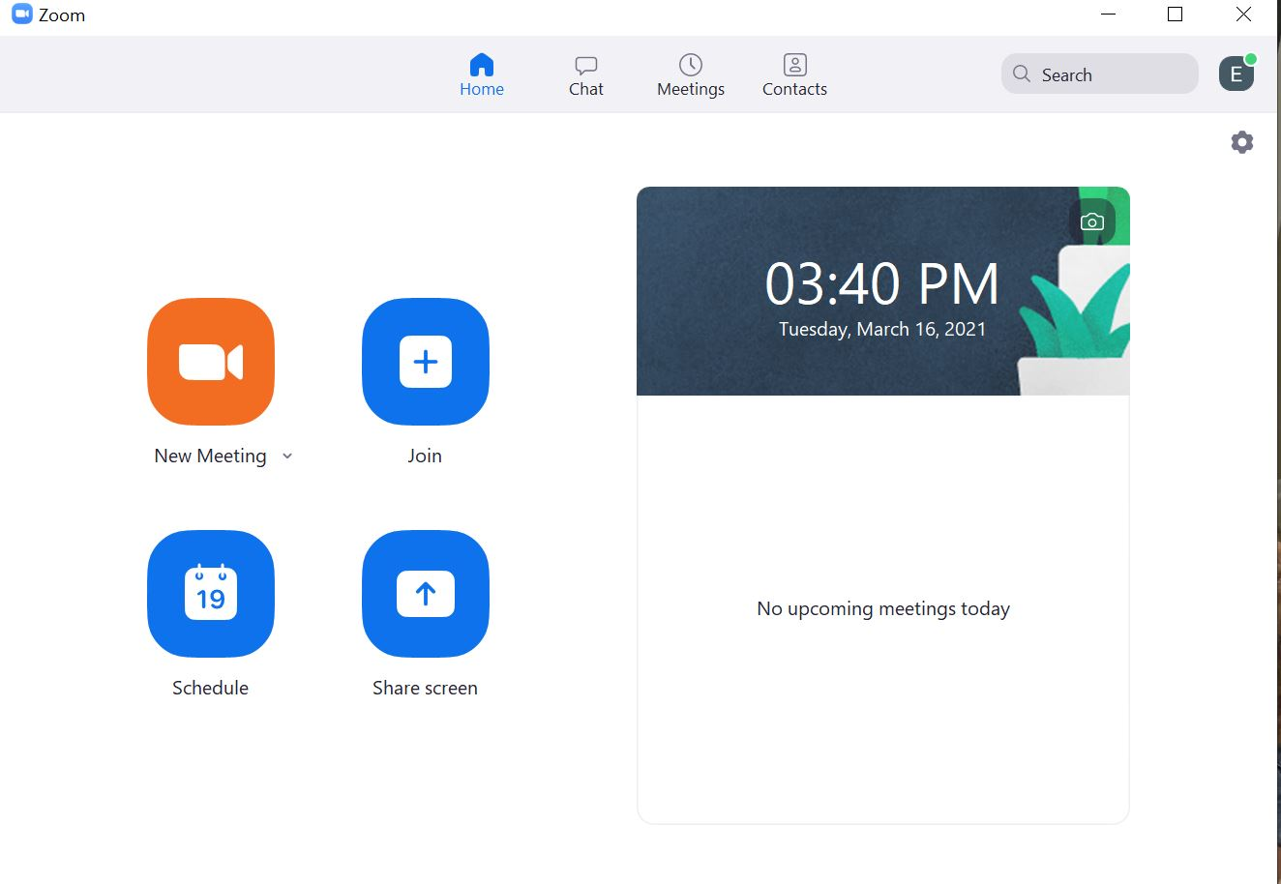
- From the drop down select “Check for Updates”
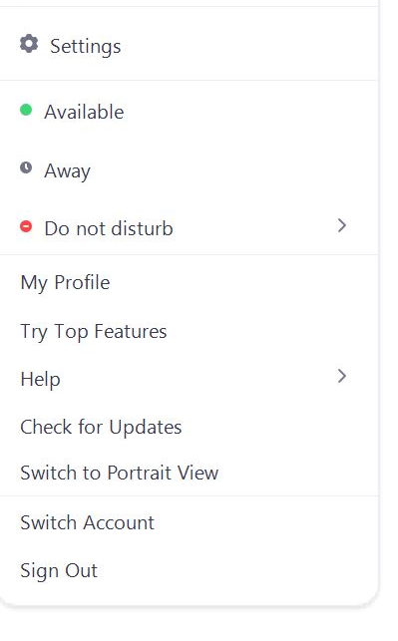

- If you have none it will show you are up to date, if not follow the prompting to update Zoom to the latest version.
