Closed Captioning in Panopto
Sharing the Video
- Make sure the professor shared the document with you and set you as a creator. If you are not set as a creator, you will not be able to make changes to the video.

- In the top right-hand corner click the share icon.

- This will take you to a screen with the accounts that have access to the video. Type in your email and select on the drop-down “can create.”
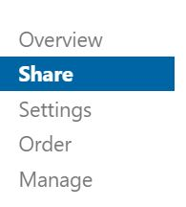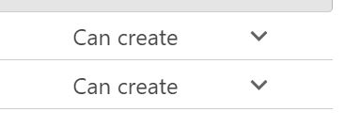
Add your email
Professors email

- Now you can access and edit the video. However, have the Professor email you the link at the top of the share screen so that you can use it to open the folder directly when you are working on captions.

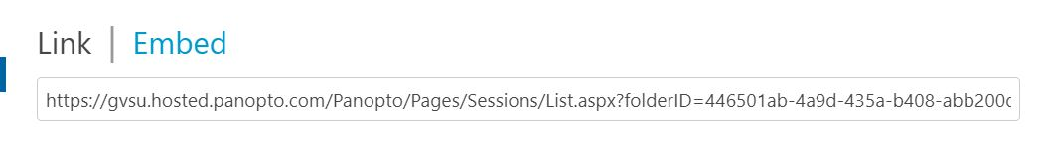

Editing the Video in Panopto
- Hover over the video you wish to edit and click the edit option. 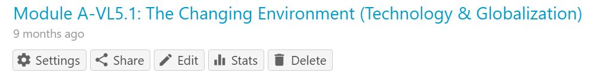

- On the left-hand side, click the captions option to begin captioning.

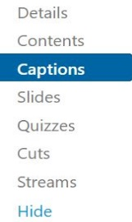
- This will bring up an option to import captions, click the drop-down and select import automatic captions.
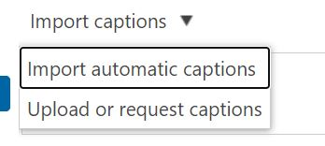
- Panopto will generate a transcript that will appear with the timing of the caption on the far right. Go through and listen to the video while watching for accuracy.

- To edit simply click the inaccurate text and you can type freely.

- If panotpo skipped over something said in the video you can add a caption by going to the empty text box at the bottom and typing what was said. It will add the caption wherever your cursor was left on the video.

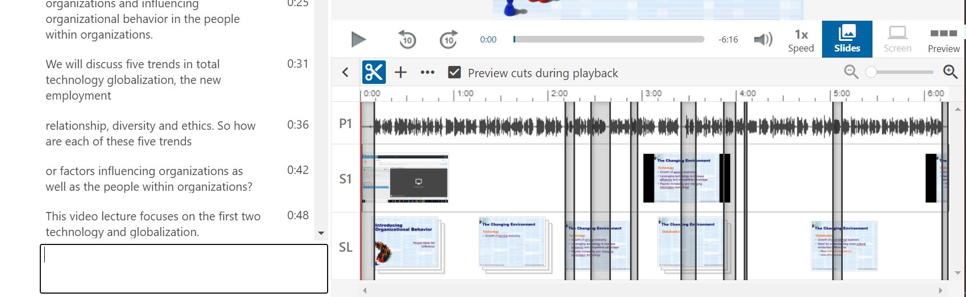

- If the timing of a caption is off, click the three dots by the time mark on the right, and select edit. You can also delete the caption completely.
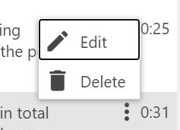

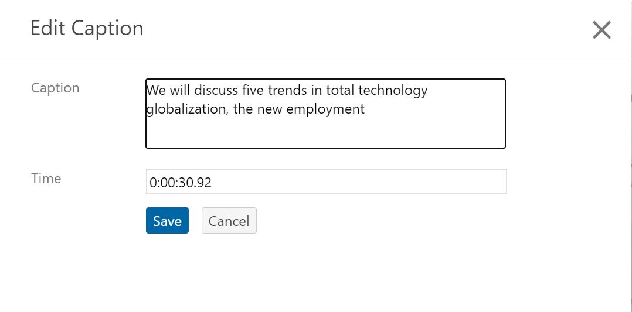

- When finished editing captions, click apply in the top menu of the caption page. This will automatically open the video in a new tab. Click on CC to watch your work.

