Bluescape Training Basics

- Canvas
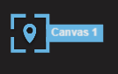

The Canvas feature allows Bluescape users to segment content into groups to better share and show that content in a variety of ways. These collections of content can be thought of as similar to how we use folders on a computer. The Canvas Icon shows a list of all the created canvases.
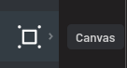

Fun Fact about the canvas location marker is that if you click on it, it also gives you options to delete, duplicate, edit and comment.

- Comments & Messages
Comments may be used to start threads on specific assets within a workspace. The list of all comments appears when the Activity Icon is selected. Private messages may also be sent directly from the menu of a canvas that is sent directly to the email of the recipient.
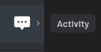

Tip: A user who is @mentioned in a comment will receive an email notifying them of the comment.

- Text and Notecards
The text feature allows you to add free-standing text into a workspace. Although sometimes seen as similar to the notecard feature, text provides added dimensions of customization.

Similar to how sticky notes are used, there are a wide variety of use cases for utilizing notecards in a workspace

Best Practice: When building content, duplicate existing text boxes, then edit the text within each duplicate. This ensures all textboxes remain the same size, font, and color.

- Uploading
Uploading content allows you to visualize your content within a greater context of information, to instantly share your work with others to receive immediate feedback. Word, PowerPoint, Excel, PDF, image, video files may all be uploaded directly from the local hard drive or various cloud storage sources.

- Draw tool
The draw tool allows you to draw and write notes in a free-form manner. The keyboard shortcut ctrl/command + z will remove the most recent pen stroke. It's a best practice to select and delete your workspace annotations, rather than erasing them. Use the eraser to remove annotations made on documents, images, and notecards.

Exercises

- Upload a video and Place a Comment
- Upload a YouTube video using the Upload Icon that is the second one from the bottom.
- Click the YouTube video and click the “Show Comments” icon and enter the comment
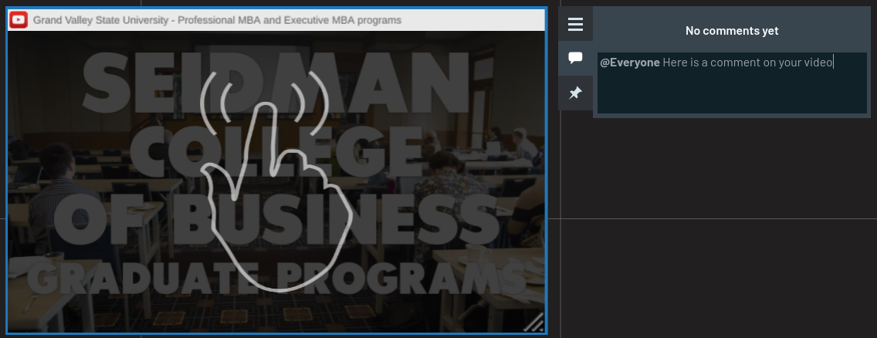

- Create a Canvas after Content has been Added
- Click the text icon and click the card option
- Pick a color and add a notecard
- Select the arrow select tool, choose the lasso, and select card
- Click the three lines to the left and select create canvas
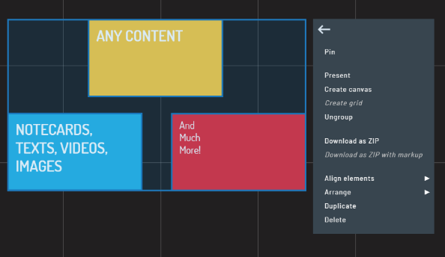

- Leading and Following
- Click the Users icon at the top of the screen
- Click the “Eye” icon to follow a user
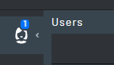

- Meet Function
- Select the Meet Icon to have teleconferencing and screen sharing capabilities.
