Bluescape Setup and Access

- Personal Device Setup

Step 1: Get Started with Bluescape by creating a log-in.

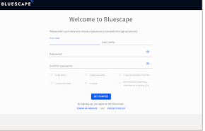

Step 2: From the portal, click on the plus icon to create a new workspace.

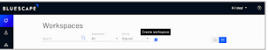
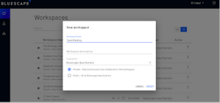

Step 3: Browse through the tools of the workspace
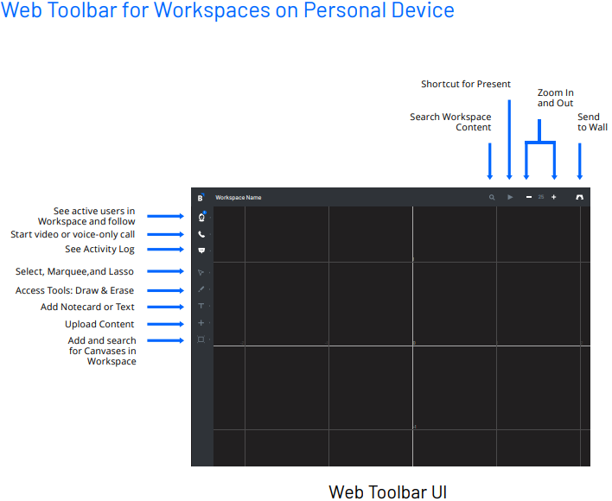

- Wall Setup
Creating Canvases:
To create a canvas, go to the “toolbar” on the left-hand side and click the “square” icon at the very bottom.
The Canvas feature allows Bluescape users to segment content into groups to better share and show that content in a variety of ways.
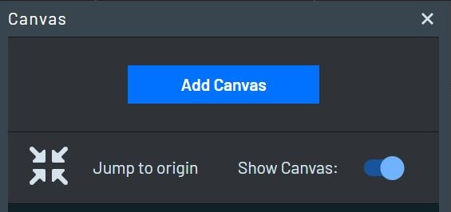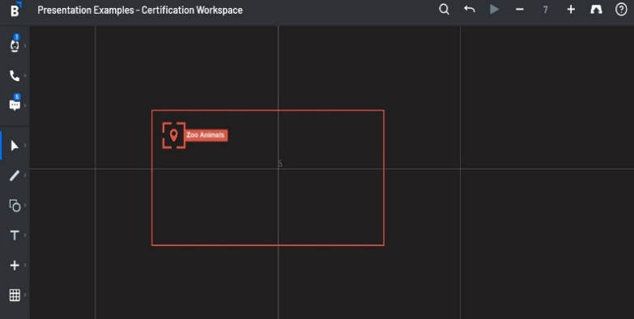
Name and create your canvas so that others in your workspace know what the canvas content pertains to.
Once created, you can use the other tools on the left-hand side to put content into your canvas.
Use the plus icon to upload content from the internet or your device.
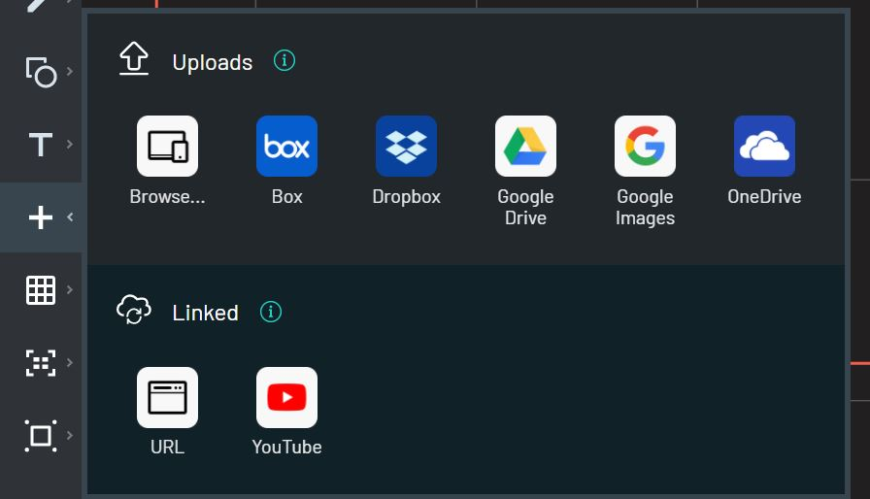
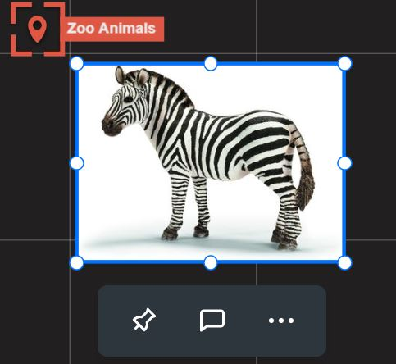
Be sure to pin any images or text in a canvas so that when navigating around the workspace content is not shifted or accidentally selected.
The arrow icon is the selection tool. This allows you to change back from a different tool to normal the normal selection mouse. It gives you the option to pan through the workspace. It also allows you to put a lasso or marquee around the items you’d like to select and group together.
The pen icon is the draw tool which allows you to draw freely in the workspace
The shape icon allows you to insert shapes
The T icon is used to insert a text box or note card

