Registering Students/Faculty for Bluescape

- Login to SCB Modality Bluescape, Bluescape used by professors/ Students does not have admin permissions to allow invitations to users.

- Click the gear icon labeled ADMIN.
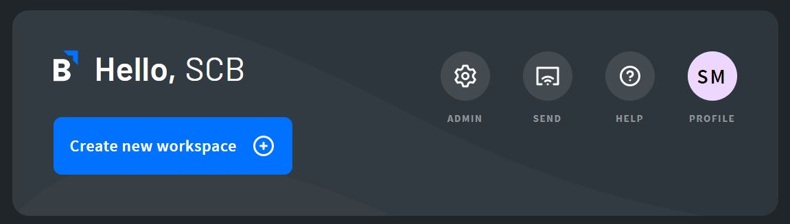

- On the left-hand side click USERS.
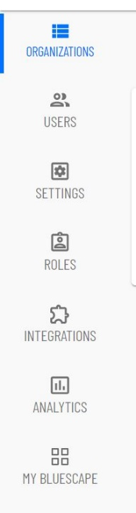

- This will pull up a list of all the currently registered users of Bluescape. At the top of the page click NEW USER.
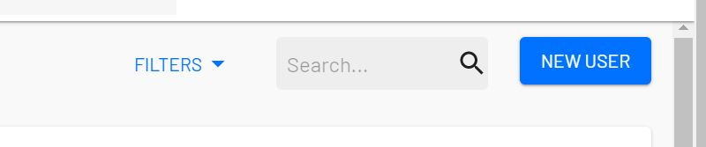
- Enter the email address and give them the appropriate permissions. The default setting is a “user”. If a Professor specifies that they only want an email as a “Guest” you can select it from the drop-down.

If a Professor is unable to edit their workspace you may have to go in and upgrade their role to “User”.

You can paste several addresses into the new user box at a time, rather than adding an email one by one.
