Administrator

- Setting up a class

- Generating Unique code: Administrators have the responsibility of creating code for each session. The code for each session is unique.
- The administrator can activate the scheduled recording of the session
Create session
- Log in to “mashme.io” using the Administrator Credentials
- Go to the top-left corner and expand the user menu using the small triangle next to your name.
- Select “Update Profile”
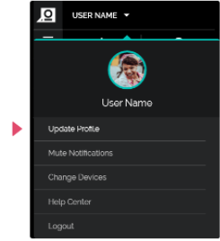
- When the page has loaded, go to “Session management” and then “New Session”
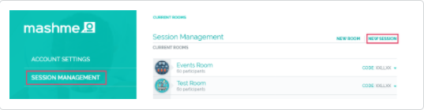
- Complete the “name”, “date”, “start/end time” and the “room” of the session
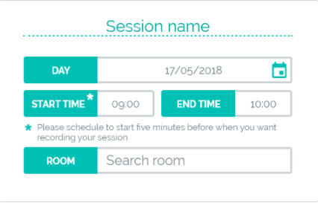
  - Choose if you want the session to be recorded or if attendees receive a notification by email about the session, putting a tick in the boxes
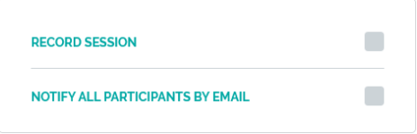
- When this page has loaded, make sure all the details of the session are correct. When you are ready, click on "Create Room"
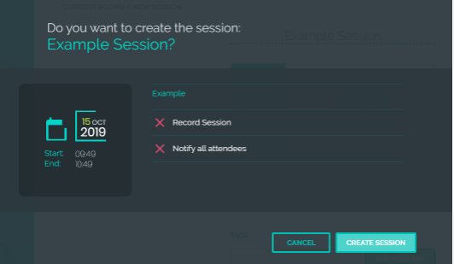
- Once you have created this session, recording throughout the entire session will occur automatically.
- If you want to stop the recording earlier than scheduled, click "Stop Recording" in the bottom right corner of the screen.
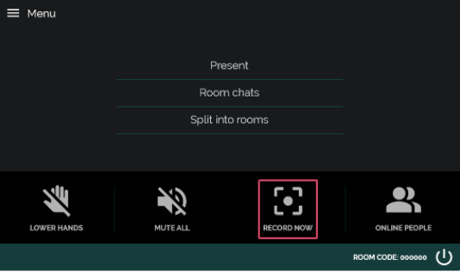

Delete session
- Remember that a session can only be deleted before and after the start time and date, never when it is in progress.
Before the session:
- Log in to mashme.io using the Administrator credentials
- Go to the top-left corner and expand the user menu using the small triangle next to your name
- Select "Update Profile"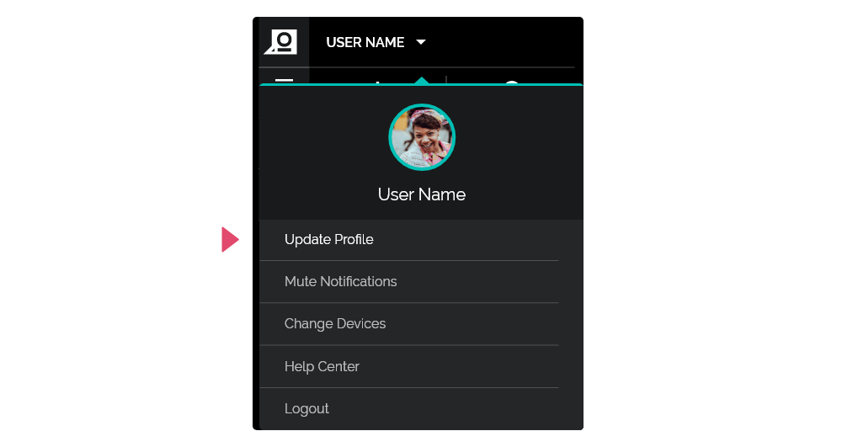
- When the page loads, go to "Session Management" and then "Room of the Future" or "Delegate Room", depending on the session that you want to delete
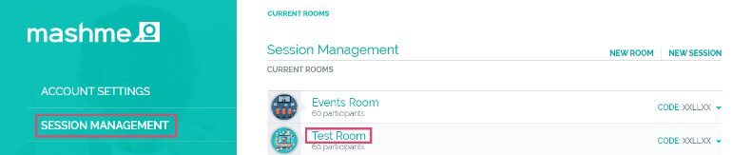
- Click on the room of the session that you wish to delete and click "View Session"
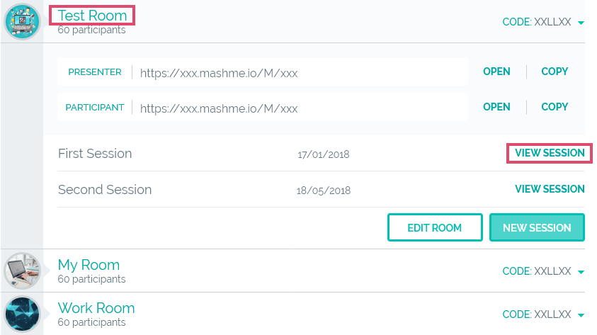
- The page will then display all the information about the session, including the time, date, and duration.
On the top right corner of the screen, click "Delete Session" and then confirm the erasement of the session
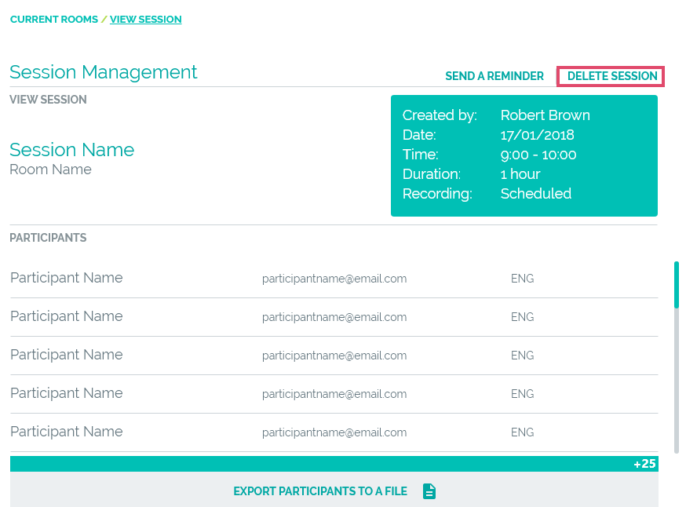
- Choose whether the attendees receive an email to confirm the erasement of the session by clicking in the box shown below
After the session:
- After the session has finished, follow the same steps above to erase the session
- The attendees will not receive an email that confirms the erasement of the session.
- During the class
- Issues/ permission during the class: Contact the Administrator or the Mashme Help chat for any issues.

- After the class
- Access to recordings: Faculty and students are provided with a unique code to access the recordings from each session.

