PIPES
Promoting Interprofessional Education for Students
Mental Wellness
When: Wednesday, April 5th, 2017
Time: 5 pm – 6 pm
Where: CHS 119 Hager Auditorium
Increase your awareness of mental illness by joining Kandice Sloop, LLMSW, from the Mental Health Foundation of West Michigan for the April PIPES meeting. This interactive session will introduce you to the signs and symptoms of mental illness and the be nice. initiative. Don’t miss out on this opportunity for interdisciplinary networking with students pursuing careers in a wide range of health care professions.
This event is free and open to any area undergraduate or graduate students enrolled in a health-related academic program. All skill levels welcome!
Food & Beverages will be Provided!

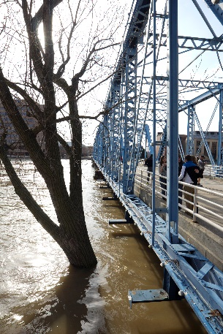

Please register by going to the PIPES website www.gvsu.edu/miperc and click on PIPES.

