A common question for those who have not visited a naturopathic doctor before, is how ND practice is different from what they might be used to in conventional models. The Therapeutic Order guides how the naturopathic principles are applied, and is based on the idea that the human body possesses an inherent drive to heal itself. It posits that the least amount of force be employed in order to promote gentle, safe and long-lasting health and well-being. The Therapeutic Order characterizes the natural progression of naturopathic therapeutic recommendations to maximize patient benefit and reduce the potential for damage or harm. Naturopathic care ultimately focuses on the individual and what is best for them at that moment in time.
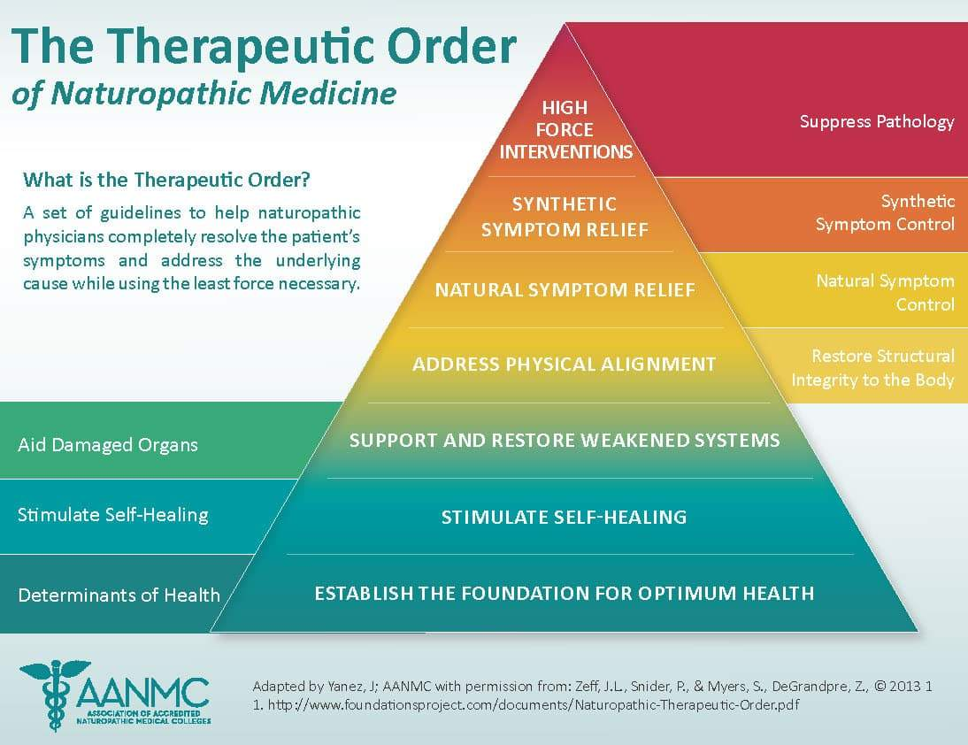
The Therapeutic Order was first developed by naturopathic physicians, Drs. Jared Zeff and Pamela Snider. Dr. Zeff’s landmark 1997 article proposed the four-part Hierarchy of Healing in “The Process of Healing – A Unifying Theory of Naturopathic Medicine.” Drs. Snider and Zeff collaborated in developing it further in 1998, expanding the four-part model to seven levels, and renaming it the Therapeutic Order. It has evolved since then through additional publications. Naturopathic physicians use it in prioritizing, individualizing and guiding treatment for their patients. The therapeutic order works from least to most invasive interventions, from the inside out, from more general strategies, to more symptomatic, specific and targeted therapies. It includes seven steps that should be applied from the bottom up, increasing in intervention as needed to restore health. Central to the therapeutic order is that the order is not rigid, and is adapted to each patient.
The following are the seven components and stages of the therapeutic order.
- Remove Obstacles to Health
In order to return to health, the initial step must be removal of anything impeding the healing process. This is often referred to as “removing obstacles to cure.” Naturopathic physicians create a plan with their patient that addresses these obstacles (common culprits are poor diet, excessive stress or disruptive coping mechanisms, digestive disturbances, inadequate rest, toxic exposures, socioeconomic stressors, trauma, etc.) in an effort to remove them and their effects, and improve the conditions under which the disease developed. Removing the things that are disturbing health allows the person’s vitality to increase, the self-healing process to be optimally engaged, and further therapeutic interventions to have the greatest beneficial effects possible. Removing obstacles to cure is core to the expression of the Naturopathic Philosophical Principle, Treat the Cause.
- Stimulate the body’s self-healing mechanisms
Every person has within them an innate wisdom and intelligence that tends toward the optimal expression of health. In naturopathic medicine, this is called the “Vis Medicatrix Naturae.” The “Vis Medicatrix Naturae” is the body’s innate healing ability, the process of healing which engages with one’s “vital force” or life force, as it is often termed. Naturopathic physicians use various therapies such as nutrition, botanical medicine, physical medicine, lifestyle counseling, acupuncture, homeopathy and hydrotherapy to stimulate and enhance this mighty and dynamic force and process allowing the body to heal itself.
- Strengthen Weakened or Damaged Systems – Restore and Regenerate
Sometimes the mind, spirit and body’s systems or functions need more than stimulation to improve. Systems that are under or overactive, or that need repair or support are addressed in this step. Naturopathic physicians use their broad and varied natural medicine(s) and healing practices to aid in restoring optimal function to an entire physiologic or organ system. This might include applying botanical medicine, endocrine balancing, professional grade supplements, homeopathy, counseling, manual therapies, acupuncture and others with the intention of enhancing the function of specific tissues, organs or systems; or at the psycho-emotional level.
- Correct Structural Integrity
This level involves the use of physical therapies such as spinal manipulation, massage therapy, electrotherapy and cranio-sacral therapy to improve, support, and maintain musculature, fascial and skeletal integrity. Therapeutic movement, optimizing biomechanics, physical therapy and exercise may also be employed at this level to promote return to optimal structural condition.
- Use Natural Therapies to Address Pathology and Symptoms
Although the primary objective of naturopathic medicine is to restore health, not to treat a distinct pathology, there are instances where specific pathologies must be addressed and managed. In these cases, naturopathic physicians utilize physiologically synergistic, dependable, effective natural substances that are unlikely to add toxic burden, cause adverse effects, place undue additional strain on an already disordered system, nor undermine the vis medicatrix naturae, while relieving the symptoms which cause suffering.
- Use Pharmaceutical or Synthetic Substances to Stop Progressive Pathology
Synthetic or pharmaceutical substances may be necessary to restrain or strongly manage symptoms, and address specific pathology that is negatively impacting a patient’s quality of life or safety. NDs recognize that suppressing symptoms removes some of the awareness that helps us better understand the root cause of an issue and the ability to restore vitality.
- Use High Force, Invasive Therapies to Suppress Pathology
Sometimes it is necessary in the interest of patient health, comfort and safety to suppress pathological symptoms, prior to addressing underlying causal factors, and ultimately restoring health. Though suppressive or palliative therapies may result in reduced symptomatic expression, even when done with the best of intentions, the end result of suppressive therapies is that the original, fundamental disturbing factors will continue to impact the person by sustaining disruption of functions (though perhaps to a lesser degree). Resolution of the disturbing factors may also be impeded or halted until the patient is stabilized and can address underlying causes while minimizing suffering and preventing further deterioration.
Naturopathic medicine is a distinct form of healthcare, and is guided by its principles and therapeutic order. Click here to find physicians who practice this safe, gentle and patient-centered model of care in the United States and Canada.

References
Zeff J. The Process of Healing: A Unifying Theory of Naturopathic Medicine. Journal of Naturopathic Medicine 1997;7:122-5.
Snider P, Zeff J. NM 5131 – NMTP 5141-5143. Naturopathic Clinical Theory. Course Syllabus and Materials 1998.
Zeff JL, Snider P, Myers S. A Hierarchy of Healing: The Therapeutic Order. The Unifying Theory of Naturopathic Medicine. In: Pizzorno JE, Murray M, eds. Textbook of Natural Medicine. Missouri: Churchill Livingston; 2006.
Zeff JL, Snider P, Myers S, DeGrandpre Z. A Hierarchy of Healing: The Therapeutic Order. A Unifying Theory of Naturopathic Medicine. In: Pizzorno JE, Murray M, eds. Textbook of Natural Medicine. Missouri: Churchill Livingston; 2013.
Zeff J, Snider P, Myers SP, DeGrandpre Z. The Therapeutic Order, the Determinants of Health, and the Process of Healing in Naturopathic Medicine and Education. In: Wisneski L, ed. The Scientific Basis of Integrative Health. 3rd ed. New York: Routledge; 2017.
Pizzorno JE, Snider P, J. K.Naturopathic Medicine. In: Micozzi MS, ed. Fundamentals of complementary and alternative medicine. 2nd, 3rd, 4th ed. New York: Churchill Livingstone; 2001, 2006, 2011:xxv, 464 p.
Pizzorno JE, Snider P, Micozzi MS. Contemporary Naturopathic Medicine. In: Micozzi MS, ed. Fundamentals of Complementary and Alternative Medicine. Philadelphia: Churchill Livingston; 2015.
Pizzorno JE, Snider P. Nature Cure, Naturopathy, and Natural Medicines. In: Micozzi MS, ed. Fundamentals of Complementary and Alternative Medicine. Philadelphia: Churchill Livingston; 2015.
Myers, SP, Hunter, A, Snider, P & Zeff, J 2003, ‘Naturopathic medicine’, in T Robson (ed.), An introduction to complementary medicine, Allen and Unwin, Crows Nest, NSW, pp. 48-66.
Finnell. J., Snider, P., Myers, S., Zeff. J. A Hierarchy of Healing. Origins of the Therapeutic Order and Implications for Research. IMCJ. May-Jun 2019. Advance Release to be published in Foundations of Naturopathic Medicine – The Healing Power of Nature. Senior Eds. Snider, P., (Executive Editor) Zeff J., Pizzorno J., Myers S., Sensenig, J., Newman Turner R., Warren D., Kruzel, T.; Medical Ed. A. Neil, Production Ed. K. Tenpa. Nature Cure Science Ed. John Finnell. Publ. Foundations of Naturopathic Medicine Institute (FNMI). © FNMI & IMCJ.

