Policy

A timecard is a legal document. Timecards must accurately reflect all hours worked. Misrepresentation of hours worked or forgery is a violation of the law. Misrepresenting hours worked or forging a timecard may lead to immediate termination of employment. It is the responsibility of the hourly staff member to submit their timecard to their supervisor for their signature. Timecards must be accurately completed and submitted to the Payroll Office, 201 Lake Michigan Hall, by 5:00 p.m. on Monday following the end of a pay period. Failure to submit timecards to the Payroll Office by the deadline may result in a delay in receiving payment for pay period.

Each timecard is coded with information for the correct pay period. It is important that you use the correct timecard for the pay period.

In order to sign a timecard, a supervisor must have signature authority on the account being charged. Faculty and Staff are paid on a bi-weekly basis. Pay checks and/or stubs are sent directly to the department for distribution. Paychecks are available on the second Tuesday following the end of a pay period.

Procedures (Timecards are to be completed in black or blue pen)

Daily
- Write the time you begin and leave work. Indicate when you left for and when you returned from lunch. Breaktime is not noted.
- In the box by the day, total the hours for that day. Overtime must be approved in advance.
- Indicate whether the hours for that day are composed of: hours worked, salary continuation (Sick Leave), Vacation, Holiday, lost time or Snowday. The proper abbreviations to be used are as follows:

W = Worked Hours (Only fill in hours actually worked)

OT = Overtime
SC = Salary Continuation (Sick Leave)
V = Vacation (New employees not eligible for 6 months)
H = Holiday Hours (Make sure the hours are recorded in the correct spot)

X = Snowday (University Open)
IW = Inclement Weather (University Closed)

JD = Jury Duty
A = Association Business
L = Lost Time (Unpaid time accounted for on the timecard)

NOTE: Jury Duty and Association Business do not count as hours worked for calculating overtime
All hours must be written as decimals not as fractions and all hours must be carried out only to the nearest quarter hour.
Weekly:
- Total the actual hours worked for the week and write the total in the regular hours (REG HRS) weekly total on the timecard. Lost time is not included in regular hours worked.
- Total the overtime hours for the week, if any, and write that number in the appropriate weekly total box on the timecard.
- Total the double-time hours (overtime hours worked on Sunday or hours worked on a University holiday) for the week, if any, and write that number in the appropriate weekly total box on the timecard.

End of Each Pay Period:
- Total the regular; overtime, and double-time hours and record these hours in the pay period total boxes on the timecard.
- Total the salary continuation, vacation and holiday hours for the entire pay period and record the hours in the appropriate boxes on the timecard.
- If you have hours for reasons not listed on the timecard (lost time, snowday, association business), give a short explanation of the hours and list the hours under "OTHER'.
- Be sure your timecard is complete before you sign your name and submit the card for your Super-visor’s approval. Timecards are to be signed by the professional staff or faculty member responsible for that unit.

NOTE: A Salary Continuation usage form must accompany the timecard for any usage of Salary Continuation over 2 hours. The hours submitted on the Salary Continuation form must match the hours and day(s) on your timecard.

Staff members who are not working on the day timecards are due in the Payroll Office, must complete their timecard before they leave.

Timecard Example

First Week

Monday Normal Day 8 hour work day.
Note: Lunchtime is recorded.

Tuesday Salary continuation usage (5 hours worked and 3 hours salary continuation). The total salary continuation hours are recorded in the salary continuation box. A Salary Continuation Usage Form is attached to the timecard.

Wednesday Vacation Usage (4 hours work and 4 hours vacation). The total of vacation hours are recorded in the vacation box.

Thursday Holiday (8 hours holiday) recorded in the Holiday box.

Friday Overtime (11.50 hour day; 8 hours worked and 3.5 hours overtime).

NOTE: The 3.5 hours of overtime are not included in regular hours; the total overtime hours for the week are recorded in the overtime box. Overtime must be approved in advance by the supervisor

Second Week

Monday Lost time (4 hours work and 4 hours lost time).

NOTE: Lost time is not included in the total regular hours for the week.

Tuesday Normal 8 hour work day.

Wednesday Overtime (9.25 hour day; 8 hours work and 1.25 hours’ overtime).

NOTE: The overtime of 1.25 hours is not included in regular hours; the total overtime hours for the week are recorded in the overtime box.

Thursday Association Business (6.5 hours worked and 1.5 hours Association/Union Business).

NOTE: Association business hours are recorded in the “OTHER” box.

Friday Vacation (8 hours’ vacation).

NOTE: The total vacation usage hours are recorded in the vacation box.
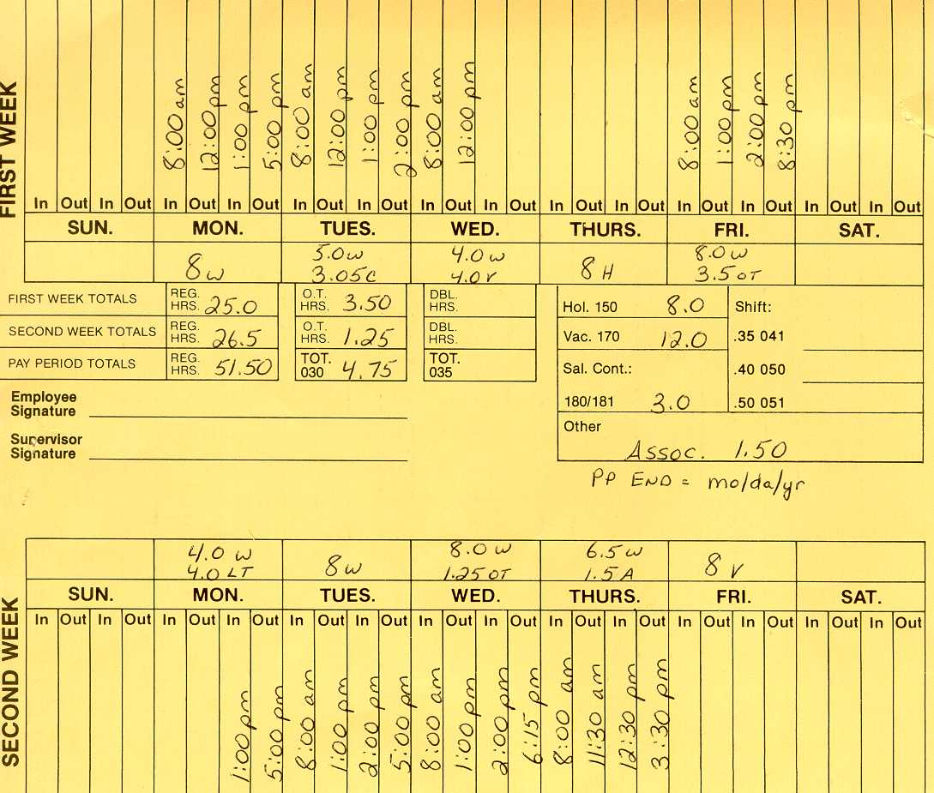

Note: Changes on timecards must be initialed by the Supervisor

