07/10/2018
Search Committee Review
PAGEUP APPLICANT TRACKING SYSTEM
Reminder: You must allow pop-ups for this system to work properly.
- Log into www.gvsu.edu/hiring using your GVSU Network account.
  - Your home screen will look like the image below.
- Click on Search Committee Review (the green bubble).

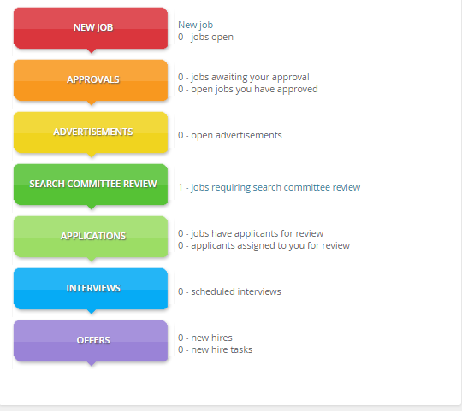

- On the next screen, the job will appear. On the far right, click the option View Applicants.
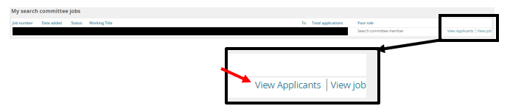
- On the next screen, the list of applicants will appear where search committee members can:
  - Sort the applicants.
  - Choose an outcome for each individual applicant after being reviewed.
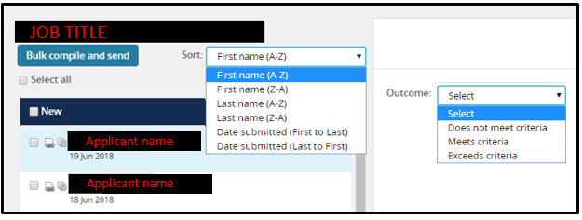
    - These outcomes cannot be seen by anyone else on the committee.
a
b
b
Sorting the applicants and/or selecting an outcome will help committee members keep track of those who have been reviewed and who are new applicants.

  - Review the applicants.
    - Individually by clicking on their first or last name.
    - Multiple applicants using the Bulk Compile and Send feature.
c
c

Reviewing multiple applicants at once (Bulk Compile and Send)
      - Choose the applicants you want by clicking on the box to the left of their name.
        - A check mark will appear next to each applicant selected.
      - Once all of the applicants are selected, click Bulk Compile and Send.

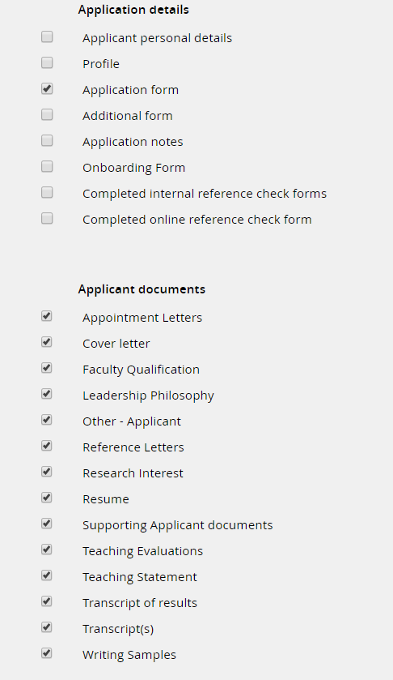
      - On the screen that appears, check the following boxes.

- Application Form
- Appointment letters
- Cover Letter
- Faculty Qualification
- Leadership Philosophy
- Other – Applicant
- Reference Letters
- Research Interest
- Resume
- Supporting Applicant Documents
- Teaching Evaluations
- Teaching Statement
- Transcript of Results
- Transcripts
- Writing Samples

      - Scroll to the bottom and click Create PDF.
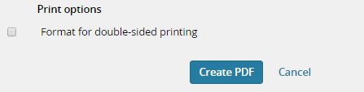

      - Wait until all of the documents have been compiled.
        - The more applicants you selected, the longer this will take.
        - Do not exit out of this screen or it will cancel the bulk compile.
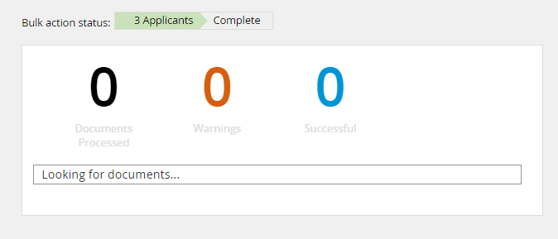

      - A screen will appear where you can either:
        - Open the compiled document as a PDF by clicking on the link to download.
        - Send the PDF file via email, if less than 5mb.

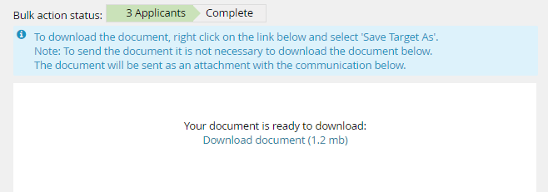

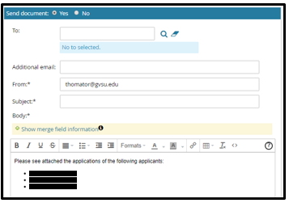
      - Scroll to the bottom and click Okay to send the email, if needed, or press Close.

Reviewing applicants individually
              - Once you click on the applicant’s first or last name, the Applicant Card will appear. Here you can review all documents submitted by the applicant. (example: cover letter, resume, transcripts)
              - Click on Form to the right of your position listed under the Applications section.

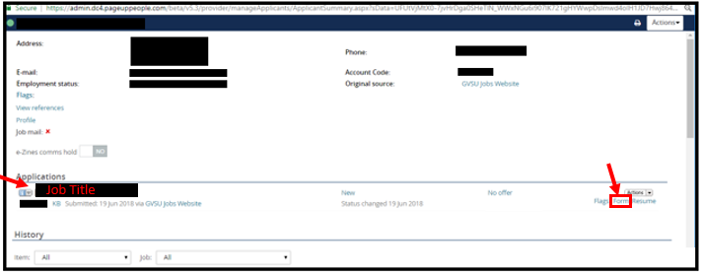
              - Once you click on the Form, the completed application will appear. Please review
the application and the documents attached.
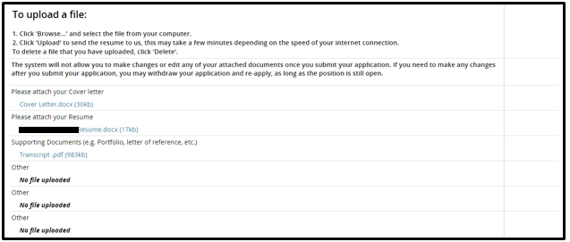
              - You can access all of the documents an applicant submitted by scrolling almost to the bottom of the application until you see:

**If you have any questions, please reach out to Human Resources at 616-331-2215 or at hremploy@gvsu.edu and one of the employment team members will be happy to assist you.**

