Application Review – Search Committee Members
As a Search Committee member, you can view and print all of the applicants to review their applications.

The number of applications shown when viewing your jobs reflect how many applicants have started the application process. When you click to view applicants, you will only see the completed applications so there may be a discrepancy.
Number of applicants that have begun an application

Part A: Viewing Jobs
- Log into www.gvsu.edu/hiring using your GVSU Network account.
- Click SEARCH COMMITTEE REVIEW.
- Click View job to the right of that job to view and print the job information and any documents that have been uploaded.
  - If you are listed as a Chairperson under Your role, click Edit job.

Part B: Reviewing Applications
Refer to Part C for instructions how to print all applications and documents at one time.
- Log into www.gvsu.edu/hiring using your GVSU Network account.
- Click SEARCH COMMITTEE REVIEW.
- Click View Applicants to the right of that job. Do not choose an outcome.
  - Click the Applicant’s name to see their basic information.
    - To view the full application, including documents, click Form which is to the right of the job title in the Applications section.

The Human Resources Office will no longer attach any documents for the applicants. All documents will have to be attached by the applicant at the time of submission.

Part C: Bulk Compile and Send
Optional: allows you to send the complete list of applicants in a PDF format via email and/or print all of the applications at once with attached documents.
- Log into www.gvsu.edu/hiring using your GVSU Network account.
- Click SEARCH COMMITTEE REVIEW.
- Click View Applicants to the right of that job. Do not choose an outcome.
- Select the applicants you want to send in an email and/or print.
  - Check the boxes to the left of the applicant’s name.
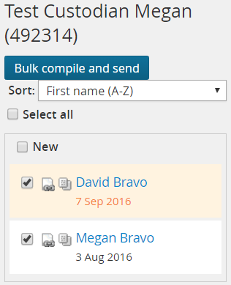

- Click Bulk compile and send located above the applicants’ names.
- Select the documents you would like to include in the document.
  - Check the boxes next to the description of each item. Here are the suggested items to click:

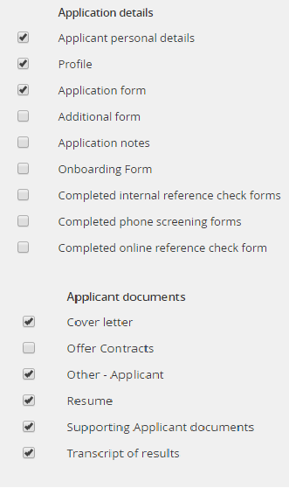

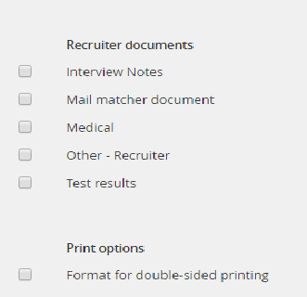

- Click Create PDF.
- Click Download document to view and print the applications.
- To send the applications, enter the recipient’s email in the Human Resources field. The Human Resources field does not have to be someone in Human Resources.
  - If you are sending to multiple people, enter their email in the Other email field. Separate each email with a semicolon.
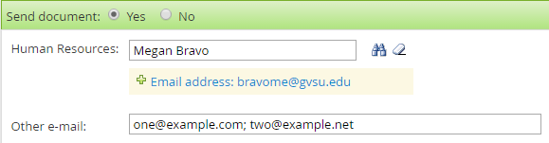

- Enter a subject into the Subject line, if it needs to be edited.
- Click Okay.

