Scheduling Interviews & Interview Status Change
There are two ways to schedule interviews. You can schedule the interviews in the system or you can call and schedule the interview yourself.
Do not schedule interviews until the approval process has been completed. You will receive an email from Human Resources letting you know that the approval process is complete.

Scheduling Interviews in the System
Part A: Creating the Interview
Optional: Video/Phone Screening and Interviews can be scheduled through the system.
- Click the menu button in the top right corner of the screen.
- Click New event which is under the Events category.
- Enter the event details – an example is shown below. Enter information into every box.
  - It is important to remember the title you have created as you will need it later in the process.
  - You want the title to be specific and unique to the position. (I.e. Affiliate Faculty – Finance Interviews or Office Coordinator SCB Interviews)
  - Public instructions are specific to the interview and should include the contact person’s information and address of the interview. You might also include any important information for the applicant, such as where the interviewee should go, whom to ask for when they arrive, or where to park. (I.e. Please inform the Office Coordinator you are here for an interview and ask for Megan).
  - Click ‘Yes’ for the question: Add owner as a user? This allows you to receive notifications on your dashboard when an applicant has accepted an interview.
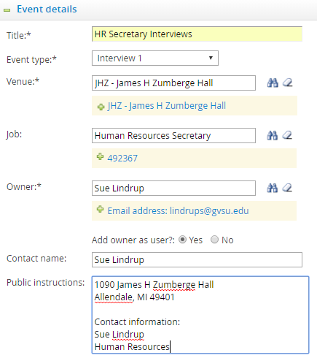

- Click Save.
- Add time slots for the interview. You can add time slots either one at a time or in bulk. We suggest bulk if it is several slots to add. When it asks for Positions, it is asking for how many candidates can interview during that time slot, which would normally be one.
- Add a single time slot: Enter the requested information.
    - Click Add.

- Add bulk time slots: Click Add next to Add bulk time slots and enter the requested information.
  - You can invite Users (the Search Committee members) so that they also receive notification on their dashboard when an applicant has accepted an interview. This will add the committee to each time slot all at once.

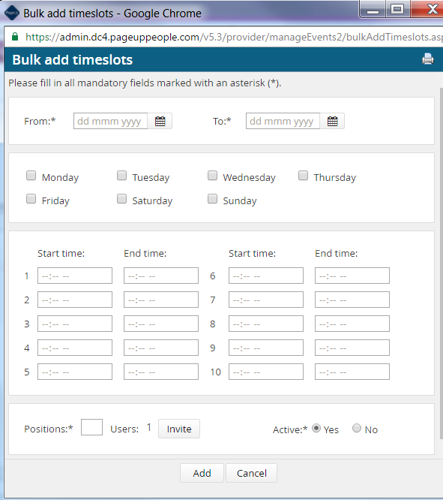

- Click Add.

Part B: Inviting the Applicant(s) to the Interview

- Click the menu button in the top right corner of the screen.
- Click Manage jobs which is under the Jobs category.
- Click the applications icon to view the applications which is located to the right of the job title.
↓

- Sort the applicants by clicking on Status to see all of the applicants who have the status ‘Interview Approved Affirmative Action’.
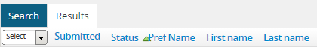
↓

- Click their status.
- Click Interview 1.
- Click Next>.
- Do not choose a communication template – there is already a template ready for you.
- Under Event, choose Select an event.
  - You will use the title of the event that you created in Part A. You can use the binoculars to search, if needed. Do not allow applicant to choose an event.
- Under Event time slot, choose Allow applicant to choose the time slot.
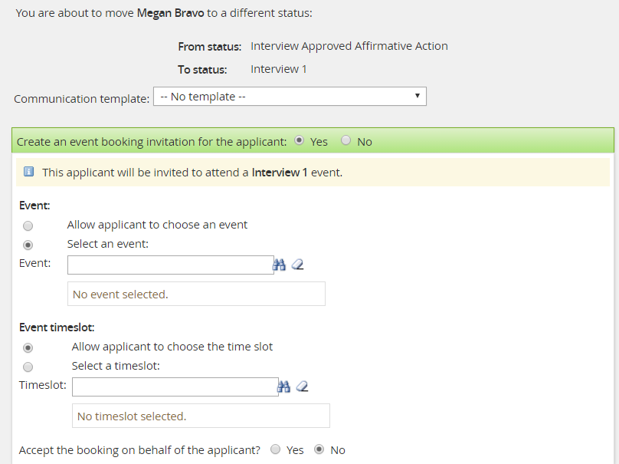

- Complete the email to the applicant.
  - The ‘From’ section of the email will pre-populate with your email address.
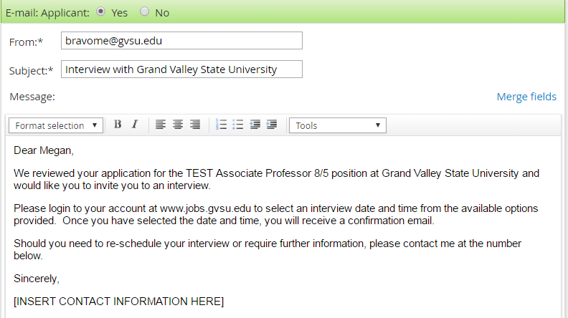

- Click Move now. The applicant will be sent the email with instructions how to accept/decline the interview request.
- Repeat this process for each applicant you want to invite to an interview.

Interview Status Change – Not Scheduling in the System
Part C: Changing the Status to Interview
Once the applicant has been approved to interview, and you have scheduled the interview, their status must be changed in the system so that the interview is documented.
- Log into www.gvsu.edu/hiring using your GVSU Network account.
- Click the menu button in the top right corner of the screen.
- Click Manage jobs which is under the Jobs category.
- Click the applications icon to view the applications which is located to the right of the job title.
↓

- Sort the applicants by clicking on Status to see all of the applicants who have the status ‘Interview Approved Affirmative Action’.
↓

- Click their status.
- Click Interview 1.
- Click Next>.
- Click the radio button next to ‘No’ where it says ‘Create an event booking invitation for the applicant.’
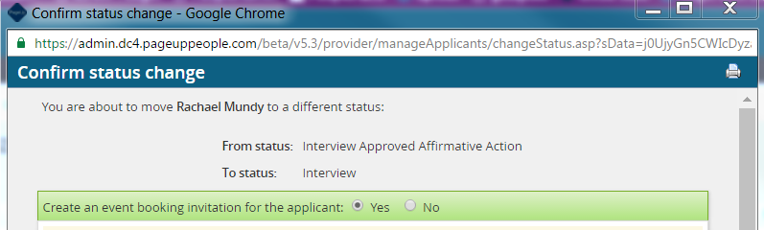

- If you would like to send an email to the applicant confirming their interview, you have the option to do that here. You will have to edit the body of the email. If not, click the radio button next to ‘No’ to turn it off.

You can make edits to the body of this email

Refer to the document Application Statuses and Changes Part B in regards to this email.

- Change the Date and Time of the interview in the Status section.

Here is an example: I have scheduled an interview for Wednesday, October 26, 2016.

Before any changes are made: The date and time reflects the current date & time.
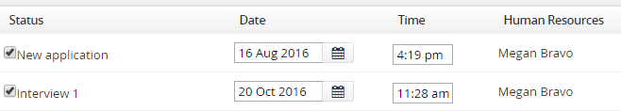
After changes are made: The date and time reflects the scheduled interview.

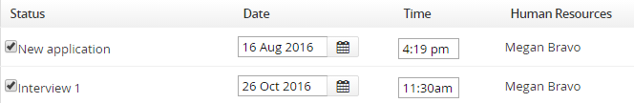

- Click Move now to confirm the status change.
- Repeat this process for each applicant that has been scheduled for an interview.

Part C: Documentation of Changes to Scheduled Interviews
This step can only be completed by the originator of the status change to Prescreen Phone/Video Interview, Interview 1 or Interview 2 and allows you to update the date & time of the interview.
- Click the menu button in the top right corner of your screen.
- Click Manage jobs which is under the Jobs category.
- Click the applications icon to view the applicants which is located to the right of the job title.
↓

- Click the name of the applicant.
- In the History section of the applicant card, change the Item dropdown to Activities. If needed, you can also search by the Job.
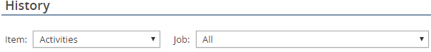

- Under the Item column, find the status for the Interview (Phone screen 1, Interview or Interview 2) and click Edit to the right of the status.
→

- Edit the field to reflect the actual date and time of the interview.
