**How to Print Offer Documents**

1. Log into [www.gvsu.edu/hiring](http://www.gvsu.edu/hiring) using your GVSU Network account.
2. Click the menu button in the top right corner of your screen.
3. Click **Manage jobs** which is under the **Jobs** category.
4. Click the applications icon to view and print the applications which is located to the right of the job title.

 ↓

1. Click the applicant’s name to see the applicant card.
2. In the **History** section of the applicant card, change the Item dropdown to Documents.

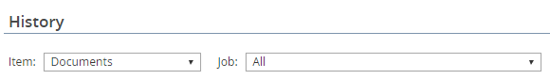

1. If the applicant has applied to more than one position, change the Job dropdown to the correct position.
2. Click **View** or **PDF** to view and print the document.