Letter of Recommendation (References)
You can confidentially request a letter of recommendation from the references listed by the applicant in the system. It will send the reference an email requesting the letter.

Part A: Sending Initial Request for a Letter of Recommendation
- Log into www.gvsu.edu/hiring using your GVSU Network account.
- Click the menu button in the top right corner of your screen.
- Click Manage jobs which is under the Jobs category.
- Click the applications icon to view the applicants which is located to the right of the job title.
↓

- Click on the applicant’s name.
- Under the Applications section, click Actions to the right of the position you are viewing.
→
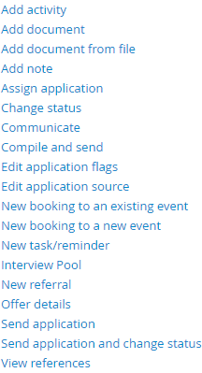

- Click View references.
- Click Send invitations in the top left corner.

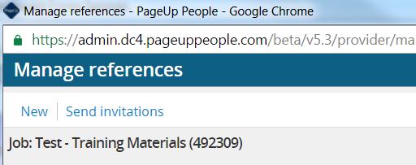

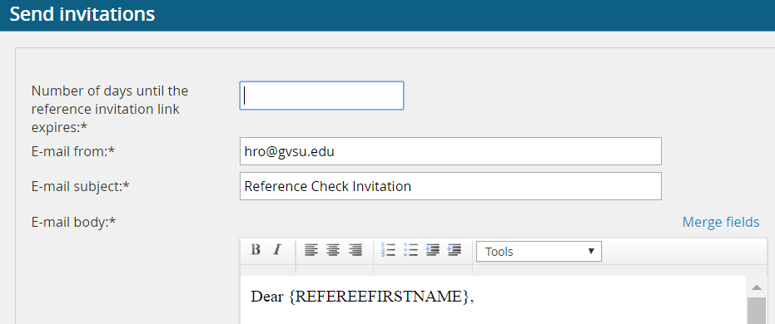
- Enter number of days until the reference invitation link expires.

- Do not edit the capitalized merge fields in the email.
- Click Send. An email will automatically be sent to the references that the applicant provided.

Part B: Re-sending a request
If the reference does not respond within the given timeframe and you need to re-send the link.
- Log into www.gvsu.edu/hiring using your GVSU Network account.
- Click the menu button in the top right corner of your screen.
- Click Manage jobs which is under the Jobs category.
- Click the applications icon to view the applications which is located to the right of the job title.
↓

- Click on the applicant’s name.
- Under the Applications section, click Actions to the right of the position you are reviewing.

→

- Click View references.
- Click Resend to the right of the reference’s name.

- Enter number of days until the reference invitation link expires.
- Do not edit the capitalized merge fields in the email.
- Click Send. An email will automatically send to the references the applicant provided.

- The person providing the reference will be able to manually type or upload a Letter of Recommendation when they click the link in the body of the email.

Part C: View Letter of Recommendation
How to view the letter of recommendation.

- Log into www.gvsu.edu/hiring using your GVSU Network account.
- Click the menu button in the top right corner of your screen.
- Click Manage jobs which is under the Jobs category.
- Click the applications icon to view the applications which is located to the right of the job title.
↓

- Click on the applicant’s name.
- Under the Applications section, click Actions to the right of the position you are reviewing.

- Click View references.
- Click View answers to the right of the reference’s name.

- You can view and print the references. We do not use the score, so you ignore that part of the form.

