Job Approval Process
Approving new/replacement positions or position changes.
Part A: Approval Process
- Log into www.gvsu.edu/hiring using your GVSU Network account.
- Click the menu button in the top right corner of the screen.
- Click My Job Approvals which is under the Jobs category.
- Click View next to the job you are approving and the job card will appear.
- Depending on your role, you may have additional information to enter on the job card.
  - Affirmative Action – enter EEO (under the Human Resources section)
  - Budget – enter Labor Distribution, Account Code & Confirmed position number
  - Hiring Manager/Search Chair – enter Hiring Manager/Search Chair, add Search Committee Members and recruitment plan/advertising information. (Instructions how to add the advertising information is found in Part B of this document)
    - If you are using an external (non-GVSU) search committee member, email the Employment Manager so we can create an account for them.
  - Human Resources – enter appropriate information
  - Provost Office – approve only
  - Vice President – approve only
- Approve/Decline the job.
  - Approve: Click Approve at the bottom of the screen. This will automatically send an email to the next approver in the process.
  - Decline: Click Decline at the bottom of the screen.
    - Select a reason for this selection.
    - Click Save.

  - Click Save a draft if you would like to save the job card and finish the approval process at a later time.
    - If saving a draft, click OK in the box when it asks if you want to save the following as a draft. Note: The approval process, if set, will be deleted.

Part B: Adding Position Announcement Form
- Complete the Position Announcement form which is found here under General.
- Log into www.gvsu.edu/hiring using your GVSU Network account.
- Click the menu button in the top right corner of the screen.
- Click My Job Approvals which is under the Jobs category.
- Click View next to the job you are approving and the job card will appear.
- Scroll down to Position Details in the HIRING MANAGER/SEARCH CHAIR section.
- Enter the Advertising Summary which is a brief overview of the job. The text you enter in this field is exactly how it will appear on the job website.
Example:

On the job card:
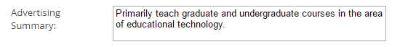

On the job website:

- Copy and paste the Position Announcement into the Advertisement Text area.
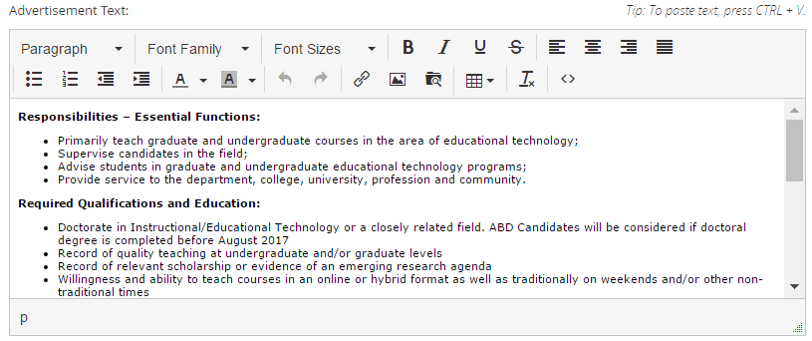
Example:

- You will receive an email notification when you are required to approve a position.
- 12-Month Adjunct AP and Visiting Faculty Positions – If you have a 12-Month Adjunct AP position or Visiting Faculty position, you will need to add the Position Announcement Form in the Hiring Manager/Search Chair section for the position to be approved.

