Getting Started – Quick Tips for Search Chair/Search Chair Assistant
Website: www.gvsu.edu/hiring
The look of your homepage will depend on your role at GVSU.

- Enable pop-ups for this website: admin.dc4.pageuppeople.com

[For Internet Explorer Users]:
- In the top right hand corner, click on the tools icon.
- Click Internet Options.
- Click the Privacy tab. Under the Pop-up Blocker section:
  - Uncheck the box for ‘Turn on Pop-up Blocker’ and click Apply OR
  - Click Settings and enter the website and click Add
[For Chrome Users]:
- In the top right hand corner, click on the menu icon.
- Click Settings.
- Scroll to the bottom of the page and click Show advanced settings.
- Under the Privacy section, click Content settings.
- Under Pop-up Blocker section:
  - Check Allow all sites to show pop-ups OR
  - Click Manage exceptions and enter the website

- Do not use the back button in your browser to go back to the previous page, as your session may be interrupted and you may lose your changes.

- Your session will timeout after 90 minutes of inactivity.

- The Recent Items history drop down displays the last 20 applicants and/or jobs viewed. This gives you the ability to quickly jump directly to a previously viewed item.
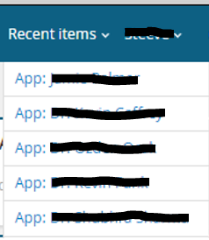

- Binocular fields are used to allow you to select from a large set of data e.g. users or departments. Click on the binocular icon to view a pop-up window which will allow you to search through the data. The eraser will delete the content in the field.

Example:
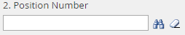
↓ ↑

Commonly used icons:
Menu button on the Dashboard – you will always see this in the top right corner
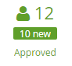
You will see this on your dashboard
Number of applicants that have begun an application.

Number of completed applications.

View Resume You will see this in People/Manage Applications
↓

← Answers (i.e. Application)
↑ Download Resume

Edit Preview Job Advertisement You will see this in Jobs/Manage Jobs
↓ ↓
← Applications
↑ ↑
Notes Job Costs (You should not have job costs to view)
(You should NOT have any notes to View, but the icon is visible)

You will see this in Jobs/Manage Jobs
← Information about the job

