Final Candidate Approval Process
Approving the final candidate for a position.

Part A: Reviewing the Offer Card
- Log into www.gvsu.edu/hiring using your GVSU Network account.
- Click the menu button in the top right corner of the screen.
- Click Manage Offer Approvals which is under the Applicants category.
- Click View next to the applicant you are approving and the offer card will appear. If you want to view the other applicants that have interviewed, please refer to Part B.
- Review the information on the job card and make changes, if necessary.
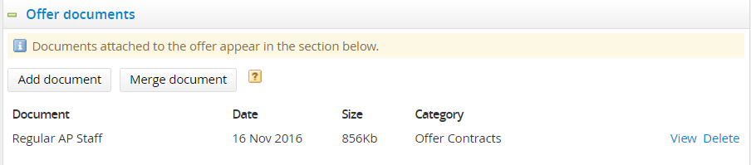
- Review/Create the appointment letter.
  - Review the appointment letter - it is found in the offer documents section.

  - Create the appointment letter – refer the document Final Candidate and Offer Part C.
- Approve/Decline the applicant.
  - Approve: Click Approve at the bottom of the screen. This will automatically send an email to the next approver in the process.
  - Decline: Click Decline at the bottom of the screen.
    - Select a reason for this selection.
    - Click Save.

Part B: Reviewing Applicants that Interviewed
- Log into www.gvsu.edu/hiring using your GVSU Network account.
- Click the menu button in the top right corner of the screen.
- Click Manage jobs which is under the Jobs category.
- Click the applications icon to view the applications which is located to the right of the job title.
↓

- Sort the applicants by clicking on Status to see all of the applicants who have interviewed.
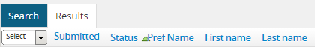
↓

- Click applicant’s name to view their applicant card.

